

**Module Code & Module Title**

**CS6P05NI Final Year Project**

**Assessment Weightage & Type**

**25% FYP Interim Report**

**Semester**

**2022 Autumn/Spring**

**Project Title:** My Room

**Student Name:** Anish Aryal

**London Met ID:** 20048825

**College ID:** np01cp4s210084

**Internal Supervisor:** Aadesh Tandukar

**External Supervisor:** Brij Sharma

**Assignment Due Date:** 28th Dec, 2022

**Assignment Submission Date:** 28th Dec, 2022

**Word Count (Where Required): 3753**

*I confirm that I understand my coursework needs to be submitted online via Google Classroom under the relevant module page before the deadline in order for my assignment to be accepted and marked. I am fully aware that late submissions will be treated as non-submission and a mark of zero will be awarded.*

**Summery**

This project involves the development of a web application for a property rental and sales platform. The project has made significant progress so far, with the initial phase and several subsequent tasks being completed. These tasks include research and planning, gathering resources, developing a risk management plan, creating a Gantt chart, designing the system architecture and user interface, and preparing various documents and diagrams. The project is currently in the development phase, with work underway on the login/register module. The remaining tasks, which include the development of various pages and features, finetuning and testing of APIs, and final testing and reviews, are yet to be started. The project is on track to be completed by April 2023 and the conclusion has been reached that the remaining tasks will be completed efficiently and on schedule.

1. Introduction 9

1.1. Project Description 9

1.2. Problem Scenario 10

1.3. Project as a solution 11

1.4. Aims and Objective 11

1.5. Structure of Report 12

1.5.1. Background 12

1.5.2. Development 12

1.5.3. Testing and analysis 12

1.5.4. Conclusion 12

2. Background 13

2.1. End-Users 13

2.1.1. Sellers 13

2.1.2. Buyers 13

2.2. Understanding the solution 14

2.3. Functions and Features 15

2.3.1. Main Features 15

2.3.1.1. Online Ad Posting 15

2.3.1.2. Option for Seller to Specify Sale or Lease 15

2.3.1.3. Expiry Date of 30 Days on All Ads Posted 15

2.3.1.4. Visible Time Since Ad Posted for Users 15

2.3.1.5. Ads Disappear After Expiry 15

2.3.1.6. Option to Repost Ad if Property Remains Available 15

2.3.1.7. Embedded Map Displayed in Property Details (Mandatory) 16

2.3.1.8. Image Upload 16

2.3.1.9. Property Filter Options for Rent, Buy, or Both 16

2.3.1.10. Advanced Property Search Function 16

2.3.1.11. Buyer Wishlist Functionality 16

2.3.1.12. Property Details 16

2.3.2. Secondary Features 17

2.3.2.1. Nearby Schools and Hospital on the map 17

2.3.2.2. Property Filter for Pets Allowed/Not Allowed 17

2.3.2.3. Seller Video Uploads for Virtual Property Tours 17

2.3.2.4. Report Feature to Flag user with Inappropriate Ads 17

2.3.2.5. Admin Action on user 17

2.4. Similar Systems 18

2.4.1. Room Finder Nepal 18

2.4.2. Gharbeti 19

2.4.3. DalayDai 20

2.4.4. Hamro rental 21

2.5. Comparison Between the Systems 22

3. Development 23

3.1. Considered Methodology 23

3.1.1. Scrum Methodology 23

3.2. Selected Methodology 24

3.2.1. Evolutionary Prototyping 24

3.2.2. Phases of Evolutionary Prototyping 25

3.2.2.1. Initial Planning and Requirements Gathering 25

3.2.2.2. Design 25

3.2.2.3. Build Prototype 26

3.2.2.4. Test 26

3.2.2.5. Feedback and Refinement 26

3.2.2.6. Iterative Prototyping 26

3.2.2.7. Final Product Development 26

3.2.2.8. Deployment and Maintenance 26

3.3. Requirement Analysis 27

3.3.1. Overall requirements 27

3.3.1.1. Software Requirements 27

3.3.1.2. Hardware Requirement 27

3.3.2. Generalized list of requirements 27

3.3.2.1. Non-functional 27

3.3.2.2. Functional 28

3.3.3. Gantt Chart 29

3.3.4. Work Break Down Structure 30

3.3.5. SRS Document 30

3.3.5.1. Purpose 30

3.3.5.2. Project Scope 31

3.4. Design 32

3.4.1. Logo of the application 32

3.4.2. Wireframes 32

3.4.2.1. Wireframe for the Whole System 32

3.4.2.2. Wireframe for the individual component 33

3.4.3. Graphical Designs of the application (UI/UX) 33

3.4.4. Flow Chart for the whole application. 34

3.4.4.1. Flow chart of user as seller. 34

3.4.4.2. Flow chart of user as buyer. 35

3.4.4.3. Flow chart of Admin. 36

3.5. Process Design (UML) 36

3.5.1. Actors 36

3.5.2. Register 37

3.5.2.1. High Level use case 37

3.5.3. Login 37

3.5.3.1. High Level use case 37

3.5.4. Property Listing 38

3.5.4.1. High Level use case 38

3.5.5. Delete Listing 39

3.5.5.1. High Level use case 39

3.5.6. Map View 39

3.5.6.1. High Level use case 39

3.5.7. Show Nearby schools, colleges, hospitals, stores. 40

3.5.7.1. High Level use case 40

3.5.8. Search Feature 40

3.5.8.1. High Level use case 40

3.5.9. Chat Feature 41

3.5.9.1. High Level use case 41

3.5.10. Report Feature 41

3.5.10.1. High Level use case 41

3.5.11. Report Review 42

3.5.11.1. High Level use case 42

3.5.12. Ban User 42

3.5.12.1. High Level use case 43

3.5.13. Undo Report 43

3.5.13.1. High Level use case 43

3.6. Implementation 44

3.6.1. MongoDB Schema 44

3.6.1.1. User Schema 44

3.6.1.2. Ad Schema 45

3.6.1.3. Chat Model Schema 46

3.6.1.4. Message Model Schema 46

3.6.2. Important Screenshots 46

4. Testing and Analysis 51

4.1. Test plan 51

4.1.1. Black box testing 51

4.1.2. White box testing 51

4.1.3. Integration testing 51

4.1.4. Customer evaluation testing 52

4.2. Black Box Testing 52

Test-1: Logout Functionality 52

Test-2: Login Functionality 53

Test-3: Testing nearby locations features on property details page. 57

Test-4: Recover Account Functionality 60

Test-5: Display different type of ad to choose to post when rent or sell button is clicked for creating an app. 63

Test 6: Add to Wishlist 65

4.3. White Box Testing 70

Test 1: User Registration 70

Test 2: Admin Login 75

Test 3: Create a new for Selling Apartment 76

5. Appendix s 84

5.1. SRS Document 84

1. Project Title: My Room 84

2. Category: Web Application 84

3. Introduction 84

5.2. Purpose 84

5.3. Project Scope 85

4. Overall Description 86

4.1. Product Description 86

4.2. User Characteristics 86

4.3. Constraints 86

5. System Perspective 87

6. System Features 88

TABLE OF TABLES

Table 1: Comparison Between Similar systems 28

Table 2: Actors of the web application 44

Table 3: High level use case for register 44

Table 4: High Level Use case diagram for Login 45

Table 5: High Level Use case Diagram for property Listing 46

Table 6: High Level Use case Diagram for property Listing 46

Table 7: High Level Use case diagram for map Location 47

Table 8: High Level Use case diagram for show nearby schools/hospitals 47

Table 9: High Level Use case diagram for Advance search 48

Table 10: High Level Use Case Diagram for Chat Feature 49

Table 11: High Level Use Case Diagram for Report Feature 50

Table 12: High Level Use Case Diagram for Report Review Feature 50

Table 13: High Level Use Case Diagram for Ban user feature 51

Table 14: High Level Use Case Diagram for Ban user feature 51

Table 15: Logout Test 63

Table 16: Login Test 65

Table 17: Login Test Step 4 67

Table 18: Nearby Location Test 69

Table 19: Recover account Test 72

Table 20: Choosing Different Ad type test 75

Table 21: Add to Wishlist test 78

Table 22: Add to Wishlist test after fixing error (step 5) 81

Table 23: Test to Display all the ads posted by the user 82

Table 24: Test for Update Profile Functionality 86

Table 25: Test for Message Seller Functionality. 89

Table 26: Test for Chat Functionality 92

Table 27: User Registration test 95

Table 28: Admin Login test 101

Table 29: Creating a new ad test 104

FIGURE OF FIGURE

Figure 1: (Room Finder Nepal, 2022) Room Finder Nepal 24

Figure 2: (Gharbeti, 2022) Gharbeti 25

Figure 3: (Dalay Dai, 2022) Dalay Dai 26

Figure 4: (Hamro Rental, 2022) Hamro Rental 27

Figure 5: (tech-ict, 2022)Evolutionary Prototyping 31

Figure 6: Gantt Chart 35

Figure 7: Work Breakdown Structure 36

Figure 8: Logo for the web application. 39

Figure 9: Wireframe for the whole system 40

Figure 10: Flowchart of user as seller. 41

Figure 11: Flowchart of user as buyer. 42

Figure 12: Flowchart of user as buyer. 43

Figure 13: User Schema 53

Figure 14: Ad Schema 54

Figure 15: Chat Model Schema 54

Figure 16: Chat Model Schema 55

Figure 17: Importing required Packages 55

Figure 18: Admin Middleware 56

Figure 19: Require Login Middleware 57

Figure 20: Packages used in the application 57

Figure 21: Ad APIs and endpoints. 59

Figure 22: User APIs and endpoints. 60

Figure 23: Chat APIs and Endpoints 60

Figure 24: Message APIs and Endpoints 61

Figure 25: Logout Test Step 1 64

Figure 26: Logout Test Step 2 64

Figure 27: Login Test Step 1 65

Figure 28: Login Test Step 3 66

Figure 29: Login Test Step 3 66

Figure 30: Login Test Step 4 67

Figure 31: Login Test Step 5 68

Figure 32: Login Test Step 6 68

Figure 33: Nearby location test step 1 69

Figure 34: Nearby location test step 2 (Nearby hospitals) 70

Figure 35: Nearby Location test step 3 (Nearby Schools) 70

Figure 36: Nearby location test step 4 (Nearby Markets/Stores) 71

Figure 37: Nearby location test Step 5 (Nearby Colleges/Universities) 71

Figure 38: Recover account step 1 72

Figure 39: Recover account step 2 73

Figure 40: Recover Account test step 3 73

Figure 41: Recover account test step 4 74

Figure 42: Recover account test Step 5 74

Figure 43: Choosing Ad type to post Step 1 76

Figure 44: Choosing Ad type to post Step 2 76

Figure 45: Choosing Ad type to post Step 3 (figure 1) 77

Figure 46: Choosing Ad type to post Step 3 (figure 2) 78

Figure 47: Add to Wishlist test Step 1 78

Figure 48: Add to Wishlist test Step 2 79

Figure 49: Add to Wishlist test Step 3 79

Figure 50: Add to Wishlist test Step 4 80

Figure 51: Add to Wishlist test Step 4 (fig 1) 80

Figure 52: Add to Wishlist test Step 4 (fig 2) 80

Figure 53: Add to Wishlist test Step 5 81

Figure 54: Add to Wishlist test Step 6 82

Figure 55: Step 1 of Test to see all the ads posted by the user 83

Figure 56: Step 2 of Test to see all the ads posted by the user 83

Figure 57: Step 3 of Test to see all the ads posted by the user (Apartments for sell) 84

Figure 58: Step 3 of Test to see all the ads posted by the user (Rooms for Sell) 84

Figure 59: Step 3 of Test to see all the ads posted by the user (Rooms for Rent) 85

Figure 60: Step 3 of Test to see all the ads posted by the user (Apartments for Rent) 85

Figure 61: Step 1 of Test for Update Profile functionality. 87

Figure 62: Step 2 of Test for Update Profile functionality. 87

Figure 63: Step 3 of Test for Update Profile functionality. 88

Figure 64: Step 4 of Test for Update Profile functionality. 88

Figure 65: Step 1, Buyer's Chat list before performing the test. 89

Figure 66: Step 2, Seller's Chat list before performing the test. 90

Figure 67: Step 2 of test for message seller functionality. 90

Figure 68: Step 3 of test for message seller functionality. 91

Figure 69: Step 4 of test for message seller functionality. 91

Figure 70: Step 5 of test for message seller functionality. 92

Figure 71: User Registration Step 1 93

Figure 72: User Registration Step 2(figure 1) 94

Figure 73: User Registration step 2 (figure 2) 94

Figure 74: : User Registration step 2 (figure 3) 95

Figure 75: : User Registration step 2 (figure 3) 95

Figure 76: : User Registration step 3 96

Figure 77: User Registration step 4 ( fig-1) 97

Figure 78: : User Registration test step 4 (fig- 2) 97

Figure 79: User Registration test step 6 98

Figure 80: Admin Login Step 1 (fig-1) 99

Figure 81: Admin login step 1 (fig-2) 99

Figure 82: Admin login step 2 100

Figure 83: Creating new ad step 1 101

Figure 84: Creating new ad step 2 (No Image Uploaded) 102

Figure 85: Creating new ad step 2 (No Title Provided) 102

Figure 86 Creating new ad step 2 (No Price provided) 104

Figure 87: Creating new ad step 2 (No Description) 105

Figure 88: Creating new ad step 3 106

Figure 89: Creating new ad step 4 107

Figure 90: Creating new ad step 5 107

Figure 91: System Perspective 113

# Introduction

## Project Description

First thing a person search for while planning to migrate from one place to another is a place to stay after reaching the destination. A room/apartment is mostly preferred by the students and working professionals who constantly need to travel from one place to another. However, there is no reliable platform for you to find a room/apartment of your choice. This complicates things a lot as you cannot shift to a new place without finding a home to stay and searching on the physical site may not be possible for most people.

The product being built for this project is room/apartment finding web application which will help the customers to negotiate or make a deal the property directly with the owner and to make the user experience as effective and efficient as possible this project will have maximum time limit/expiry-date of 1 month on the ads of the property posted by the user. A user can be a customer and seller as he/she can buy a property and sell their own property.

## Problem Scenario

1. People need to roam physically to find a room or apartment either to buy or rent.
2. There are few websites which claim to help people to find the property of their type however, most of them are run by the agencies however they are not active on the website.
3. There is no dedicated platform for the customer to find the property they need without any
4. As there are no alternatives for finding the property the customer need, finding the room for people who are planning to shift to major cities of Nepal face a lot of problems especially for students and working professionals as they don’t have their established source of income and time on their hand to roam around to search physically.
5. Most websites in Nepal which claims to help find people property to live in they got too old ads like 5–6-year-old which makes the experience for the customer troublesome.

## Project as a solution

This project will act as the best possible solution for the above-mentioned problem in the context of Nepal. With the time limit on the ad of property posted by the seller, customer can benefit the most as they will get to know how old the ad is and since there will no ads that are of before 30-day customer can surf the website with ease to find the property they need.

People can directly interact with the owner by using the contact info given by the owner on the post or in the comment section of the property ad’s details. The details on the ad include property details, owner details, property location and picture of property and surrounding. There will also be the embedded map which shows the location of the property so the customer can easily go and visit the owner in person and deal with them. Maps will further show the nearby schools, Hospitals, Markets near the property.

## Aims and Objective

The aim of this project is to create a room finding web application. Which can solve the above mention problems people are facing while finding the rooms in major cities of Nepal.

The objectives which are the basis of the completion of the project are:

* To learn about web application and their workings.
* To use build a room finder web application at the end of the project
* To understand and implement usage of database along with web application.
* To learn about user interface.
* To understand about API programming.
* To deliver a complete functional product at the end of the project

## Structure of Report

### Background

This chapter provides a clear insight into solution and further clarifies the requirements of the project. It also includes a detailed client description, review of similar systems, and technical aspects of the project.

### Development

Development section of the report consists of detailed consideration of the design and development of the web application. It covers all the work related to the development of the project including the chosen software development methodology and its phases.

### Testing and analysis

This section of the report is based on test plans, unit testing, system testing, and critical analysis of the test procedures. It consists of the process related to white-box testing, black-box testing, integration testing, and client evaluation testing.

### Conclusion

This chapter concludes the project report by discussing wider implications of the developed web application, and future improvements in the project.

# Background

## End-Users

This application id targeted towards those people who are looking for a platform to sell or lease their property and also for those individuals who are looking to buy or rent properties to live in like apartments and rooms. More importantly this is the web application which will make it easier for sellers to find potential buyers without any hassle. Mainly there are two users one is buyer and another is seller.

### Sellers

The sellers are individuals who are interested in selling or leasing their properties. These may include homeowners, landlords, property investors, or real estate agents. The platform allows them to list their properties and reach out to potential buyers without any hassle. By using the application, sellers can easily upload pictures of their properties, provide detailed descriptions, and set the price or rent that they are looking for. They can also use the platform to communicate with potential buyers and negotiate deals.

### Buyers

The buyers are individuals who are interested in purchasing or renting properties. These may include individuals who are looking for apartments, rooms, or houses to live in. By using the platform, they can easily search for properties that meet their needs and preferences. They can also use various filters to refine their search and find the properties that fit their budget and location preferences. Additionally, the application provides detailed information about the properties, such as pictures, floor plans, amenities, and location details. Buyers can also use the platform to communicate with sellers, schedule property visits, and make offers.

## Understanding the solution

## Functions and Features

## Main Features

#### Online Ad Posting

Enables users to post property ads online for potential buyers and renters to view.

#### Option for Seller to Specify Sale or Lease

Gives sellers the choice to advertise their property as for sale or for lease.

#### Expiry Date of 30 Days on All Ads Posted

Limits the duration of ads to 30 days to ensure that the platform displays up-to-date property listings.

#### Visible Time Since Ad Posted for Users

Displays the time since the ad was posted to provide users with a sense of how long the property has been listed.

#### Ads Disappear After Expiry

Automatically removes expired ads from the platform and notifies the seller of the ad's removal.

#### Option to Repost Ad if Property Remains Available

Allows sellers to repost their ad if the property is still available after the ad's expiration.

#### Embedded Map Displayed in Property Details (Mandatory)

Requires sellers to include a map of the property's location in the listing details.

#### Image Upload

Requires sellers to upload images of the property and its surroundings before making the ad public.

#### Property Filter Options for Rent, Buy, or Both

Enables users to filter listings based on whether the property is for rent, for sale, or both.

#### Advanced Property Search Function

Provides users with a search function that allows for advanced filtering based on criteria such as location, price, and size.

#### Buyer Wishlist Functionality

Enables buyers to save properties they are interested in to a Wishlist for future reference.

#### Property Details

Allows sellers to include details about the luxuries and amenities of the property, such as whether it is furnished or has parking.

## Secondary Features

#### Nearby Schools and Hospital on the map

Shows the location of nearby schools, markets, and hospitals in relation to the property.

#### Property Filter for Pets Allowed/Not Allowed

Provides a filter option for users to search for properties that allow or do not allow pets.

#### Seller Video Uploads for Virtual Property Tours

Allows sellers to upload videos of the property for potential buyers to view.

#### Report Feature to Flag user with Inappropriate Ads

Allows users to report sellers with ads that violate the platform's terms of service.

#### Admin Action on user

Notifies administrators of repeated violations and allows them to take appropriate actions, such as removing the ad or blocking the user.

## Similar Systems

### Room Finder Nepal

Roomsfindernepal is a web-based application. Rooms Finder Nepal is located at: Manamaiju, Kathmandu, Nepal 46000. According to alexa, roomsfindernepal.com has a global rank of #6991232 and it has some SEO issue. This site allows people to search for the property people need in their web. (Room Finder Nepal, 2022)

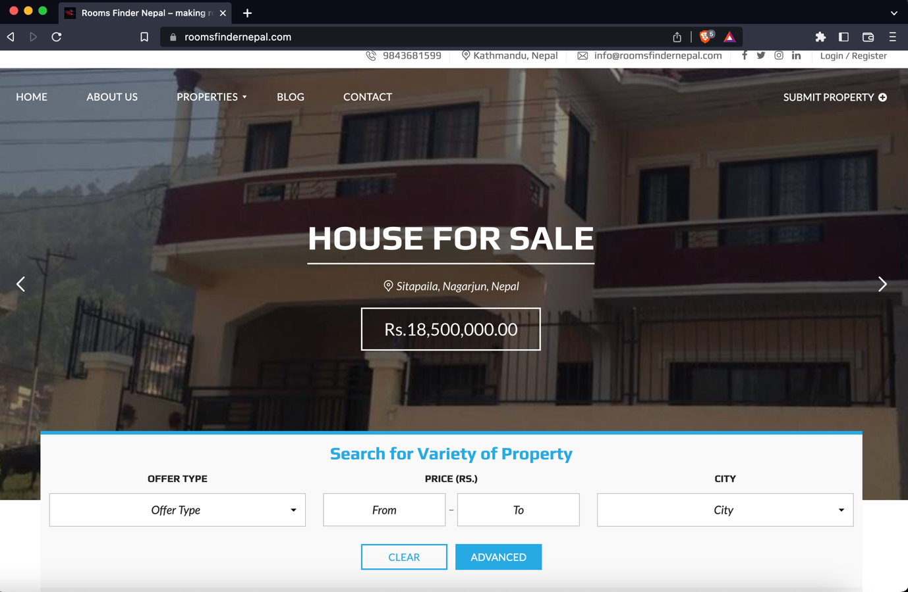

Figure 1: (Room Finder Nepal, 2022) Room Finder Nepal

### Gharbeti

Gharbeti is a web platform that provides a comprehensive list of available rental properties in Nepal, including buildings, apartments, rooms, hostels, and land. Users can search and book these properties online, and the list is regularly updated with detailed information. It offers an efficient way for people to find and book the perfect rental property. (Gharbeti, 2022).

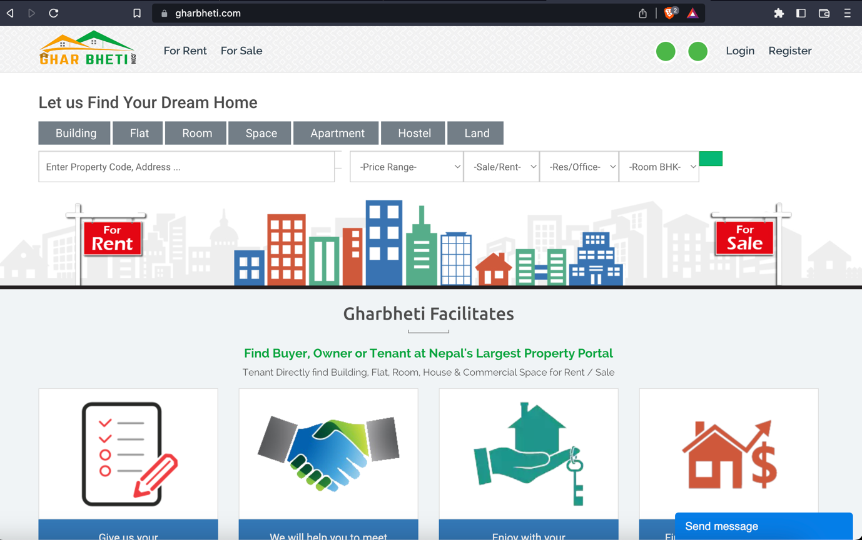

Figure 2: (Gharbeti, 2022) Gharbeti

### DalayDai

DalayDai.com is a free online platform for buying and selling Houses, Lands and everything Real Estate. dalaydai.com makes, searching a perfect Home or a perfect plot of Land for Nepali people effortless and easy like it has never been. With frequent updates to the platform (Dalay Dai, 2022).

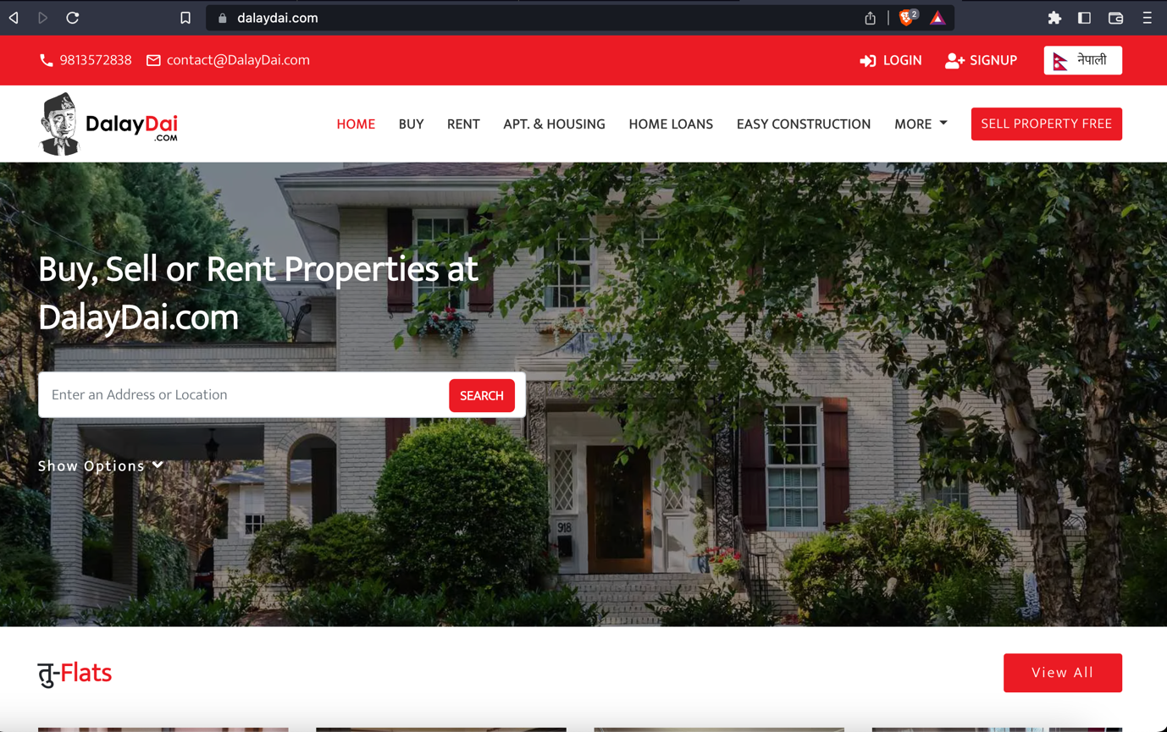

Figure 3: (Dalay Dai, 2022) Dalay Dai

### Hamro rental

Hamro Rental is a free online platform for buying and selling Houses, Lands, Apartments Shops. However, this site seems to be inactive of long time and the user experience while using this site is also not that great. (Hamro Rental, 2022)

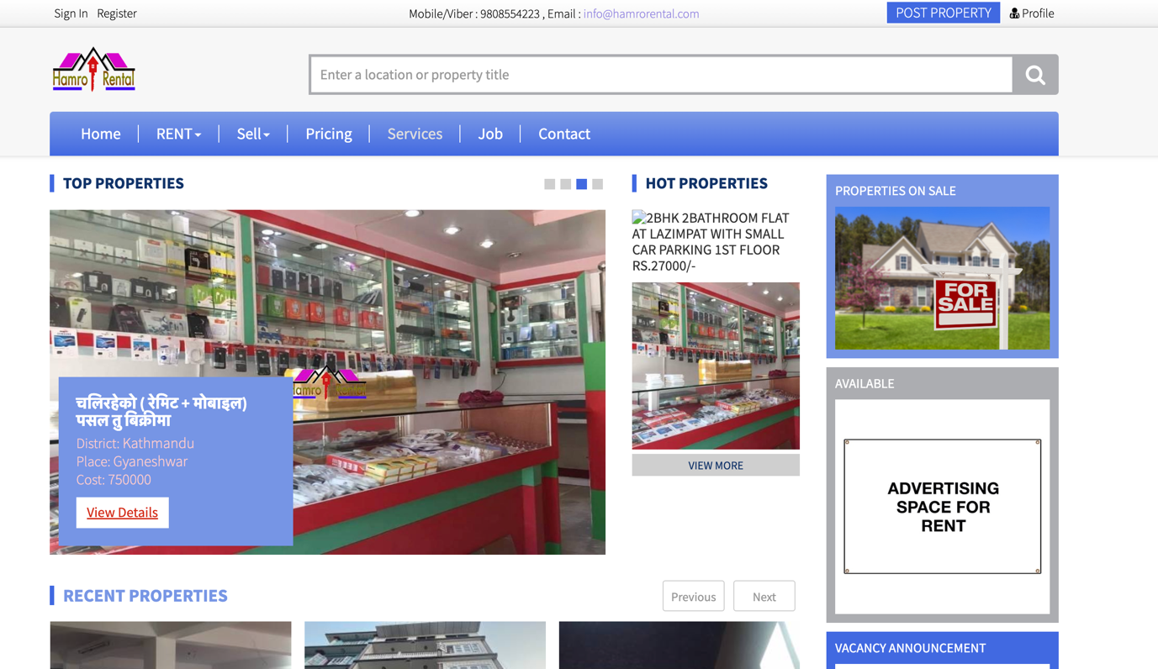

Figure 4: (Hamro Rental, 2022) Hamro Rental

## Comparison Between the Systems

|  |  |  |  |  |  |  |
| --- | --- | --- | --- | --- | --- | --- |
| **S.N.** | **Features** | **Similar Projects** | | | | |
| **Room Finder Nepal** | **Gharbeti** | **DalayDai** | **Hamro Rental** | **MYRoom (My Project)** |
| **1** | Advance Search Feature | **Checkmark** | **Checkmark** | **Checkmark** | **Checkmark** | **Checkmark** |
| **2** | Wishlist | **No sign** | **No sign** | **Checkmark** | **Checkmark** | **Checkmark** |
| **3** | Location | **Checkmark** | **Checkmark** | **No sign** | **No sign** | **Checkmark** |
| **4** | Ad Expiry Time | **No sign** | **Checkmark** | **Checkmark** | **No sign** | **Checkmark** |
| **5** | Comments in ads | **Checkmark** | **No sign** | **Checkmark** | **Checkmark** | **Checkmark** |
| **6** | Realtime Chat | **No sign** | **No sign** | **No sign** | **No sign** | **Checkmark** |
| **7** | Report unreliable ads | **No sign** | **No sign** | **No sign** | **No sign** | **Checkmark** |
| **8** | Pet Allowed Filter | **No sign** | **No sign** | **No sign** | **No sign** | **Checkmark** |
| **9** | Show Nearby Schools, Markets, Hospitals in map view for property | **No sign** | **No sign** | **No sign** | **No sign** | **Checkmark** |
| **10** | Upload Video tour for the property | **No sign** | **No sign** | **No sign** | **No sign** | **Checkmark** |

Table 1: Comparison Between Similar systems

# Development

## Considered Methodology

### Scrum Methodology

(Digite, 2019)Scrum is an agile software development technique that relies on incremental and iterative methods. Scrum is an agile framework that is quick, flexible, adaptable, and effective and is made to provide value to the client throughout the course of the project. Through an atmosphere of open communication, shared ownership, and constant improvement, Scrum's main goal is to serve the needs of the client. The development process begins with a general understanding of what needs to be created, then the product owner develops a list of desired qualities that are prioritized (product backlog).

* + 1. **RUP**

(Minott, 2022) The Rational Unified Process (RUP) definition, also known as the Unified Process Model, is a web-enabled, object-oriented software development process. Object-oriented software engineering refers to any software development approach that uses visual models organized around objects and iteratively goes through analysis, design, and implementation. The RUP framework was created by International Business Machines Corporation (IBM) in 2003 and was one of the first widely used iterative methods.

## Selected Methodology

### Evolutionary Prototyping

The methodology chosen for this project is Evolutionary Prototyping because this methodology provides project with the most flexibility. Since this is the first project, at this big scale working individually. The system might be developed with some modules/ features like I had hoped and the work flow might have been disturbed however That will not be the case anymore because this methodology help solve that issue as modules during in the development phase are independent to one another even if the development got stuck on some problems on one of the modules, that module could be kept on hold and also can keep working on other parts. There will also be feedbacks given by the supervisors’ after completing a module The system could further be optimized and make it better with the help of supervisors’ advice and further research.

The concept is to give the user with an initial prototype. They provide feedback and improvement suggestions. The developer takes action on these and then offers a more improved prototype. The user provides input once more. The procedure is then repeated. As a result, the prototype 'evolves' towards the final system at each iteration. (Teach-itc, 2022)

Advantage of this methodology is that the end user can interact with the prototypes and which increases the user engagement and the feedback given by the user will help improve the product to its optimal glory. This system will be very efficient to meet the user’s requirement.

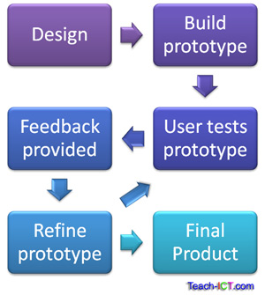

Figure 5: (tech-ict, 2022)Evolutionary Prototyping

### Phases of Evolutionary Prototyping

#### Initial Planning and Requirements Gathering

Inthis phase, the project team works with stakeholders to understand the problem and gather requirements. This involves identifying the main features and functionality that the prototype should include.

#### Design

Based on the requirements gathered in the previous phase, the project team creates a design for the prototype. This design may include wireframes, mockups, or other visual representations of the prototype.

#### Build Prototype

With the design in place, the project team begins building the prototype. This involves creating a basic version of the product that includes the core features and functionality.

#### Test

Once the prototype is built, it is tested by stakeholders to ensure that it meets their needs and functions as intended. This testing may involve user testing, functional testing, and other forms of testing.

#### Feedback and Refinement

Based on the feedback received during testing, the project team makes refinements to the prototype. This may involve adding new features, improving existing features, or making other changes to the prototype.

#### Iterative Prototyping

The refined prototype is tested again, and the feedback and refinement process are repeated in a series of iterations. With each iteration, the prototype becomes more refined and closer to the final product.

#### Final Product Development

Once the prototype has been refined and tested sufficiently, the final product is developed based on the insights gained during the prototyping process.

#### Deployment and Maintenance

The final product is deployed and maintained, with ongoing support and updates as needed.

## Requirement Analysis

### Overall requirements

#### Software Requirements

1. IDE VS code
2. HTML, CSS, JavaScript, Bootstrap and React js will be used for the front-end.
3. Node JS, Next JS will be used for backend
4. MongoDB will be used for the database.

These Technological Requirements are explained below in appendix section’s **Error! Reference source not found.**

#### Hardware Requirement

* A reliable Laptop to work on so MacBook pro will be used for this project

### Generalized list of requirements

#### Non-functional

* **Usability**

The system should be easy to use and navigate.

* **Scalability**

The system is scalable as it can be scaled up after deploying the application if need be.

* **Performance and reliability**

System should display correct information to the user and should be fast.

#### Functional

* Buyer & seller can log in into the application as users, and admin can also login.
* Users can register in the application
* User can add their room/apartment either for sell or rent.
* User can report the user with inappropriate ad to the admin.
* User can change their password and profile.
* User can modify their ad if need be.
* User can delete their ads.
* User can view the details of the property.
* Buyer can chat with the seller and make a deal about the property with private message
* Buyer can send message by clicking the button available on each ad view page and even mail the seller to and enquire about the property.
* User can add Ads to their Wishlist.
* Users can even see the property they enquired in their dashboard.
* Admin can review the report made by users.
* Admin can view the profile of user and review the user who is reported.
* Admin can block the user if user is found guilty.
* Users can get email when their ad expires, Ad expires after 30 days form the day of creation.
* User can either repost the ad if it is still available or can delete the ad.
* Admin can view the list of all the user in the application.

### Gantt Chart

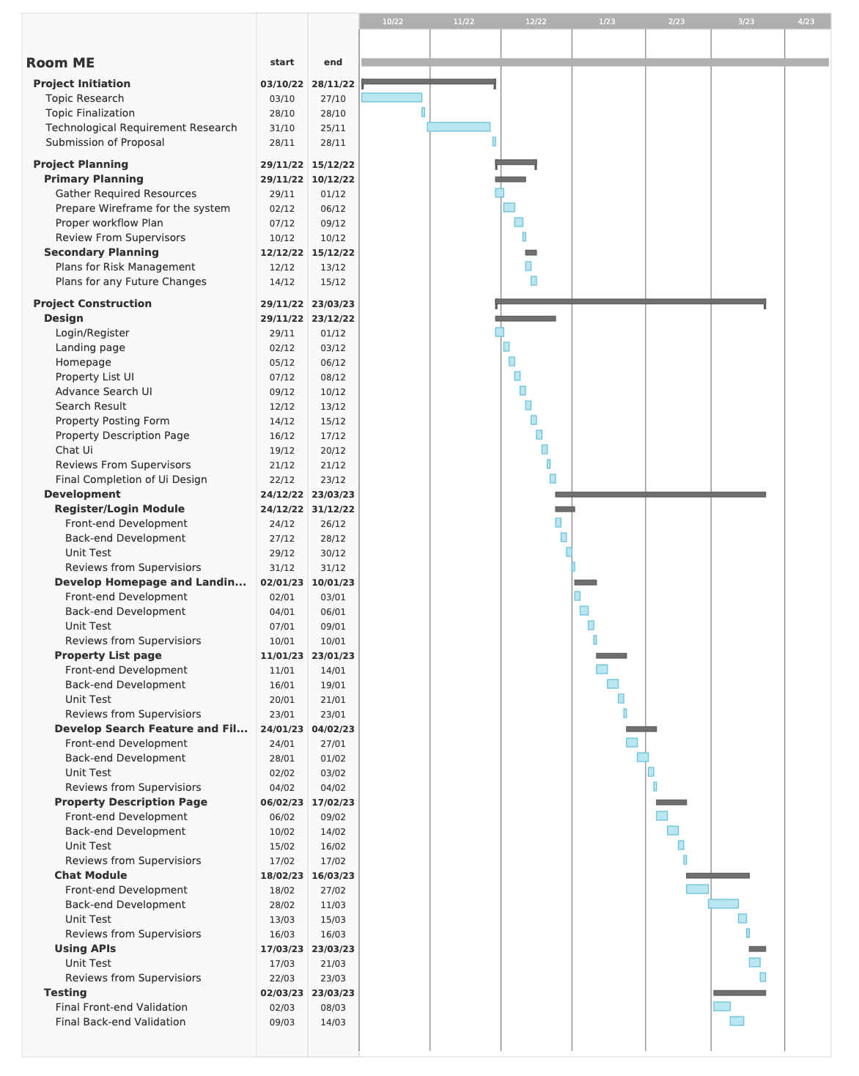

Figure 6: Gantt Chart

### Work Break Down Structure

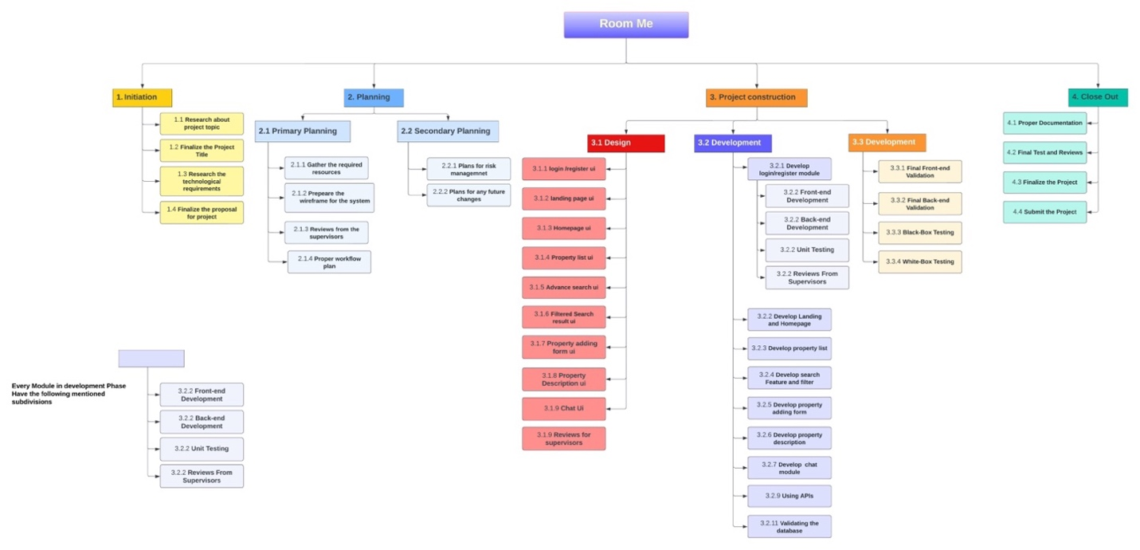

Figure 7: Work Breakdown Structure

### SRS Document

#### Purpose

When developing software, the requirements stage involves the creation of Software Requirements Specifications (SRS) (also called a requirements document). This report is created after all requirements have been collected, assessed, and laid out, serving as a foundation for software engineering initiatives. In order to help clients, determine whether the report (SRS) meets their needs, it is a formal report that also acts as a software representation. The prerequisites for both users and the system are carefully described as well.

The purpose of this SRS is to specify the requirements for the room/apartment finder web application, which will allow users to search for and list properties for lease or sale and make the process of finding rooms/apartments seamless.

#### Project Scope

The proposed room/apartment finder web application is a platform that allows users to search for and find rooms or apartments to rent or buy. The room/apartment finder web application will include a login and registration system, a chat feature, a comment feature, a property listing feature, a map showing the location of properties, a search and filtering function, a feature for reporting inappropriate listings, etc. The application will also allow users to upload images of their properties. The application will be developed making it proper responsive and optimized for the use in the desktop websites and for mobile devices as well. It allows users to list their own properties for rent or sale, and to interact with other users through a chat feature.

The application will consist of following features:

* Login
* Register
* Post Listing
* Private Chat with seller.
* 30 Day ad expiry time.
* Ban feature for admin.
* Report user with inappropriate ad posted.
* Review feature for admin
* Delete Posted ads.
* Update posted ads.
* Update Profile
* Wishlist
* Advance Search

More detailed SRS document can be found here SRS Document.

## Design

### Logo of the application

The logo for MyRoom (room/apartment finder) Web application was designed keeping the base of this application on mind. The logo was designed so that it could convey what the brand identity is all about by looking at the logo it very carefully and beautifully crafted. The logo was designed in Figma.



Figure 8: Logo for the web application.

### Wireframes

#### Wireframe for the Whole System



Figure 9: Wireframe for the whole system

#### Wireframe for the individual component

The detailed images of wireframe of whole project are kept further down inside the appendix section. Here, is the link to navigate to the detailed **Error! Reference source not found.** for each webpage.

### Graphical Designs of the application (UI/UX)

The Graphical Design of the application can be found below in the Appendix Section.

### Flow Chart for the whole application.

#### Flow chart of user as seller.

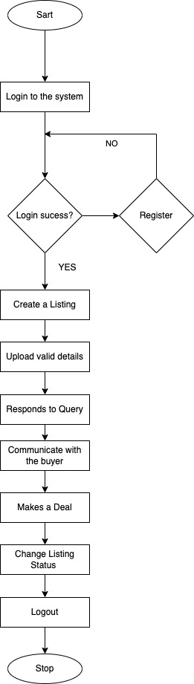

Figure 10: Flowchart of user as seller.

#### Flow chart of user as buyer.

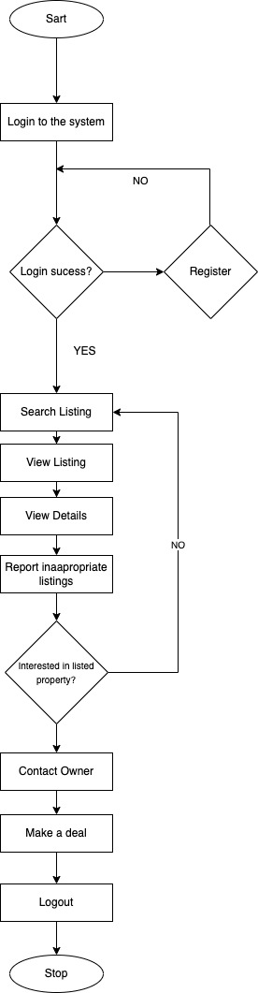

Figure 11: Flowchart of user as buyer.

#### Flow chart of Admin.

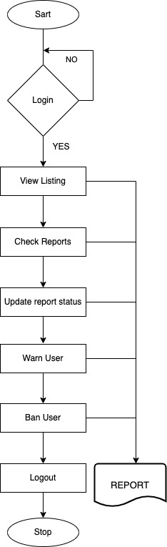

Figure 12: Flowchart of user as buyer.

## Process Design (UML)

### Actors

|  |
| --- |
| **Actors:** User(General People) and Admin |

Table 2: Actors of the web application

### Register

#### High Level use case

**Preconditions:** The user does not have an account with My room.

|  |
| --- |
| **Name:** Register |
| **Actor:** User |
| **Description:** The user opens the registration page and fills the form then, they click the "register" button, and the application checks the phone and email address to ensure it is unique. If it is unique, the application creates a new user record with the provided information and logs the user in. If the email address is already in use, the application displays an error message. |

Table 3: High level use case for register

### Login

#### High Level use case

**Preconditions:** The user has an account with My Room.

|  |
| --- |
| **Name:** Login |
| **Actor:** User |
| **Description:** The user needs to go to the login page and enter their email address and password. Then, clicks the "login" button and the system will check if their email and password are correct. If they are, the system will let the user log in and take them to the homepage of My Room. If the email and password are not correct, the website will show an error message.  **Exceptions:**  If the user does not have an account, user can click the "register" button to create a new account. |

Table 4: High Level Use case diagram for Login

### Property Listing

#### High Level use case

|  |
| --- |
| **Name:** Property Listing |
| **Actor:** User |
| **Description:** The user needs to be logged in and click the "list property" button. They can then enter information about their property, like type, rent amount, etc. and further upload images or videos, and click "submit". new property listing with the provided information will be created and displayed on the website for other users to see.  **Exceptions:**  If the user is not logged in, they will be redirected to login page upon clicking on list property button. |

Table 5: High Level Use case Diagram for property Listing

### Delete Listing

#### High Level use case

|  |
| --- |
| **Name:** Property Listing |
| **Actor:** User |
| **Description:** The user needs to be logged in and select the ad they wish to delete from their dashboard. Then a form will be displayed to the user with two buttons update Ad and Delete ad. Then they can delete the ad by clicking on the delete ad button.  **Exceptions:**  If the user is not logged in, they will be redirected to login page upon clicking on list property button. |

Table 6: High Level Use case Diagram for property Listing

### Map View

#### High Level use case

|  |
| --- |
| **Name:** Map Location |
| **Actor:** User |
| **Description:** User needs to click on a property listing to view its details. The website will show the property description page, which includes all the details of the property. The user can see a map with the location of the property marked on it in location section. |

Table 7: High Level Use case diagram for map Location

### Show Nearby schools, colleges, hospitals, stores.

#### High Level use case

|  |
| --- |
| **Name:** Show Nearby Schools, Hospitals, College, Stores |
| **Actor:** User |
| **Description:** the user needs to click on a property listing. They can then click the "view nearby schools/hospitals" toggle button in the map view section, and the website will show a map with the location of the property and nearby schools and hospitals. |

Table 8: High Level Use case diagram for show nearby schools/hospitals

### Search Feature

#### High Level use case

|  |
| --- |
| **Name:** Advance Search |
| **Actor:** User |
| **Description:** They can then enter their search criteria and click the "search" button. The web application will look for properties that match the search criteria entered by the user and display a list of them on the search results page. If the user does not fill out the search form correctly or the criteria, they entered are not valid, the website will display an error message. |

Table 9: High Level Use case diagram for Advance search

### Chat Feature

#### High Level use case

|  |
| --- |
| **Name:** Chat |
| **Actor:** User |
| **Description:** The user clicks on the chat button of navbar or property description page. Then the application displays the chat window accordingly either list of people or specific person’s chat box. The user can then send and receive the messages.  **Exceptions:**  If the user is not logged in, they will be redirected to login page after clicking the chat button. |

Table 10: High Level Use Case Diagram for Chat Feature

### Report Feature

#### High Level use case

|  |
| --- |
| **Name:** Report |
| **Actor:** User |
| **Description:** The user must be logged in and visit the Property Description page. They can then click the "report" button, which will open a form for them to type in a reason for the report. After the user submits the form, the application will notify the admin about the report.  **Exceptions:**  If the user is not logged in, they will be redirected to login page after clicking the chat button. |

Table 11: High Level Use Case Diagram for Report Feature

### Report Review

#### High Level use case

|  |
| --- |
| **Name:** Report Review |
| **Actor:** Admin |
| **Description:** Admin must first log in and click the "row of the table” of the user who is reported. Admin can see the reported users in user list and can select one to review. The admin can then review the report and the associated property listing. They can decide to dismiss the report or take action on the user (e.g., warn the user, ban the user, remove the report). They must click "submit" to save their decision." |

Table 12: High Level Use Case Diagram for Report Review Feature

### Ban User

#### High Level use case

|  |
| --- |
| **Name:** Ban User |
| **Actor:** Admin |
| **Description:** Admin must click the "ban user" button on the report review page. A confirmation message will appear and the admin must confirm to ban the user. The application will then ban the user and show a success message." |

Table 13: High Level Use Case Diagram for Ban user feature

### Undo Report

#### High Level use case

|  |
| --- |
| **Name:** Undo report |
| **Actor:** Admin |
| **Description:** Admin must click the "reviewed" button on the report review page. A confirmation message will appear and the admin must confirm to ban the user. The application will then ban the user and show a success message." |

Table 14: High Level Use Case Diagram for Ban user feature

## Implementation

### MongoDB Schema

#### User Schema

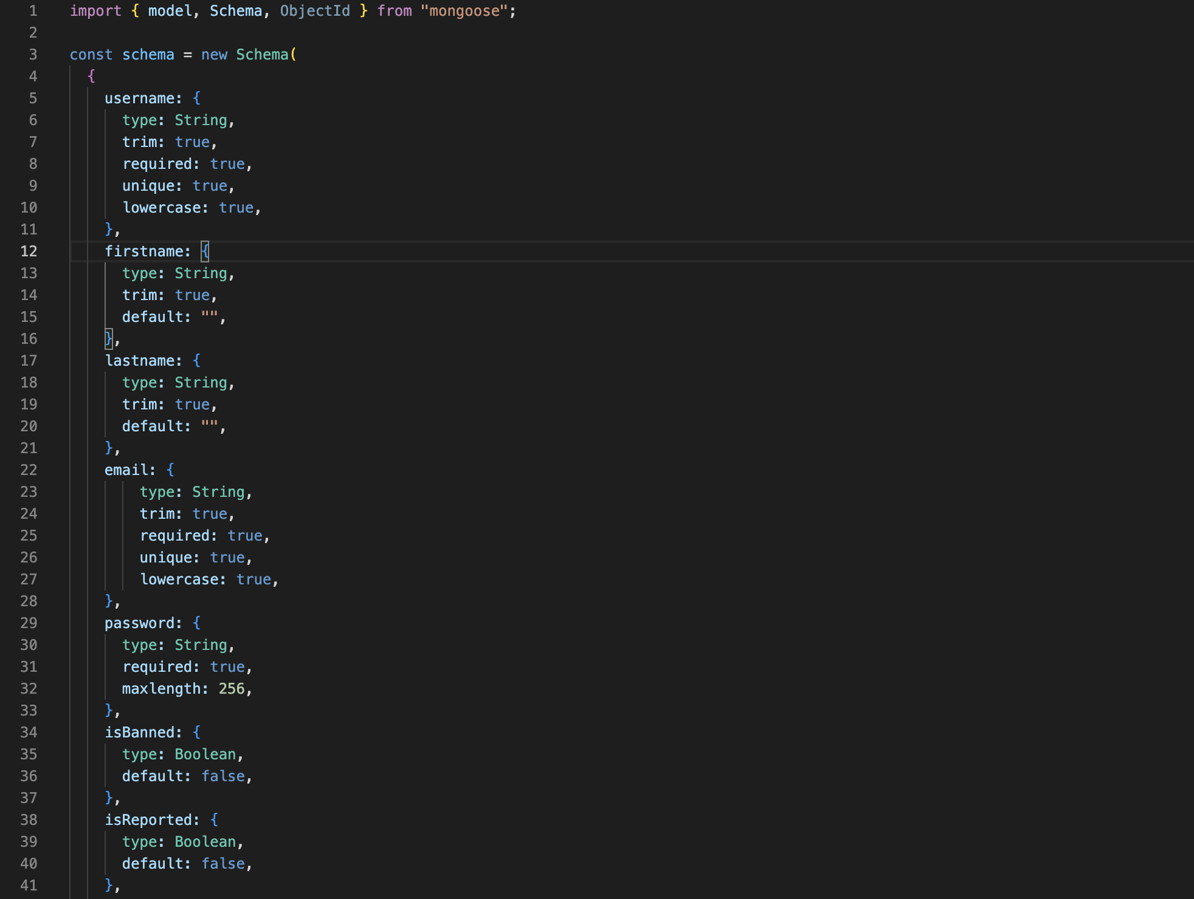

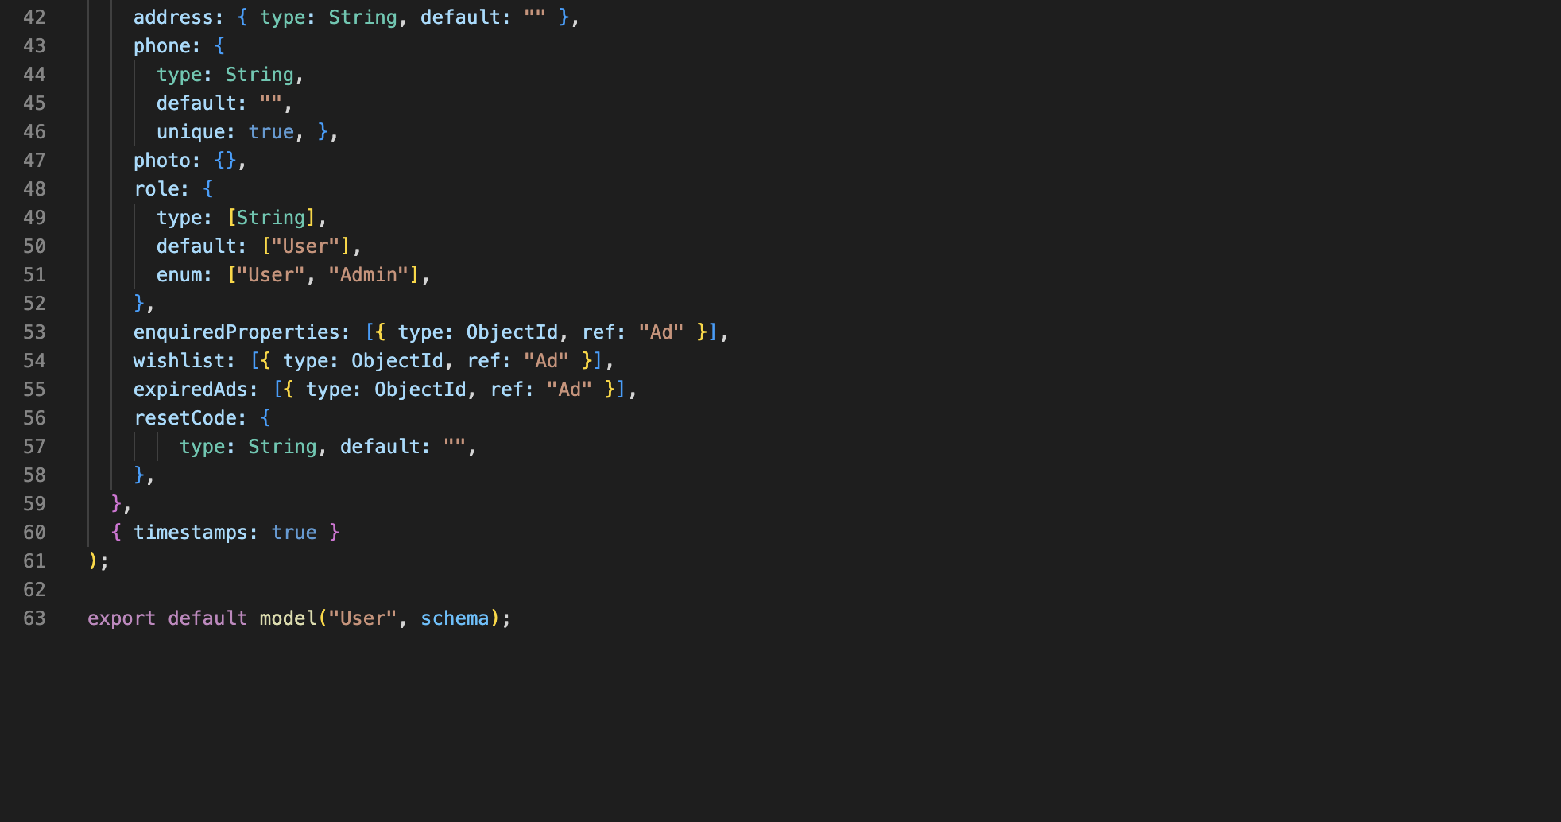

Figure 13: User Schema

#### Ad Schema

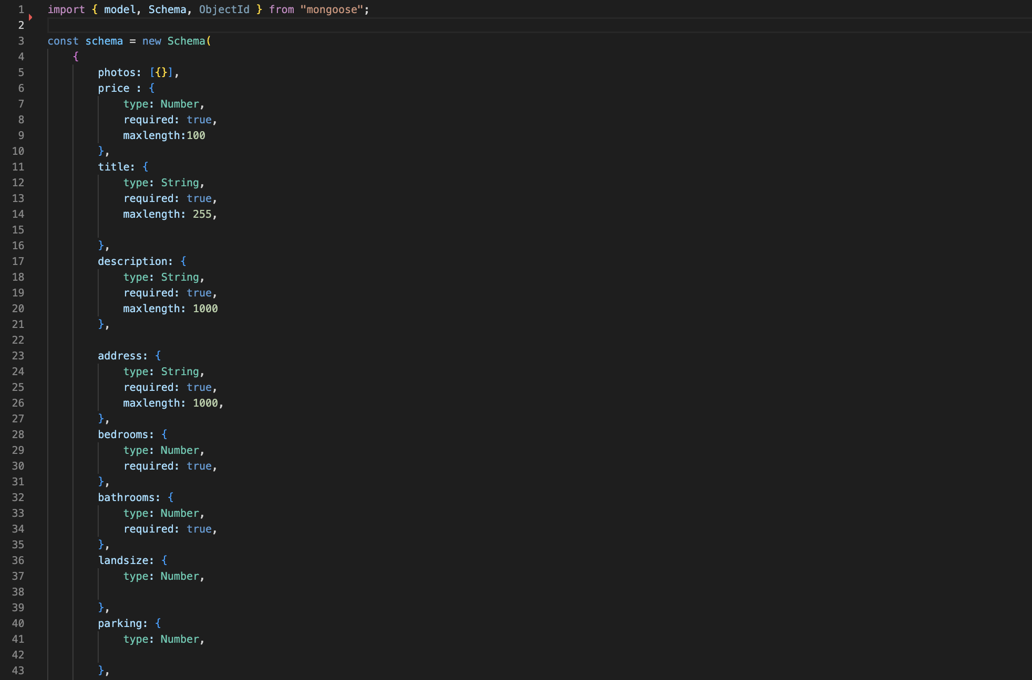

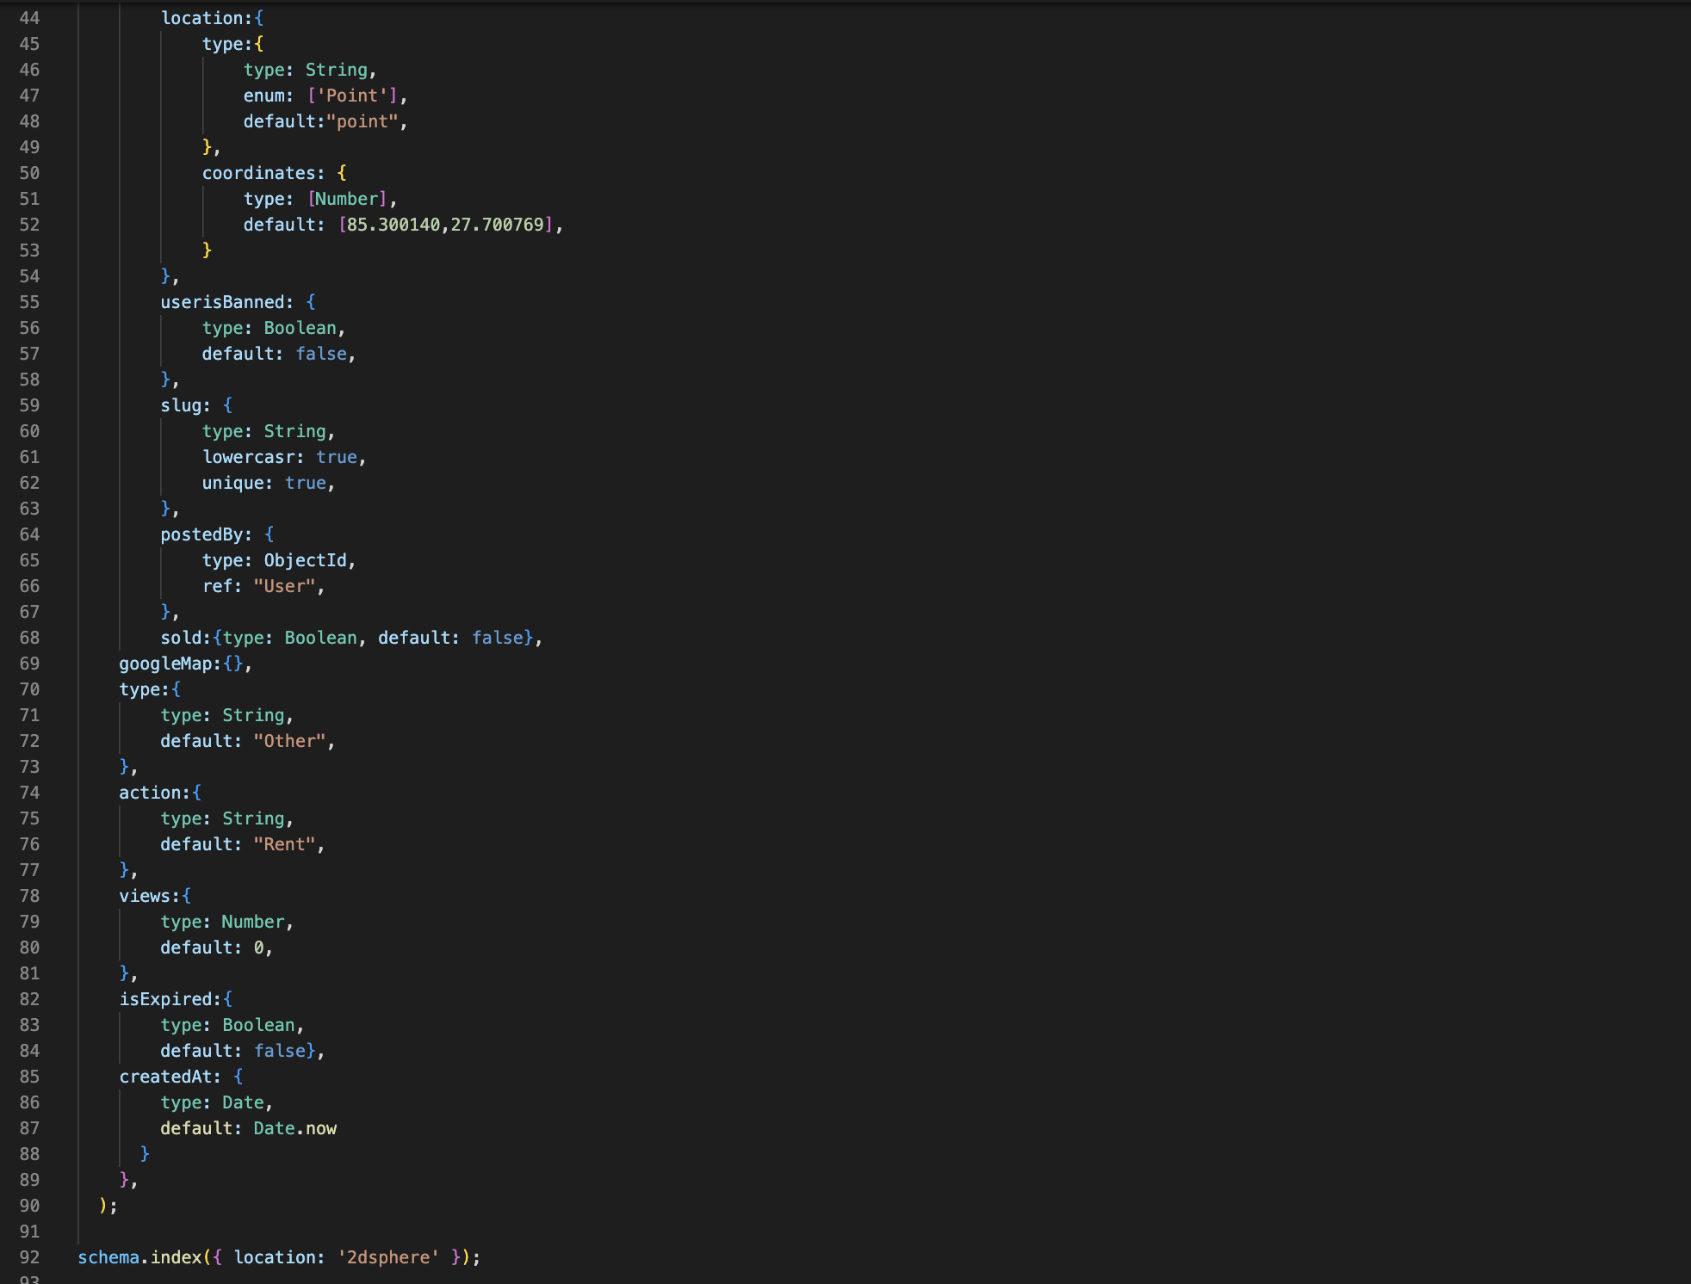

Figure 14: Ad Schema

#### Chat Model Schema

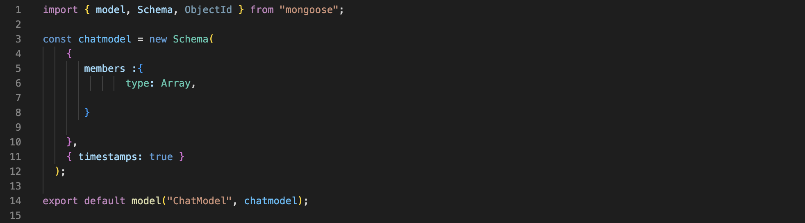

Figure 15: Chat Model Schema

#### Message Model Schema

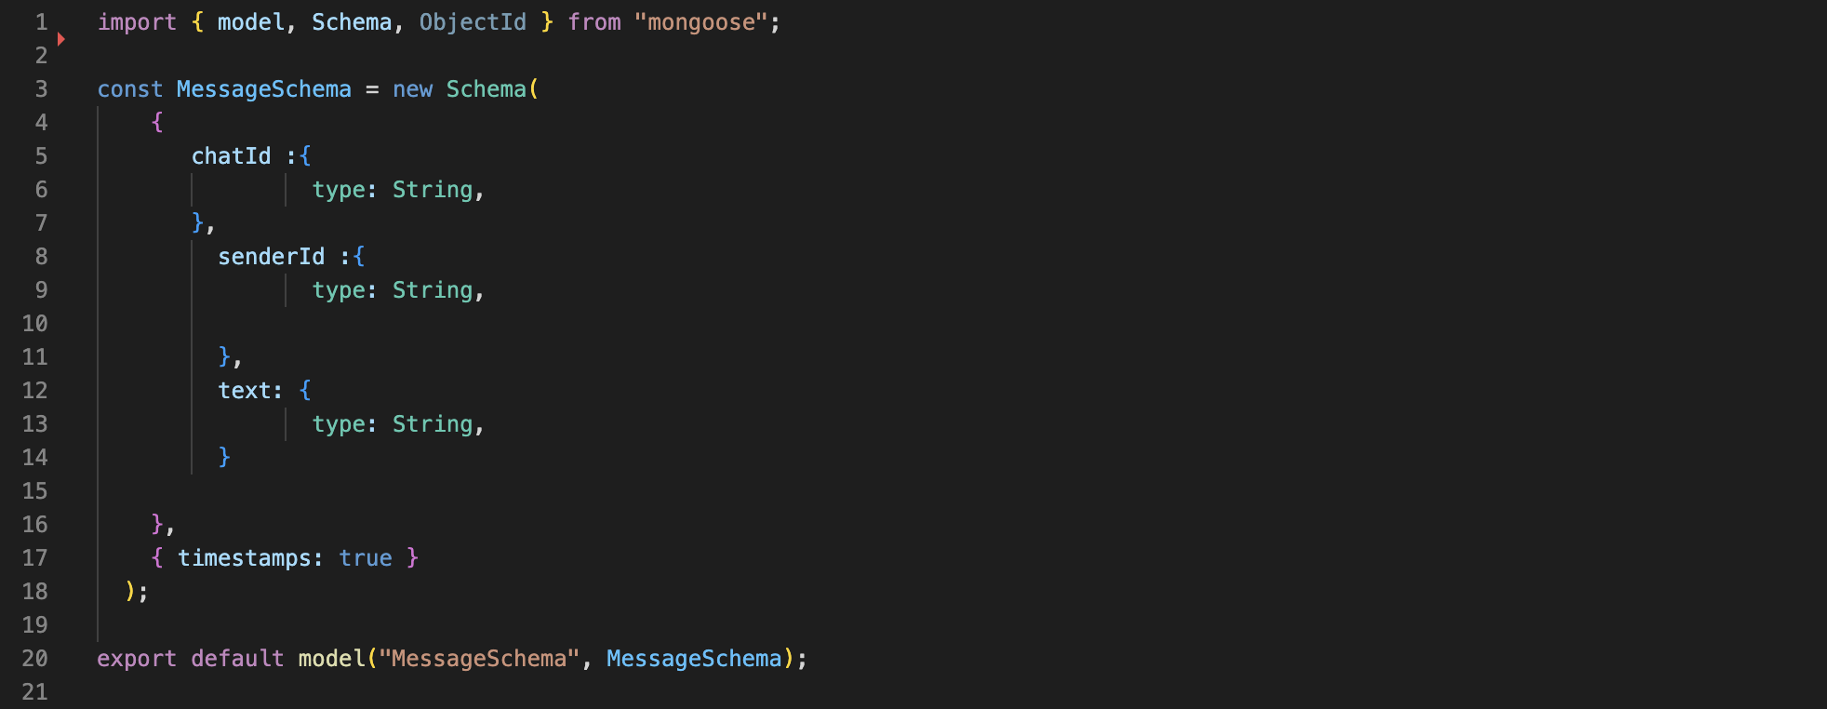

Figure 16: Chat Model Schema

### Important Screenshots

* **Importing required Packages**

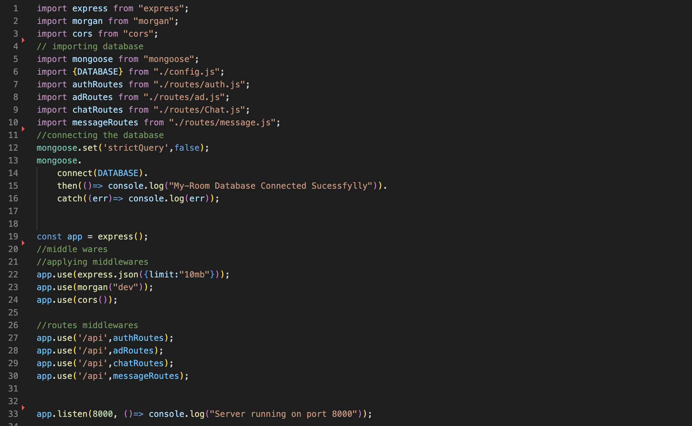

Figure 17: Importing required Packages

* **Admin Middleware**

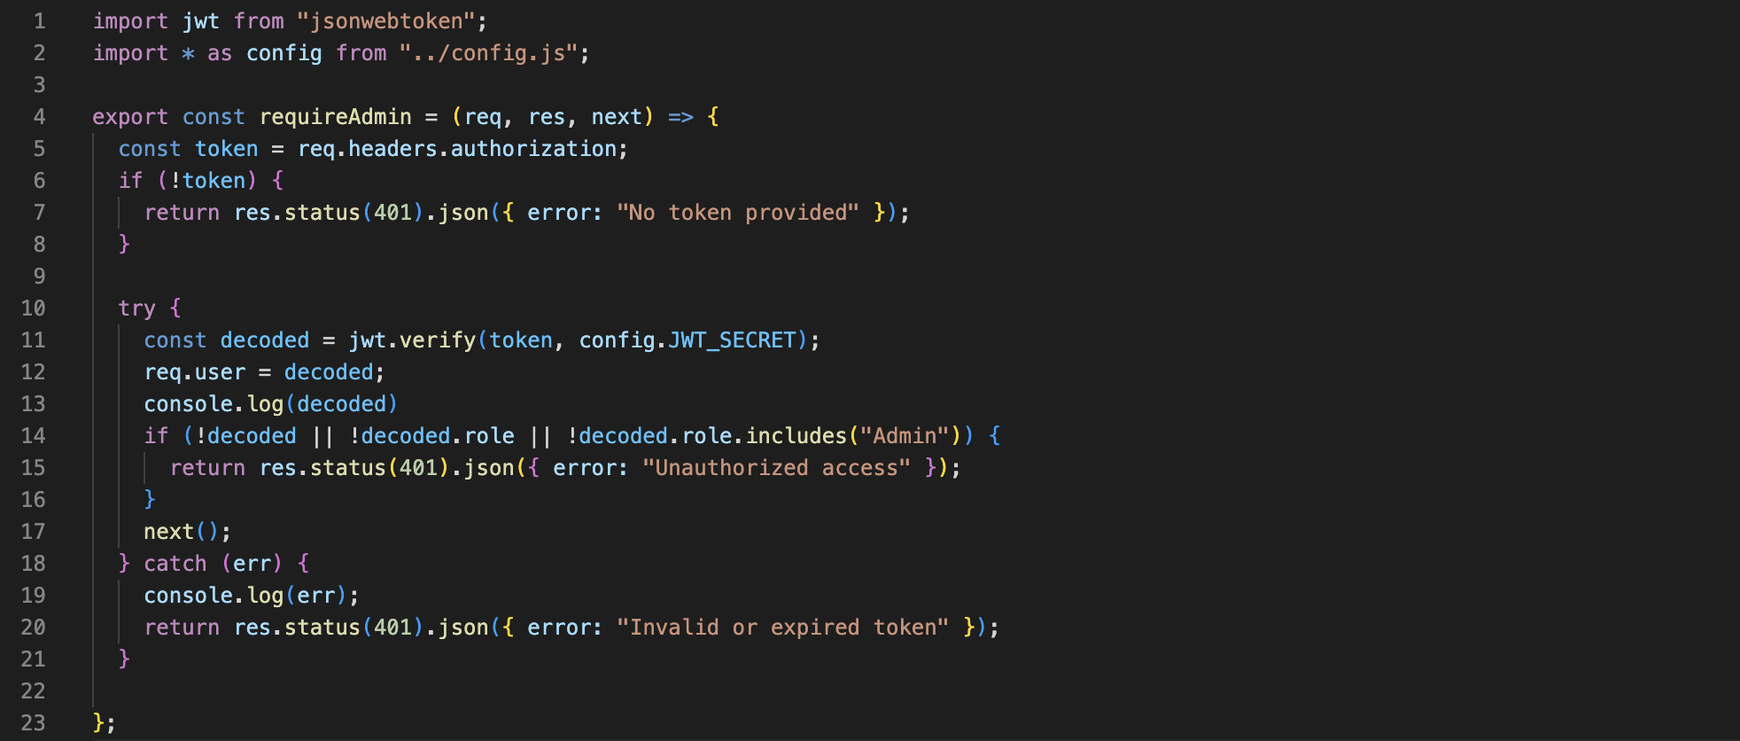

Figure 18: Admin Middleware

* **Require Login Middleware**

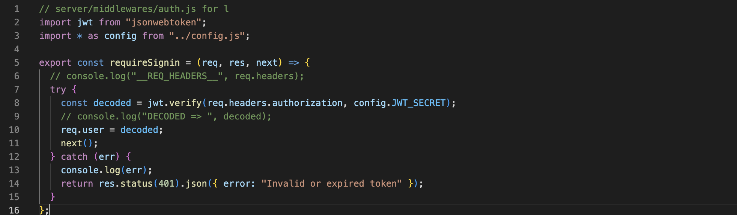

Figure 19: Require Login Middleware

* **Packages used in the application.**

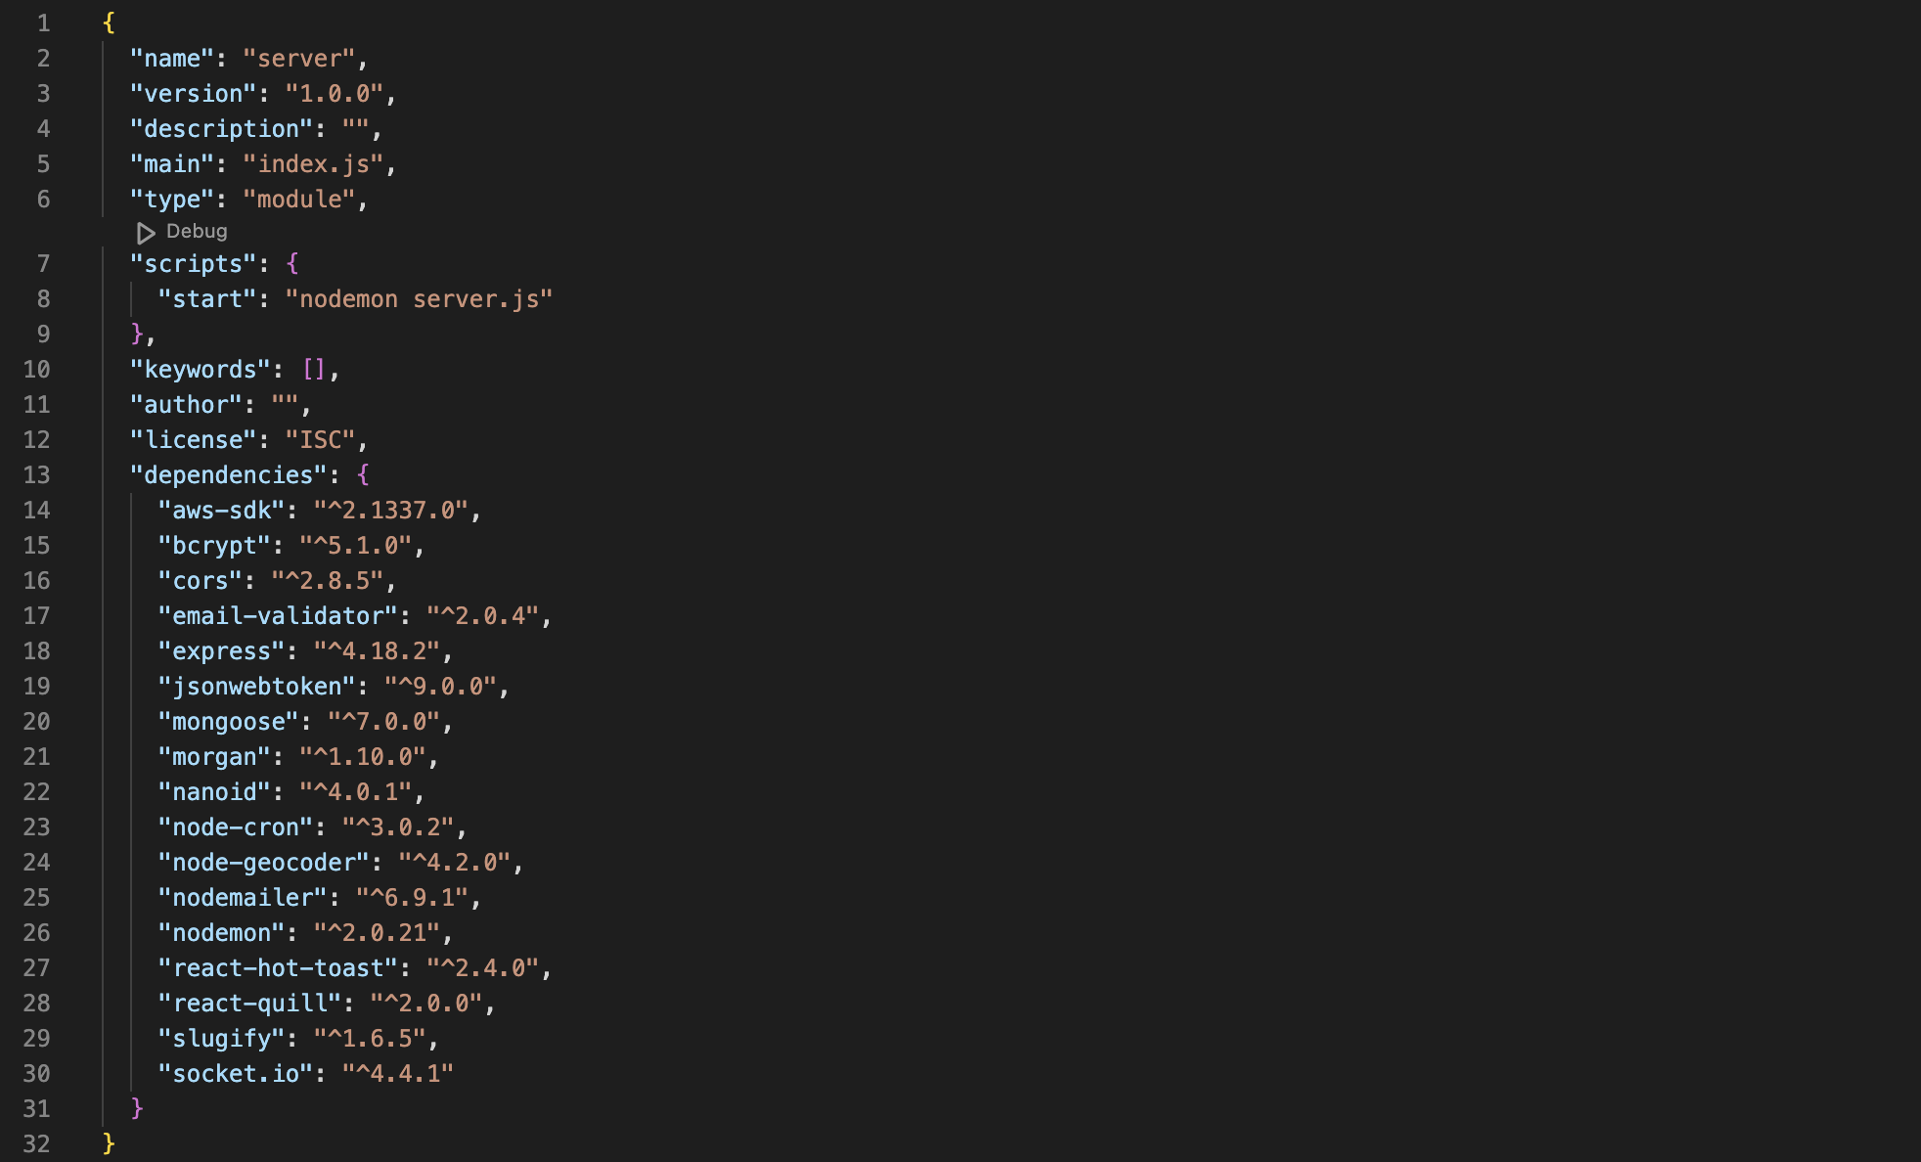

Figure 20: Packages used in the application

* **Ads APIs and endpoints**

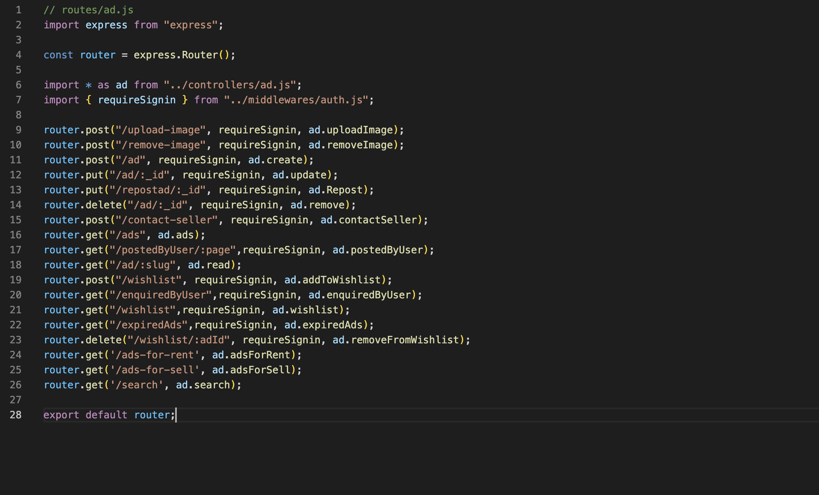

Figure 21: Ad APIs and endpoints.

* **User APIs and endpoints**

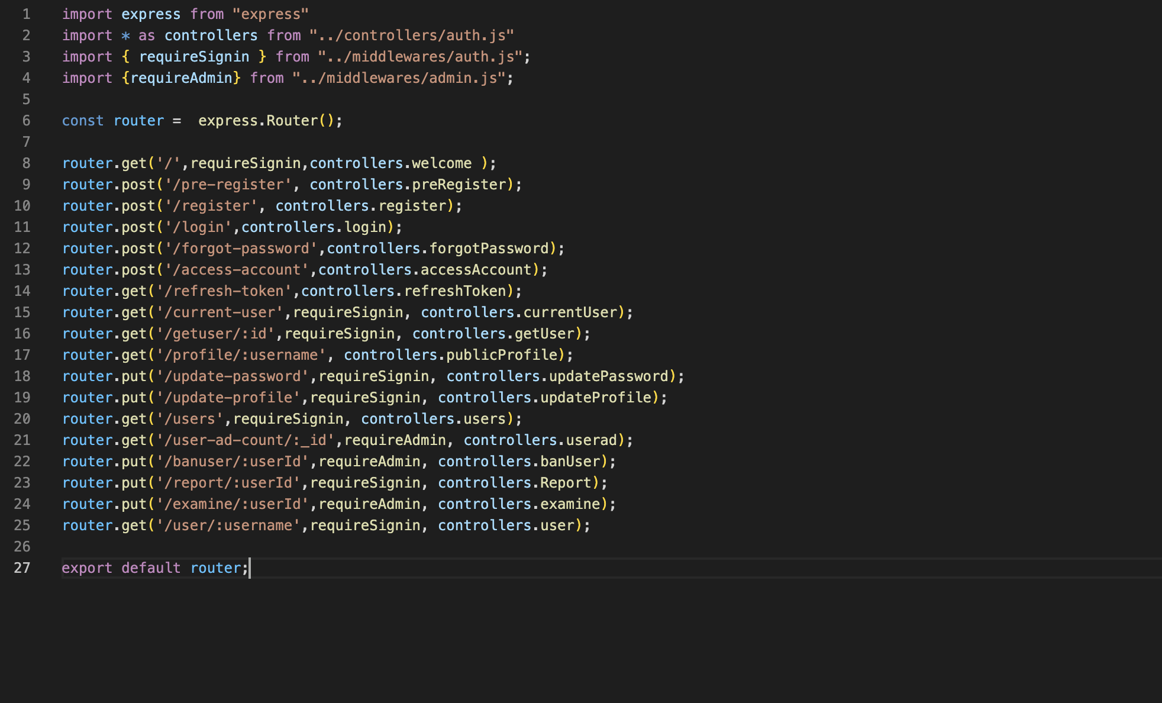

Figure 22: User APIs and endpoints.

* **Chat APIs and endpoints**

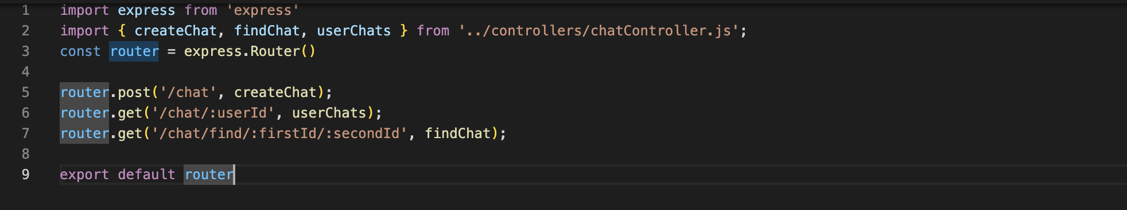

Figure 23: Chat APIs and Endpoints

* **Message APIs and endpoints**

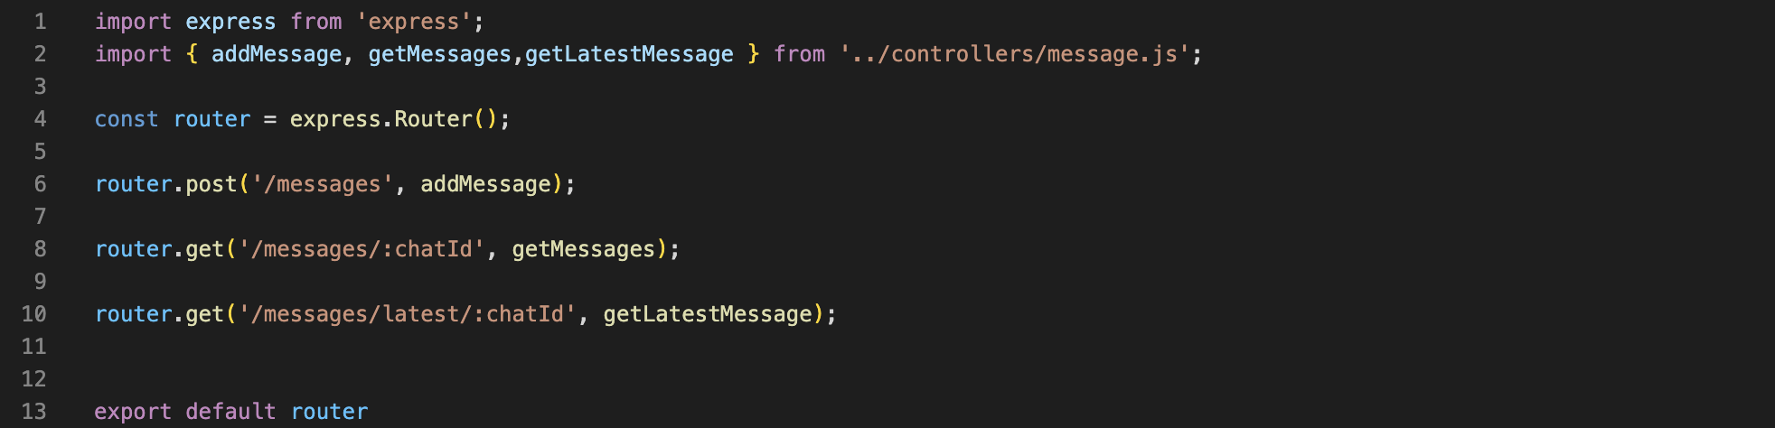

Figure 24: Message APIs and Endpoints

# Testing and Analysis

## Test plan

For a software developer, maintaining quality attributes of a software is a very crucial part of development. The goal lies in developing applications that are reliable, stable, and convenient. Thus, to maintain a good software quality and achieve this goal, the application must be tested during the developmental phase so that any future failures might be avoided.

There are four types of testing conducted for MediPoint which are:

### Black box testing

Black box testing is a technique in which the functionality of the application is examined without having prior knowledge of its internal structure or coding (javatpoint, 2011-2021). This testing is conducted to examine the application features and usability to avoid the risk of failure at the user’s end.

### White box testing

White box testing is also known as transparent box testing which primarily focuses on testing application’s internal structure and coding (whitehatsec, 2022). It is carried out in this project to strengthen security, test the flow of inputs and outputs, and improve the design and usability of the application.

### Integration testing

Integration testing is type of testing technique where all the modules of a software are integrated logically and tested as a group (Hamilton, 2022). This test covers the CRUD functionality of MediPoint and also tests the database interaction.

### Customer evaluation testing

Customer evaluation testing is type of testing which is performed by the client or the end-user of the application before deployment. Any changes required by the client must be made after receiving their feedback. For MediPoint, the customer evaluation testing is done through google forms.

## Black Box Testing

### Test-1: Logout Functionality

|  |  |
| --- | --- |
| **Objective** | **Test if logging functionality is working properly** |
| **Action** | Click the “logout” option present in the navbar under user’s name |
| **Expected Result** | User should be logged out of the application and should be redirected to the homepage |
| **Actual Result** | User is successfully logged out of the application and is redirected to homepage |
| **Conclusion** | Test Successful. |

Table 15: Logout Test

**Step 1:** Click on the logout option under the user’s name in navbar.

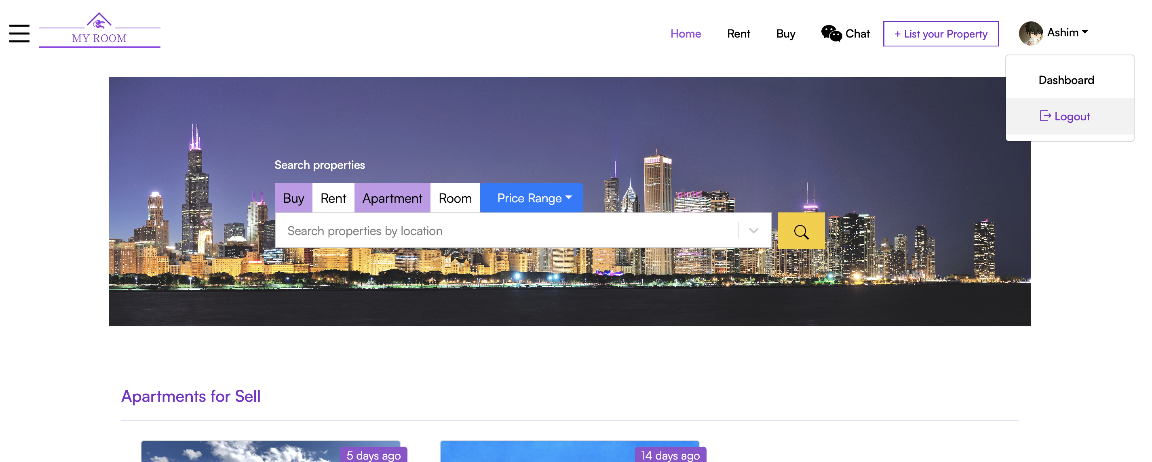

Figure 25: Logout Test Step 1

**Step 2:** User is logged out of the application and redirected to homepage

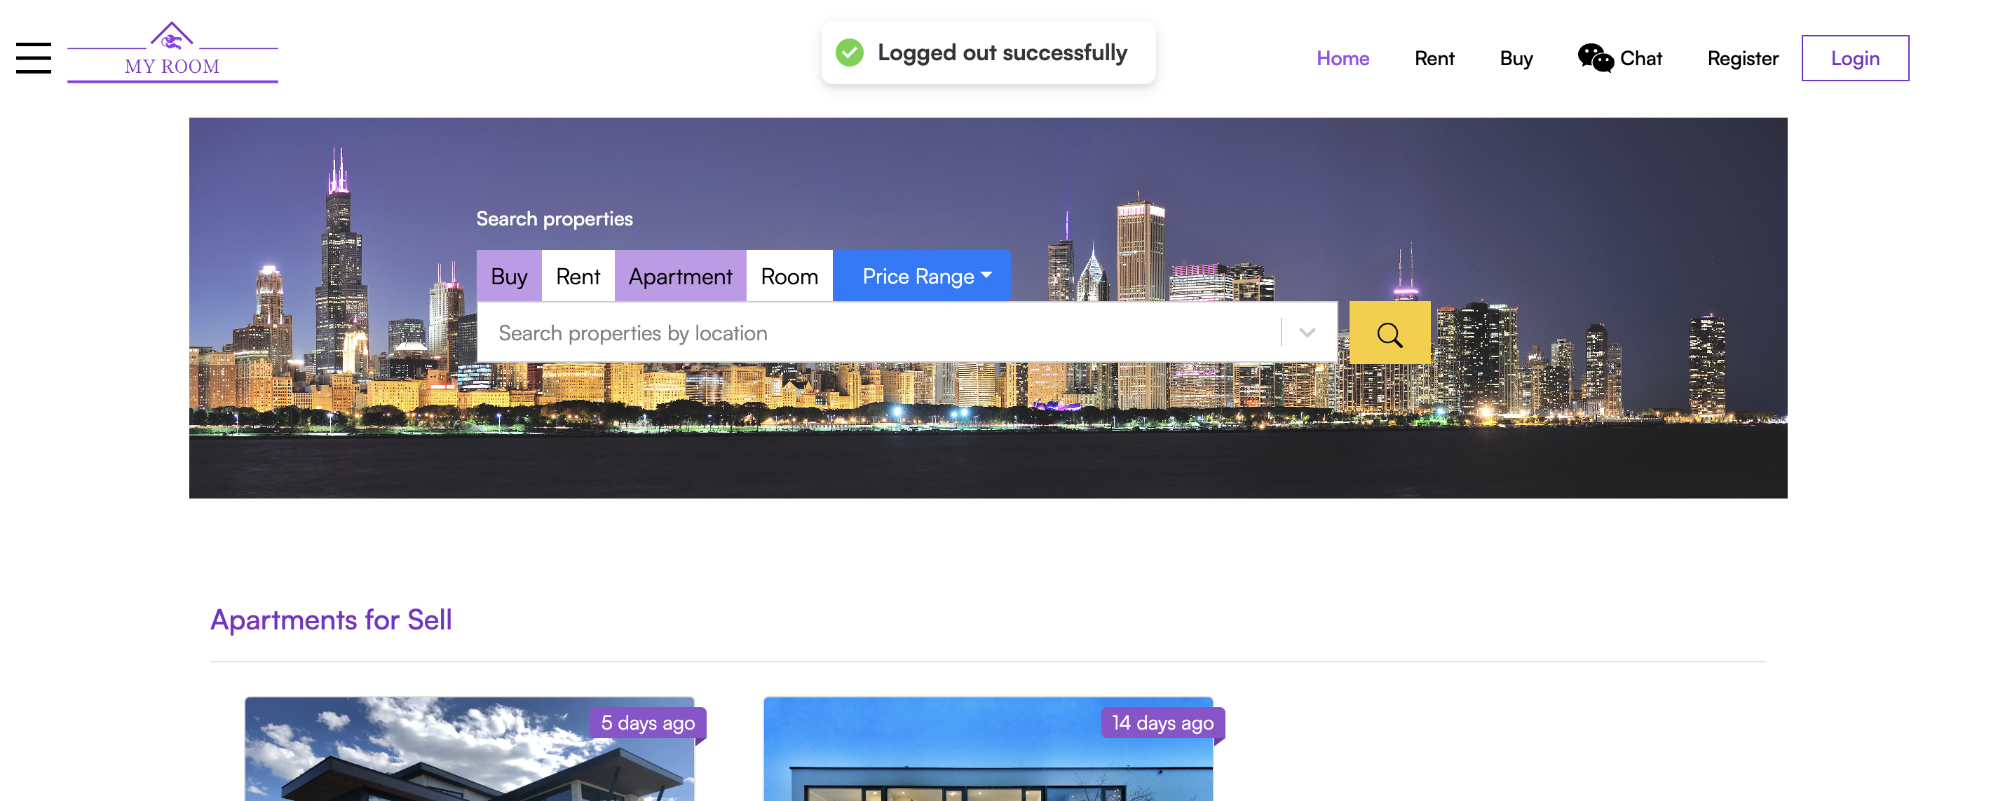

Figure 26: Logout Test Step 2

### Test-2: Login Functionality

|  |  |
| --- | --- |
| **Objective** | **Test if logging functionality is working properly** |
| **Action** | Click the “login” button after filling the information correctly |
| **Expected Result** | User should be logged in to the application and redirected to home page. |
| **Actual Result** | Button is being clicked but nothing is happening. |
| **Conclusion** | Test Unsuccessful. |

Table 16: Login Test

**Step 1:** Clicking the login button on the login page after filling the form correctly. User is not being redirect or anything. Nothing is happening.

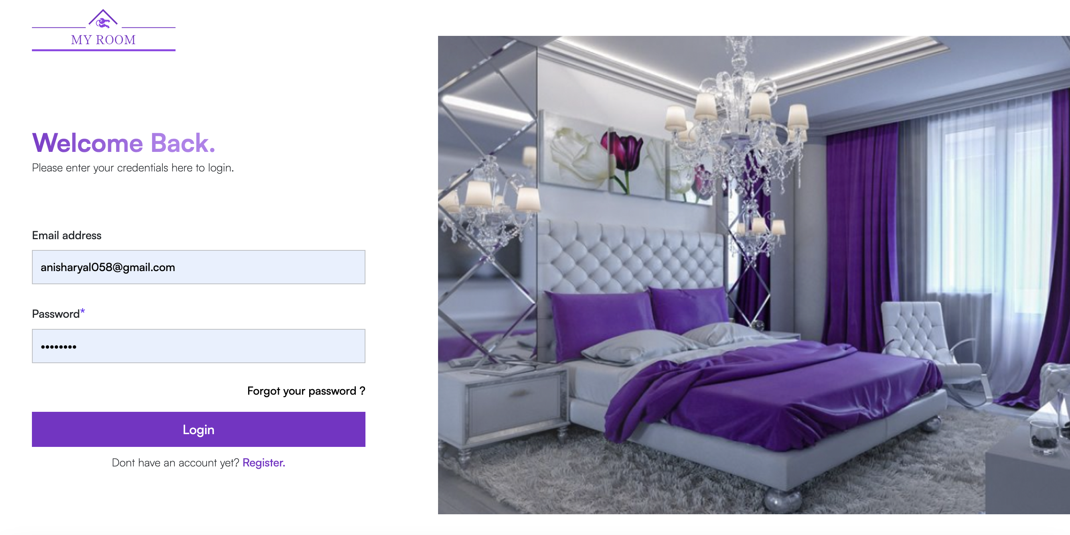

Figure 27: Login Test Step 1

**Step 2:** checking the console for the error.

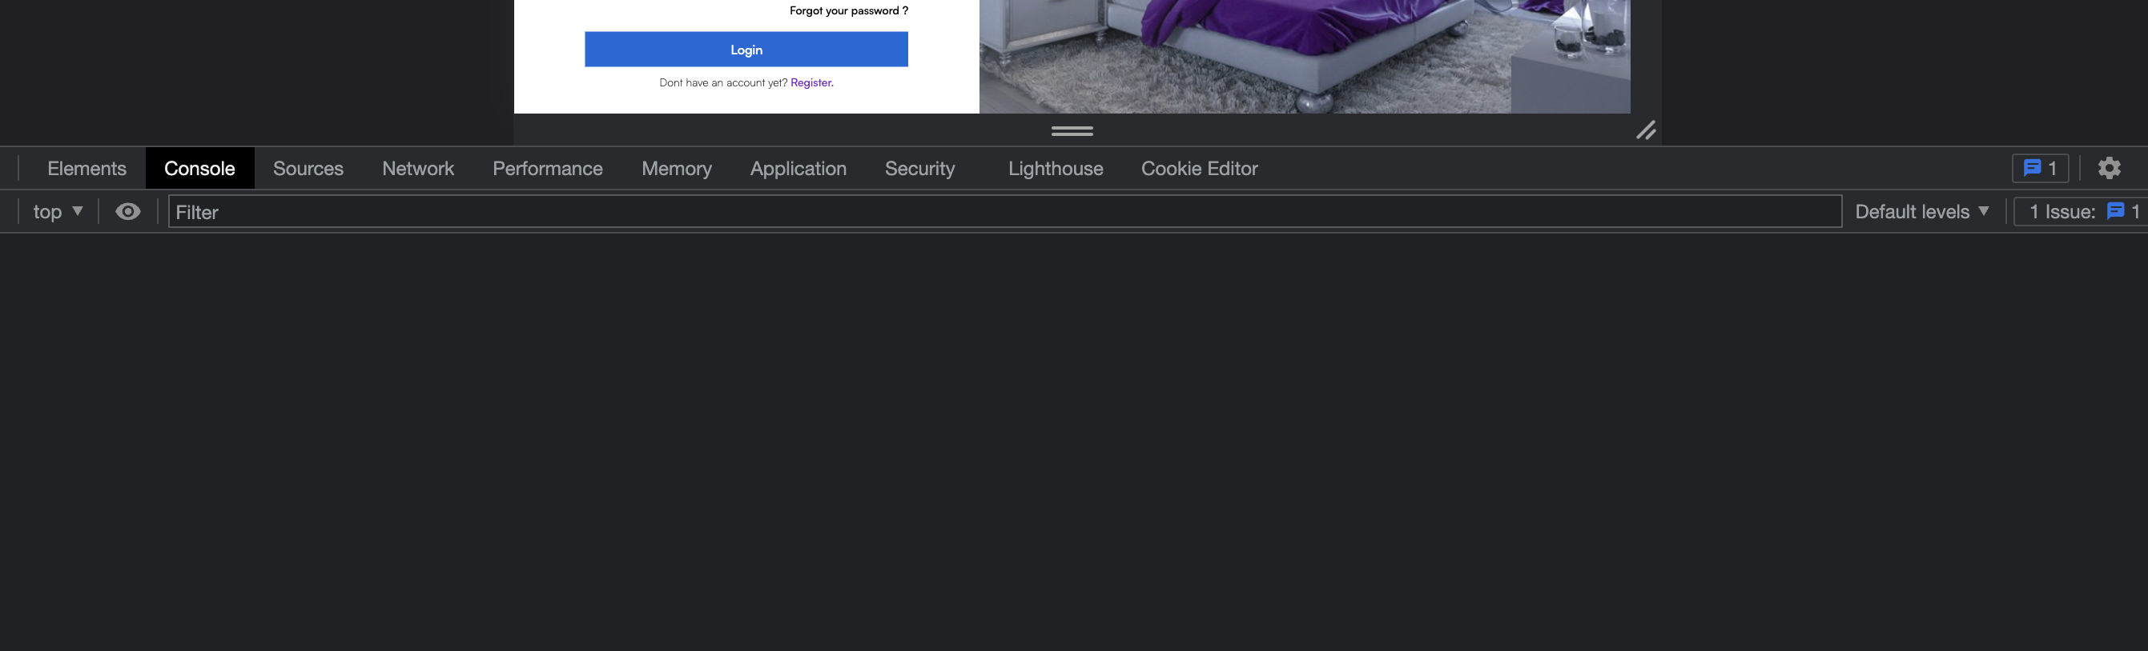

Figure 28: Login Test Step 3

**Step 3:** No error message was displayed int the console. Finding the issue in the code

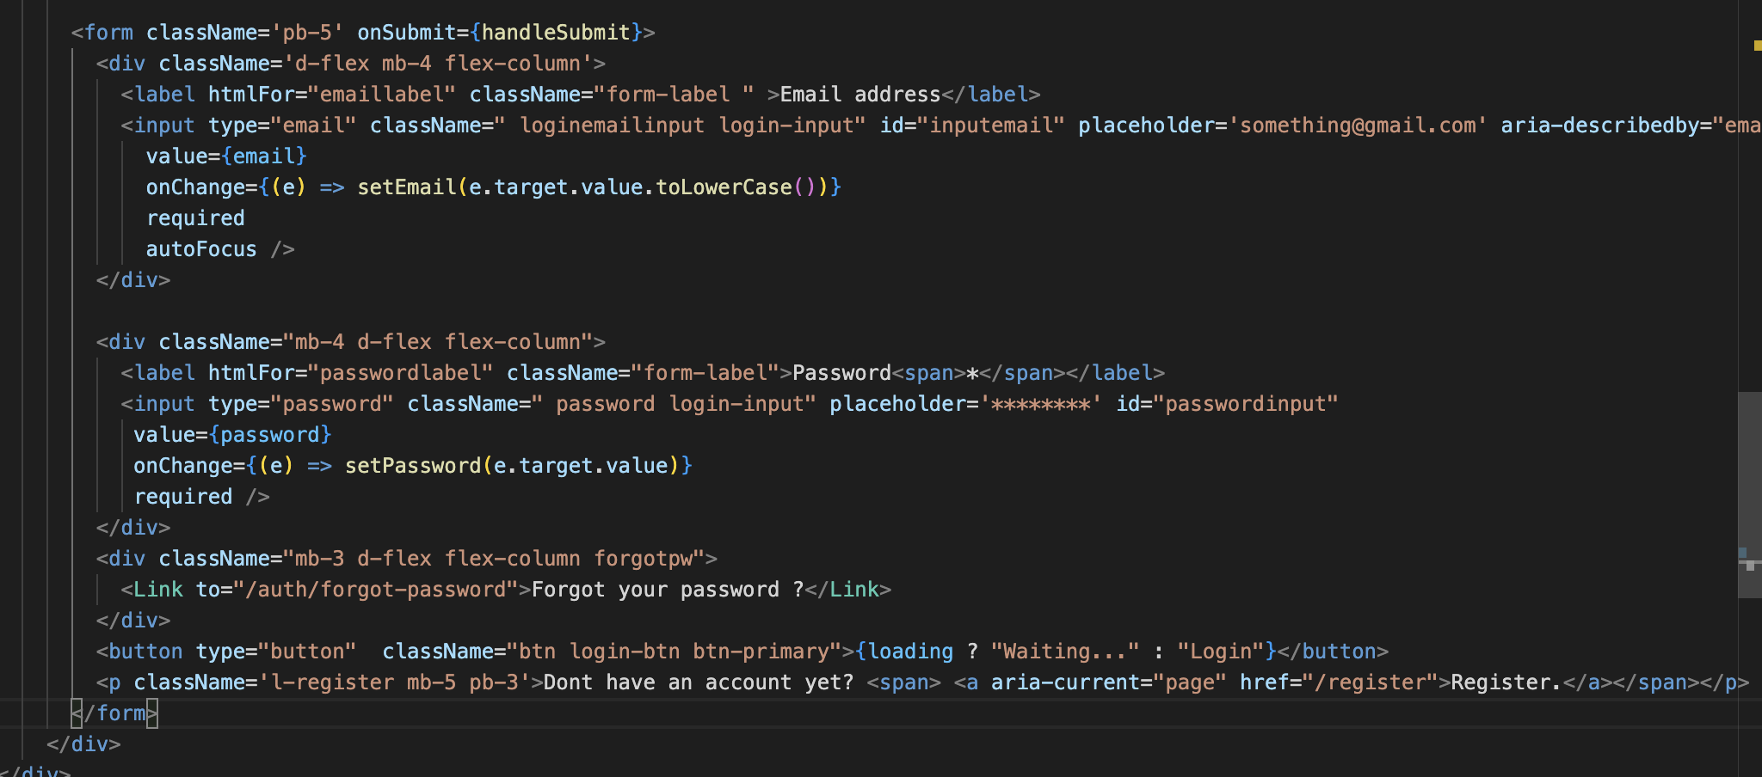

Figure 29: Login Test Step 3

**Step 4**: Issue found and solving the issue

As shown in step no 3 the issue with the code is even though the button is clicked no event is being triggered. It is because the event “handleSubmit” is not being triggered as it only triggers when the form is submitted and the form is not being submitted because the form inside the button is of type button instead of submit.



Figure 30: Login Test Step 4

Changed the button type to submit.

**Step 4**: Testing if the error is fixed.

|  |  |
| --- | --- |
| **Objective** | **Test if the login functionality is working as expected** |
| **Action** | Click the “login” button after filling the form correctly. |
| **Expected Result** | User should be logged in and redirected to homepage. |
| **Actual Result** | User is logged in to the system successfully. |
| **Conclusion** | Test successful. |

Table 17: Login Test Step 4

**Step 5**: Filling the login form correctly.



Figure 31: Login Test Step 5

**Step 6**: Test Successful User is redirected to home page and user’s name is being displayed in the navbar.

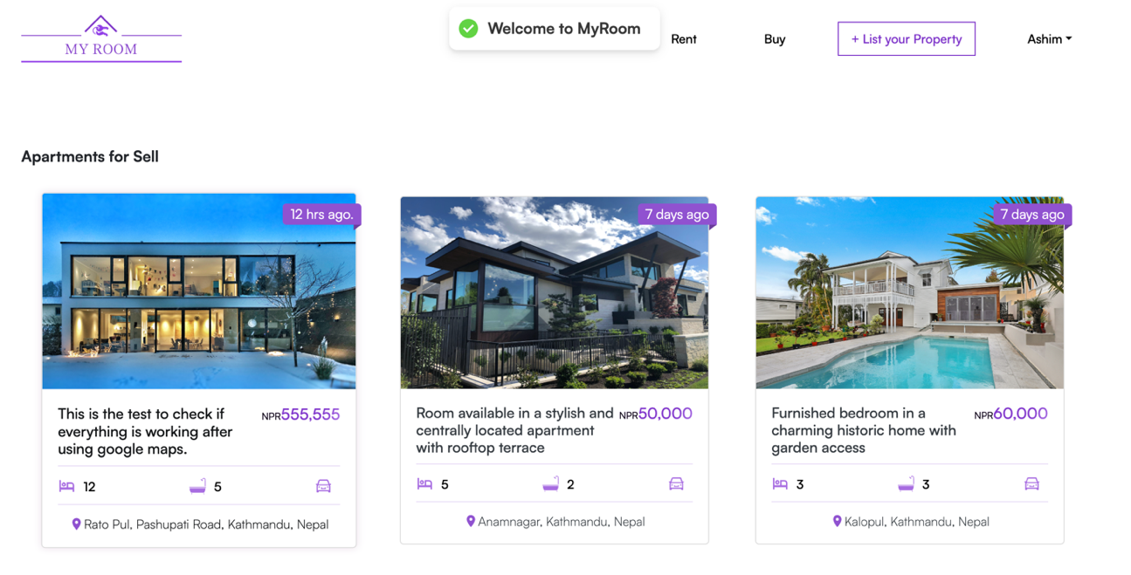

Figure 32: Login Test Step 6

### Test-3: Testing nearby locations features on property details page.

|  |  |
| --- | --- |
| **Objective** | **Testing nearby location features** |
| **Action** | Click the buttons to see the nearby hospitals, schools, colleges, stores. |
| **Expected Result** | Markers along with the property’s marker should be displayed when each button is clicked |
| **Actual Result** | Markers along with the property’s marker is being displayed on the map |
| **Conclusion** | Test Successful. |

Table 18: Nearby Location Test

**Step 1:** Click on the Nearby hospitalsbutton on the property detail page present above map.

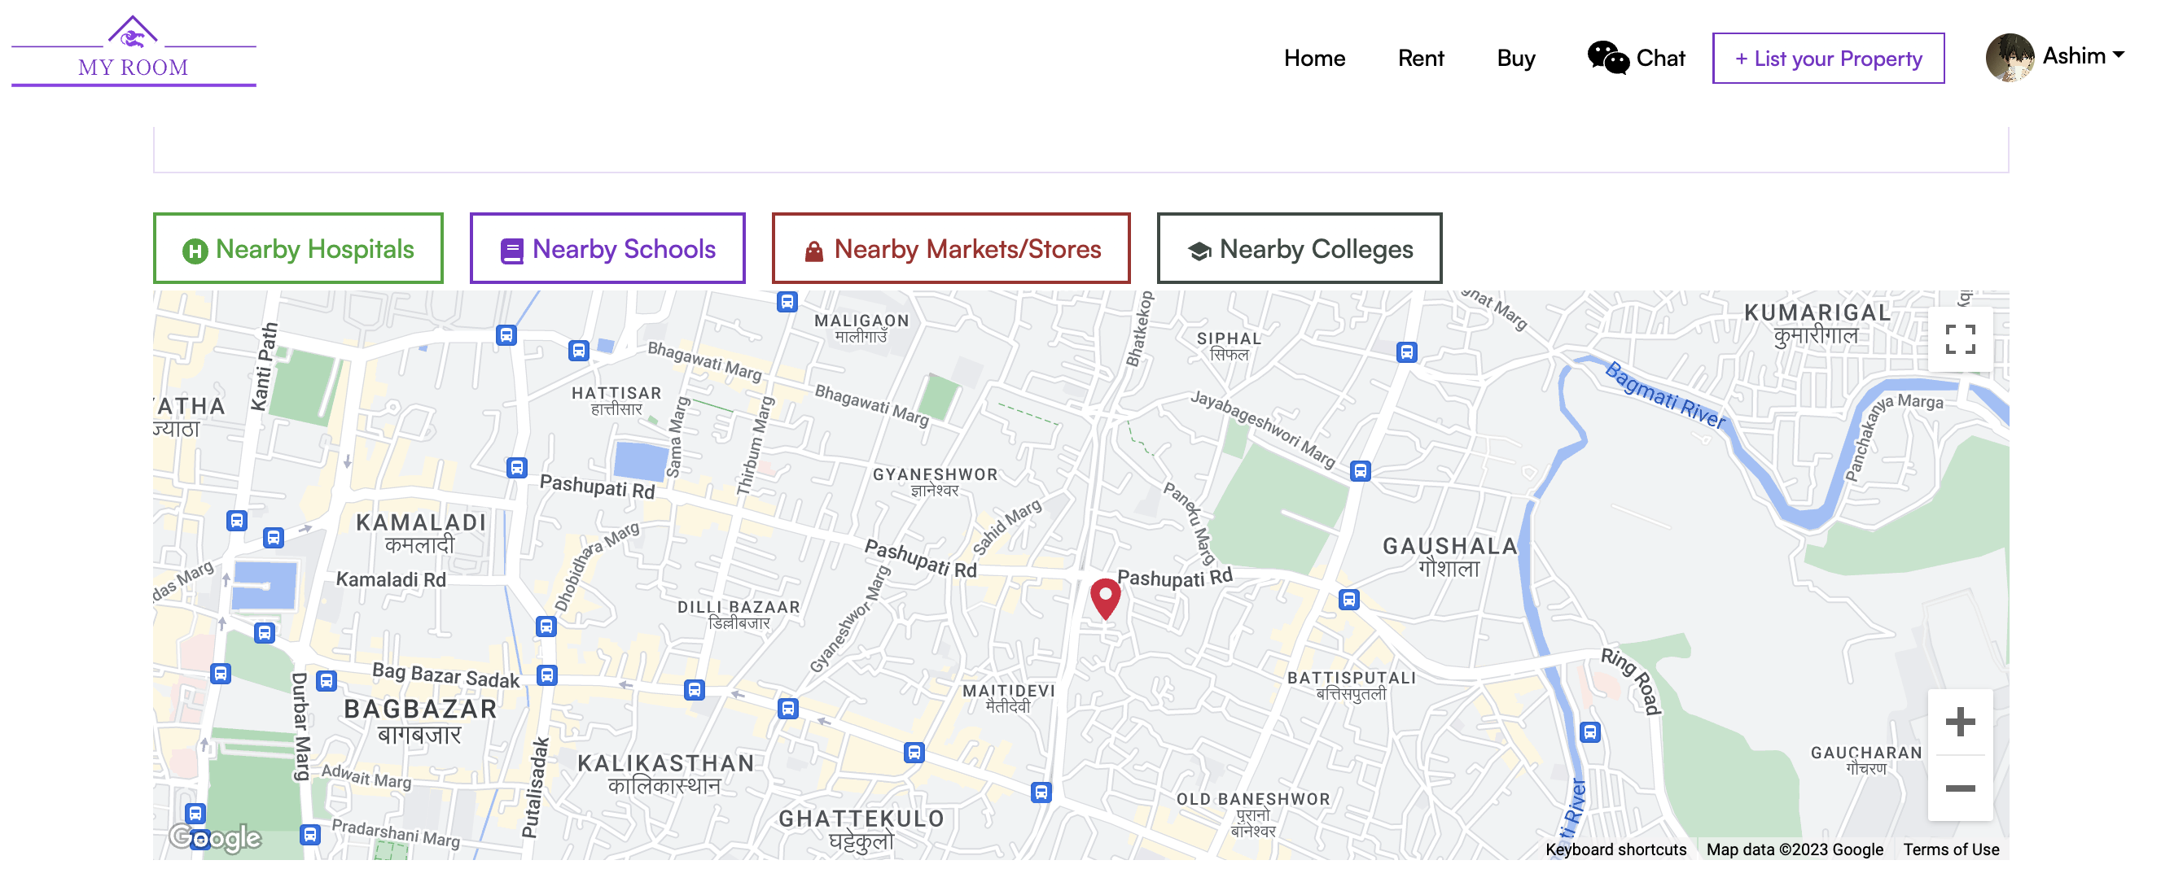

Figure 33: Nearby location test step 1

**Step 2:** Nearby Hospitals that are close to the location of property are displayed on the map.

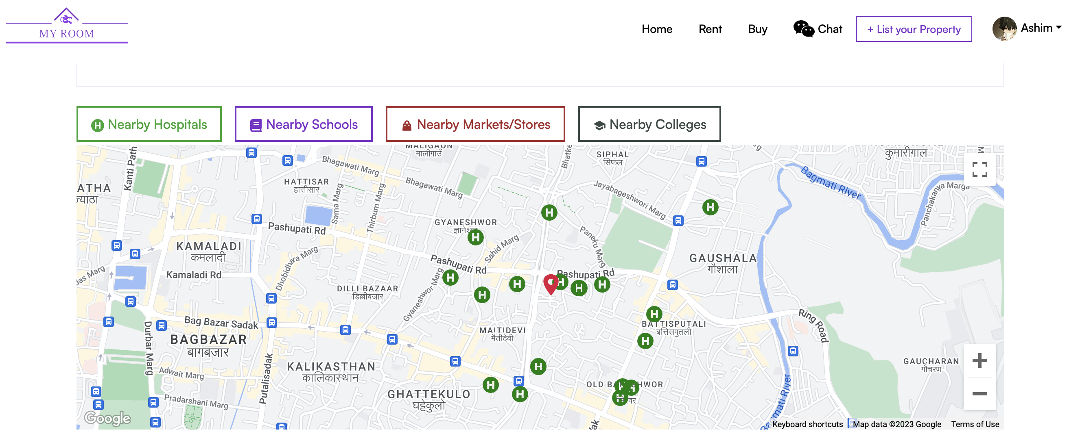

Figure 34: Nearby location test step 2 (Nearby hospitals)

**Step 3:** Clicking on nearby schools and schools that are nearby the property location is being displayed on the map.

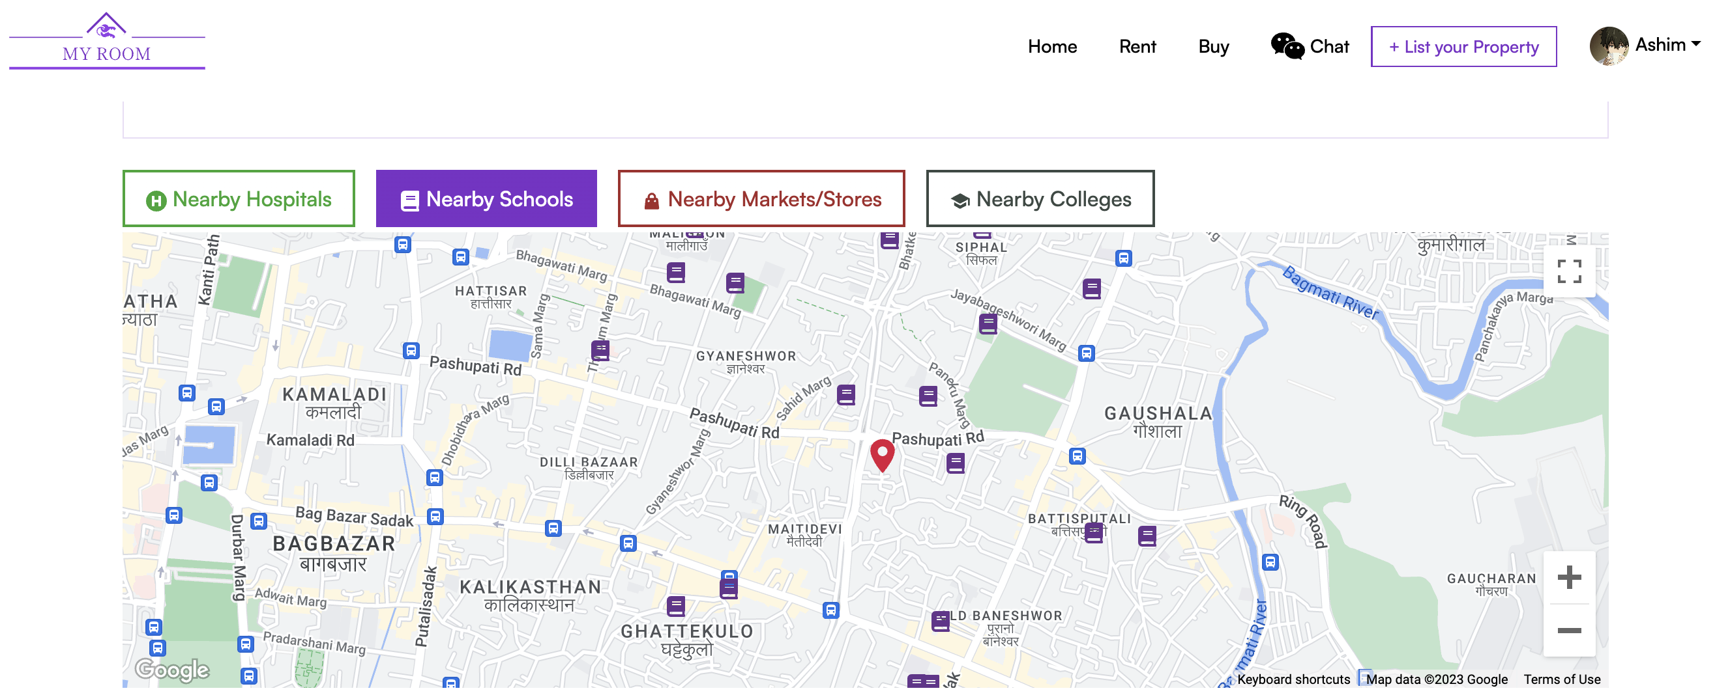

Figure 35: Nearby Location test step 3 (Nearby Schools)

**Step 4:** Clicking on the nearby Markets/stores button and stores/markets near the property is being displayed on the map.

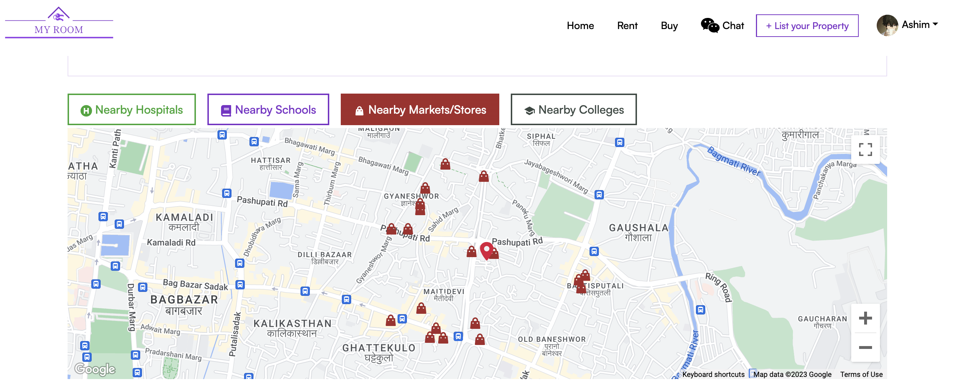

Figure 36: Nearby location test step 4 (Nearby Markets/Stores)

**Step 5:** Clicking on the nearby Colleges button and colleges/universities near to the property’s location is being displayed on the map.

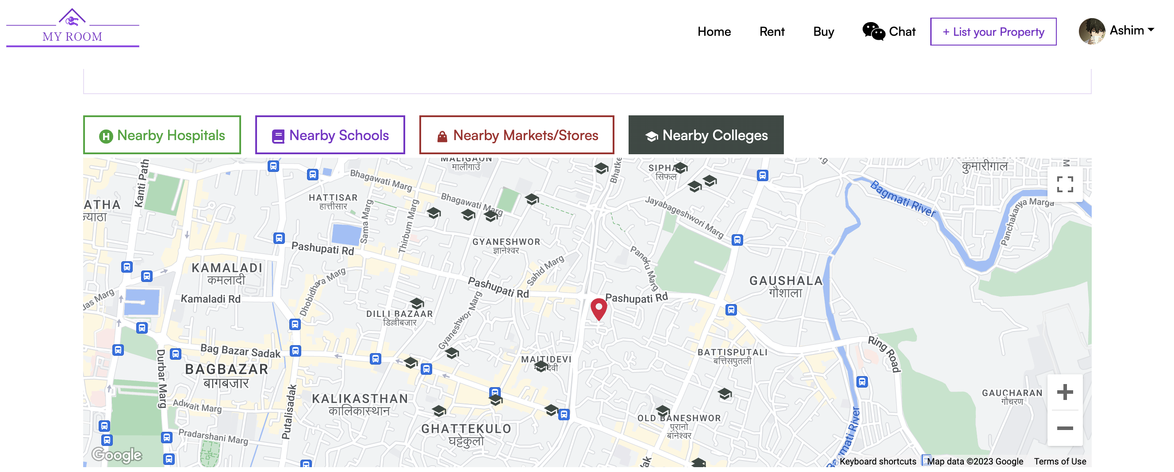

Figure 37: Nearby location test Step 5 (Nearby Colleges/Universities)

### Test-4: Recover Account Functionality

|  |  |
| --- | --- |
| **Objective** | **Test for Recover account Feature** |
| **Action** | Click the “Revocer” button on the forgot password page after filling the email input field with your email |
| **Expected Result** | User should receive an email after clicking the recover button and user should be logged in after clicking on the link from the email and redirected to update password page. |
| **Actual Result** | User received an email after clicking the recover button and user is logged in after clicking on the link from the email and redirected to update password page. |
| **Conclusion** | Test Successful. |

Table 19: Recover account Test

**Step 1:** Click on forgot password present in the login page.

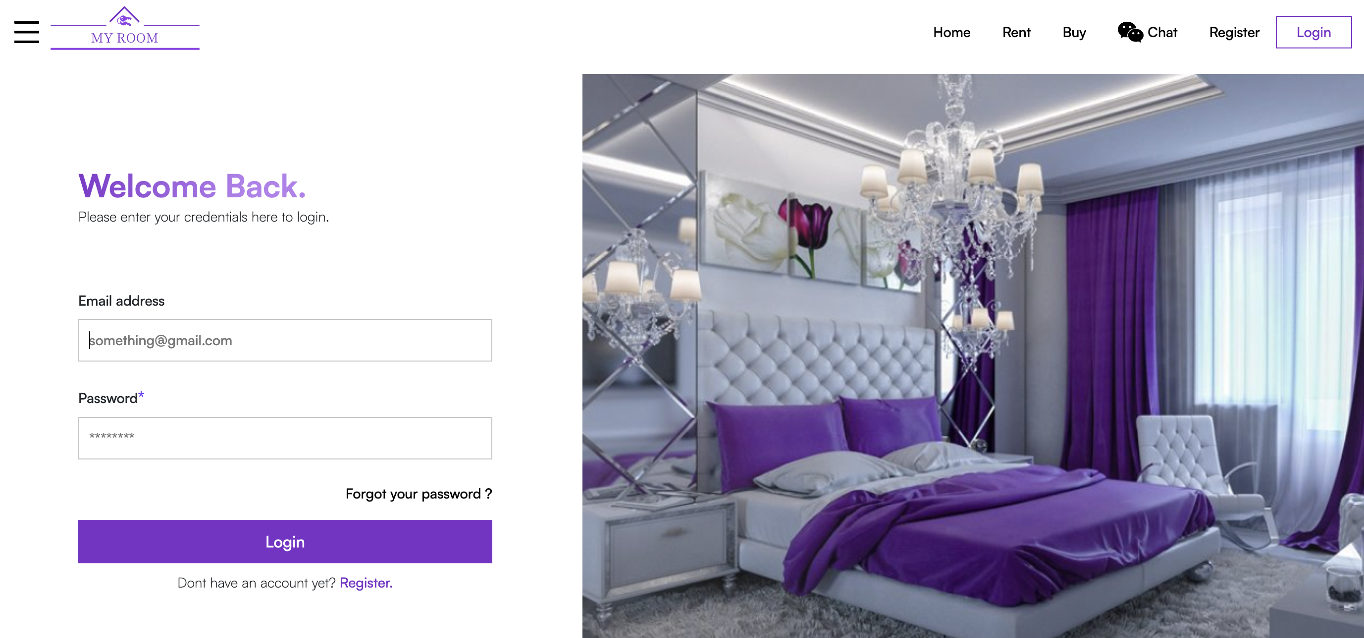

Figure 38: Recover account step 1

**Step 2:** Fill the form with valid email and click on Recover button

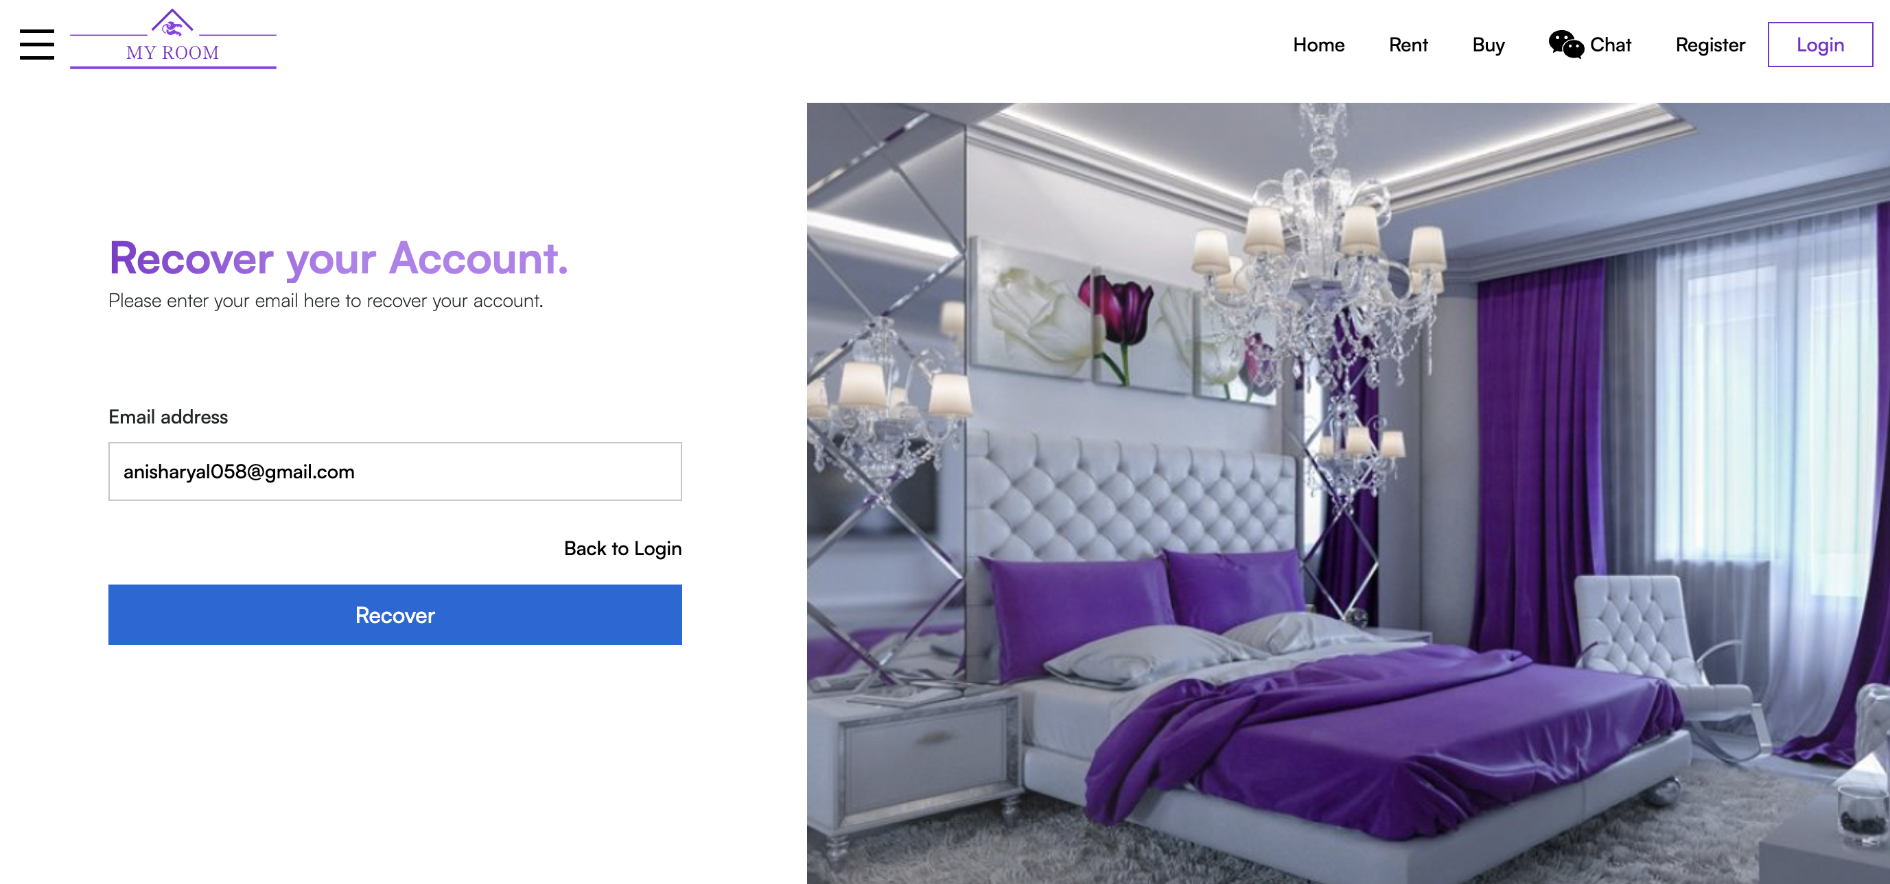

Figure 39: Recover account step 2

**Step 3:** User is redirected to home page with message recovery link sent to your email.

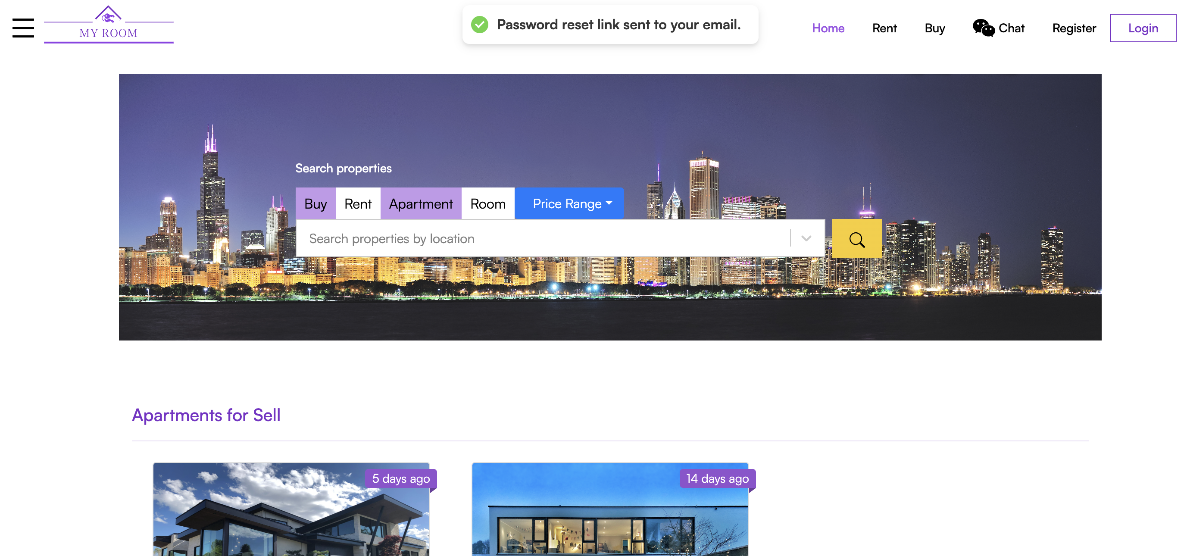

Figure 40: Recover Account test step 3

**Step 4:** Email received and clicking on the link from the email.

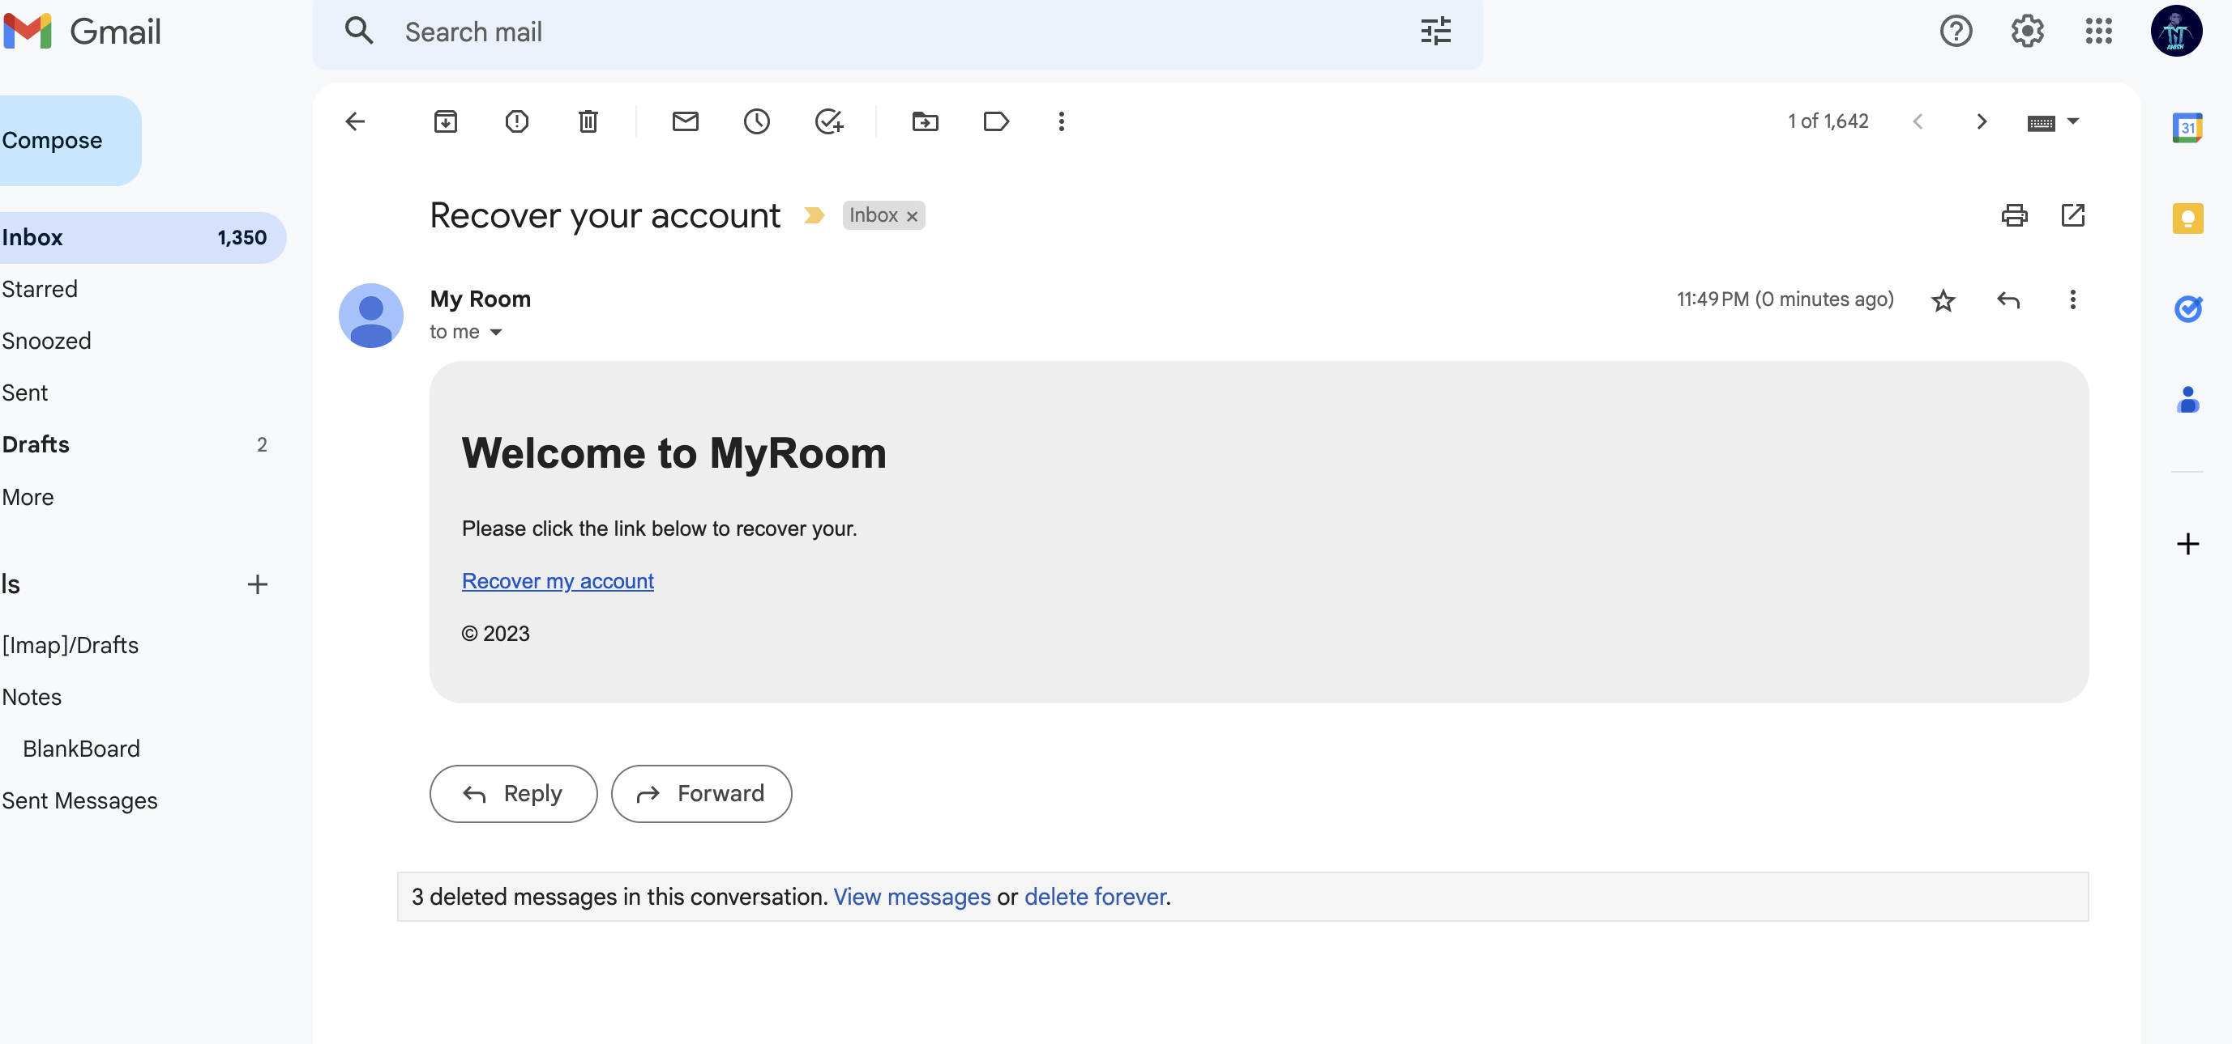

Figure 41: Recover account test step 4

**Step 5:** User is Logged in and is redirected to update password page.

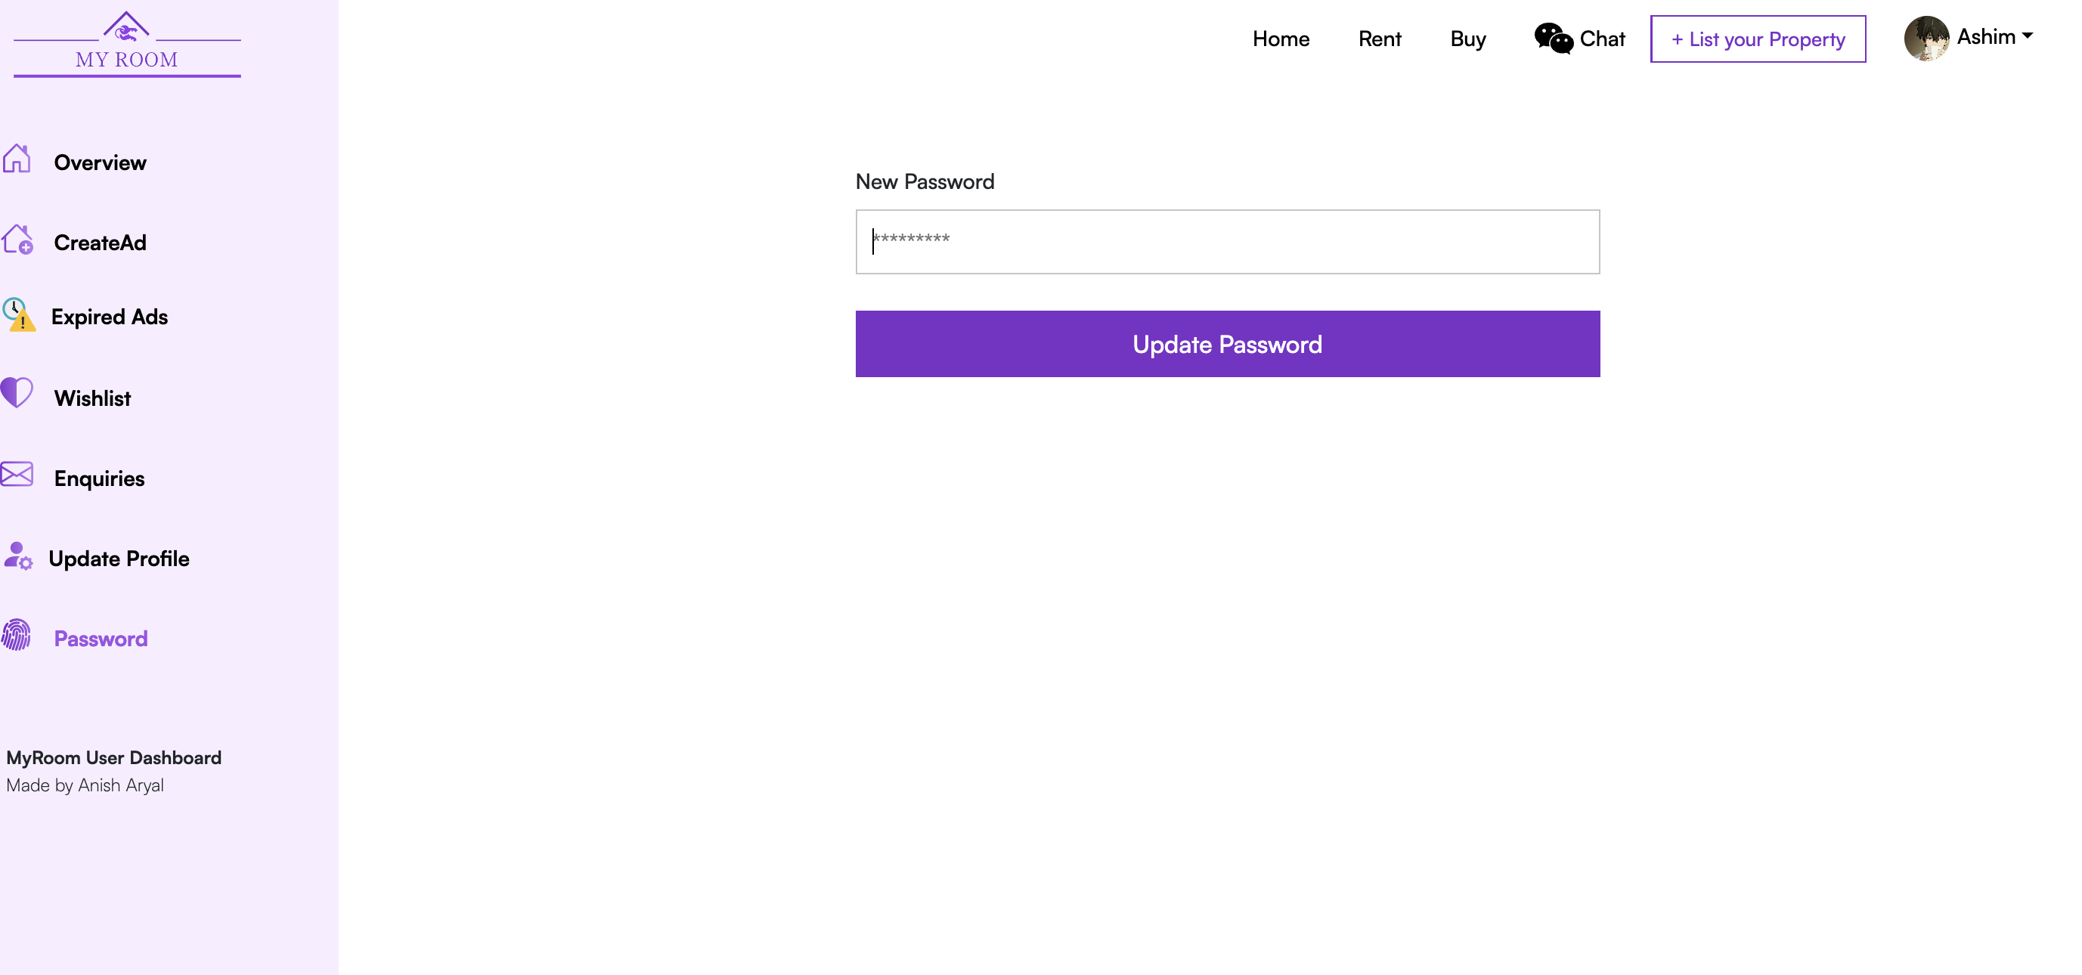

Figure 42: Recover account test Step 5

### Test-5: Display different type of ad to choose to post when rent or sell button is clicked for creating an app.

|  |  |
| --- | --- |
| **Objective** | **Test different type of ad to choose from is displayed in the frontend.** |
| **Action** | Click the “List your property” button on the navbar after logging in. Choose the type of ad you wish to post. |
| **Expected Result** | When the user chooses the type of ad to post i.e, either to for or for sell they should be displayed the type of property they want to post the about |
| **Actual Result** | User is shown 2 different options Apartments , Room to choose from after user chooses the type of ad they wish to post. |
| **Conclusion** | Test successful. |

Table 20: Choosing Different Ad type test

**Step 1:** User is Logged In and as we can see the name of user in navbar and then clicking the “List your property button”.

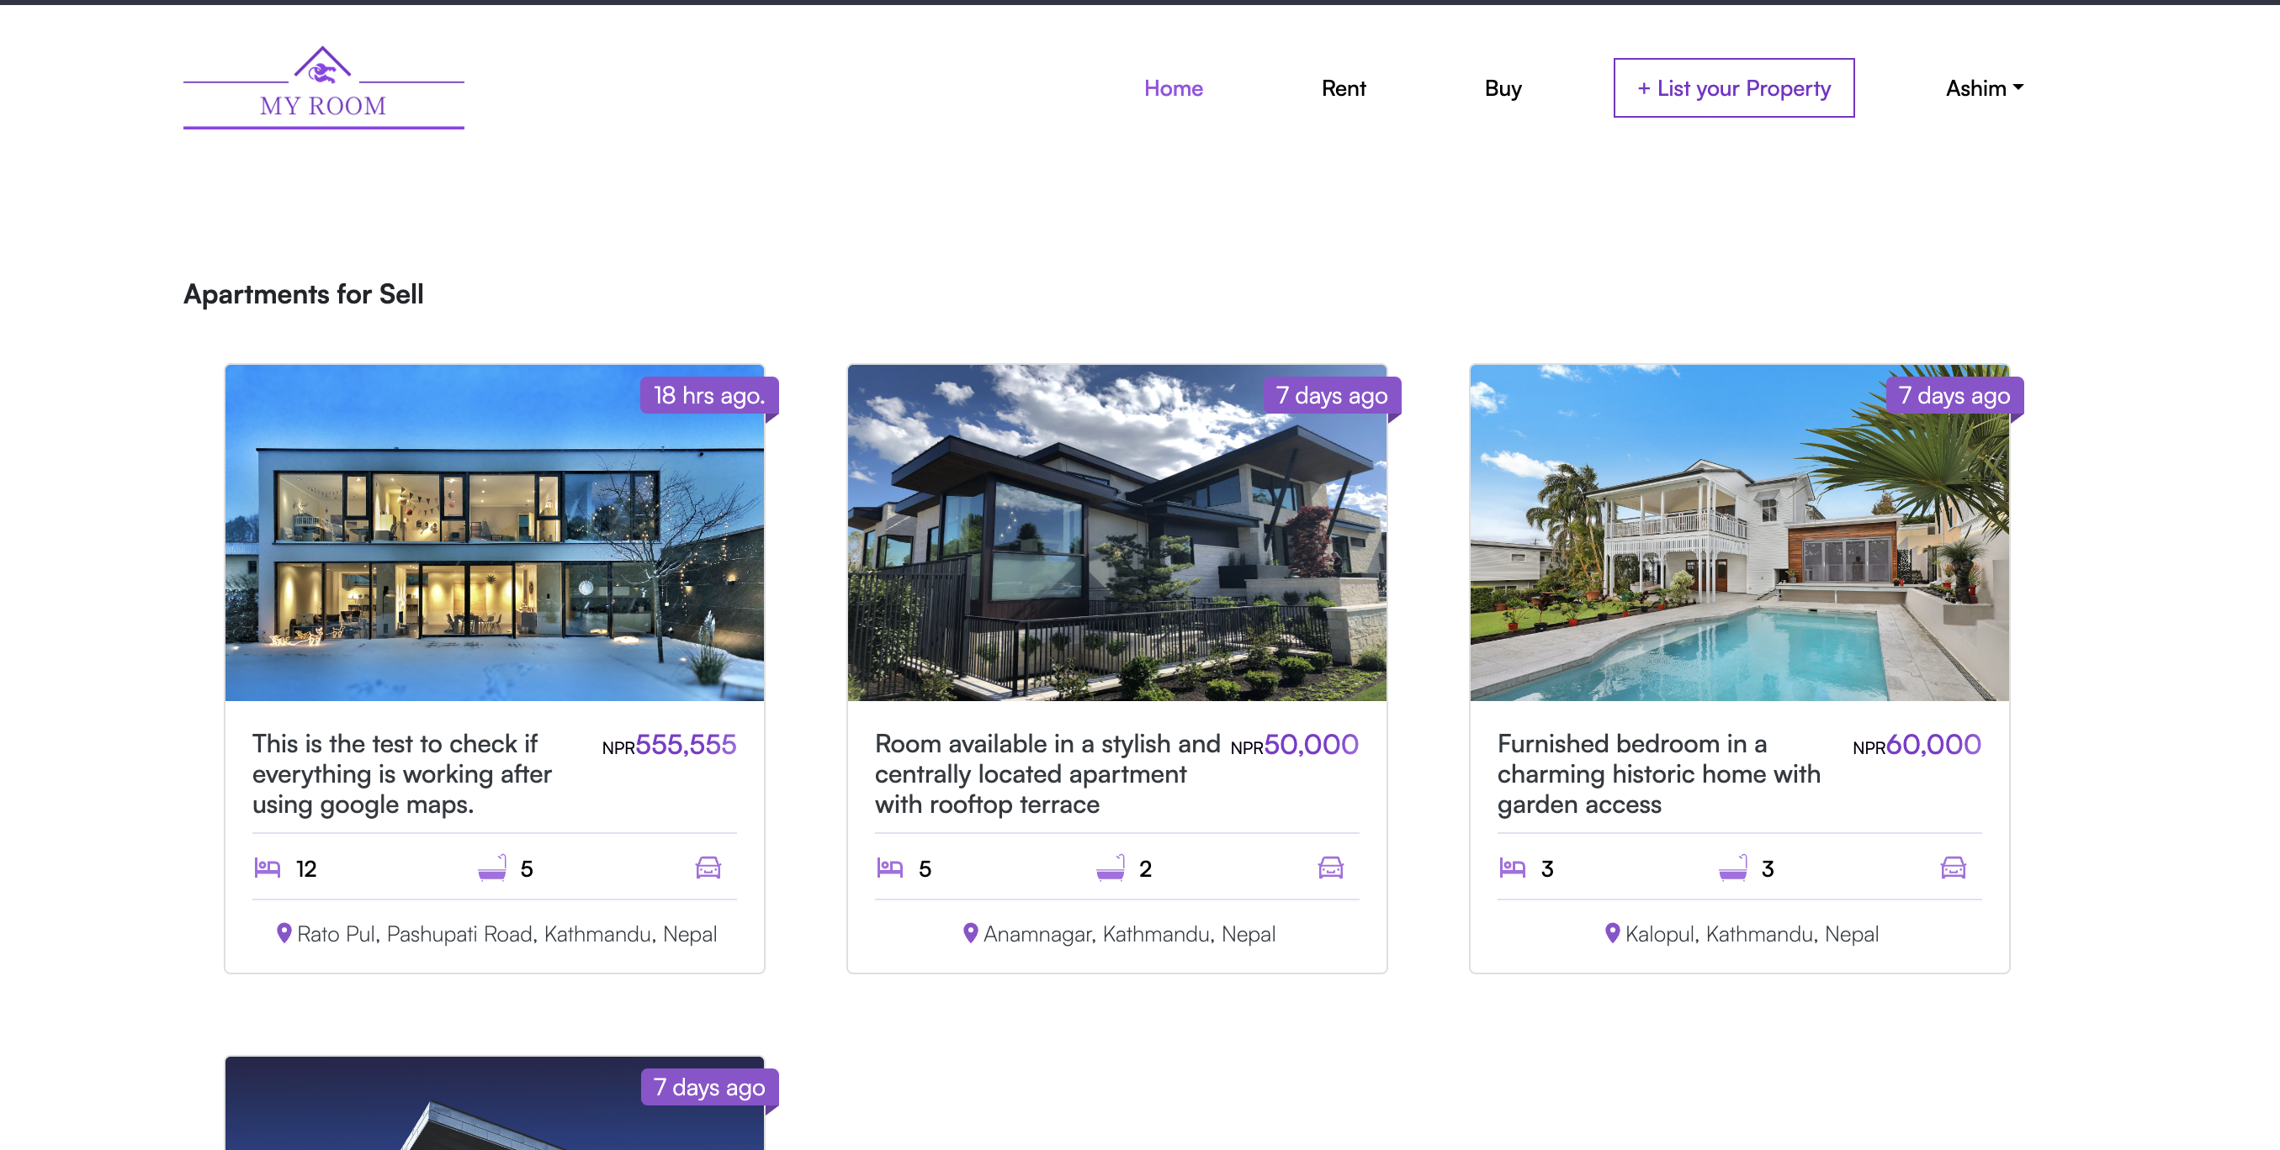

Figure 43: Choosing Ad type to post Step 1

Step 2: After “List your property” button is clicked user is redirected to create ad page.

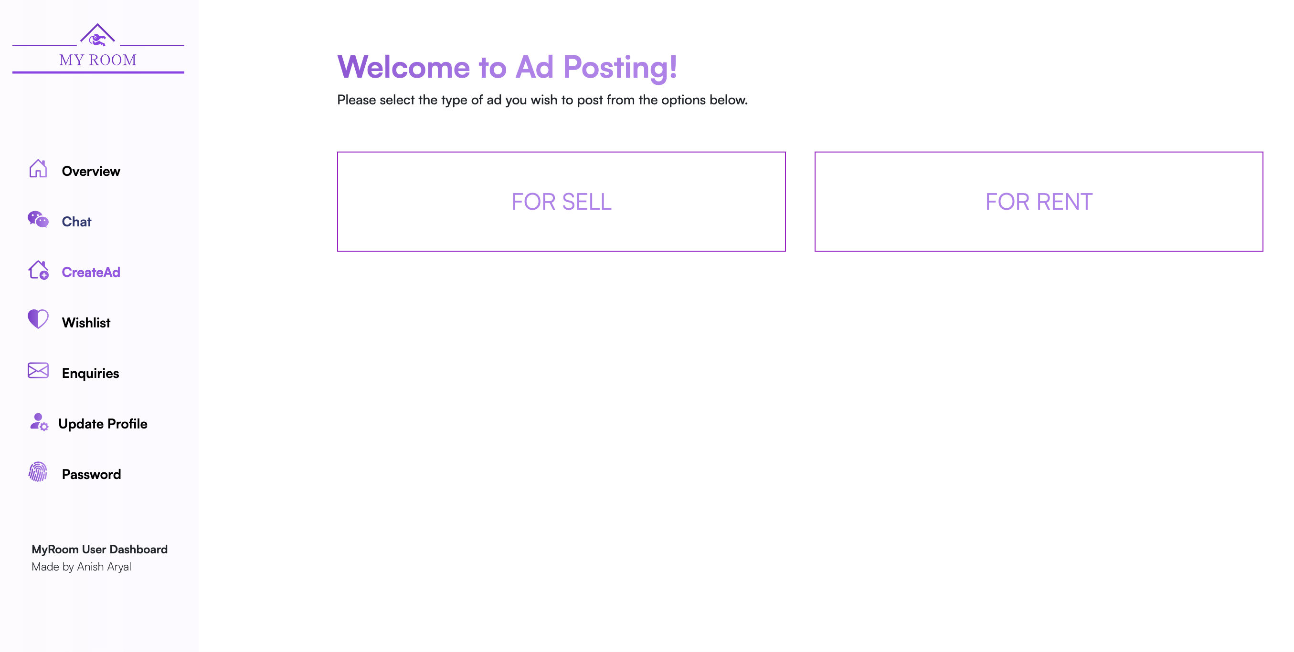

Figure 44: Choosing Ad type to post Step 2

**Step 3:** Test successful since clicking on the button choosing either for sell or for rent displays two more options to choose from

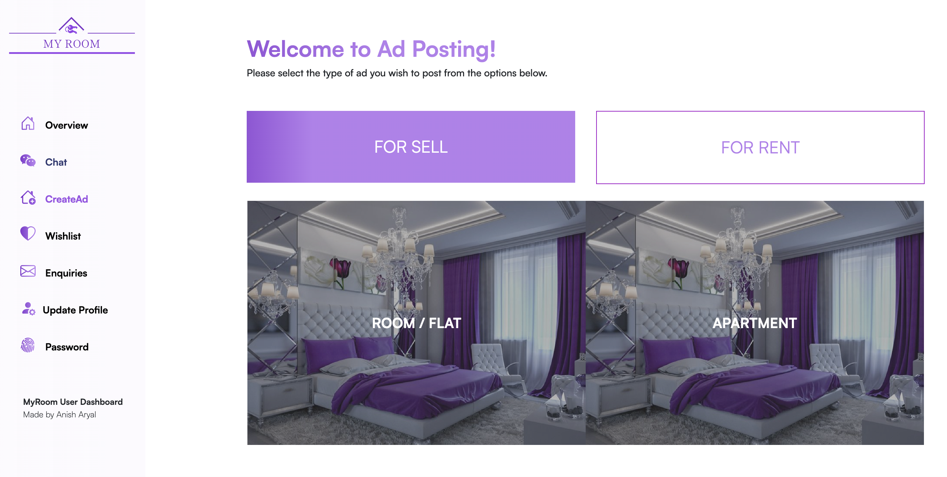

Figure 45: Choosing Ad type to post Step 3 (figure 1)

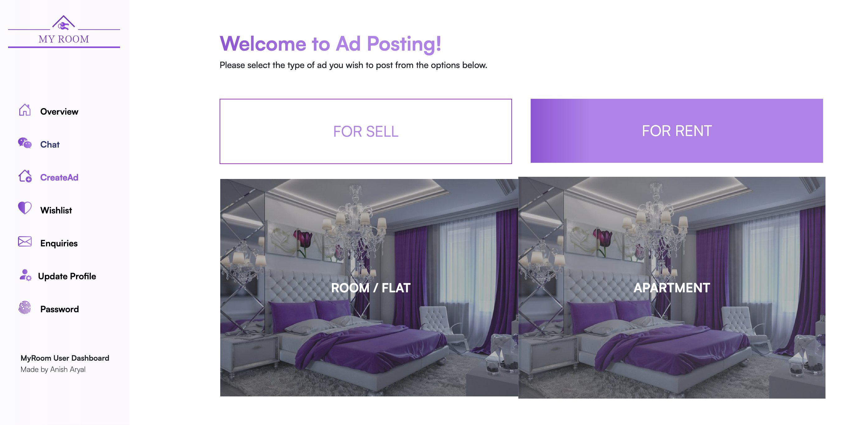

Figure 46: Choosing Ad type to post Step 3 (figure 2)

### Test 6: Add to Wishlist

|  |  |
| --- | --- |
| **Objective** | **Test if Wishlist is working properly** |
| **Action** | Click the heart icon on the ad view page to add the item to the wish list |
| **Expected Result** | Liked ad should be added to users Wishlist |
| **Actual Result** | User’s Wishlist is not being updated once they like the ad. |
| **Conclusion** | Test Unsuccessful. |

Table 21: Add to Wishlist test

=

**Step 1:** Check the Wishlist before liking any of the ads.

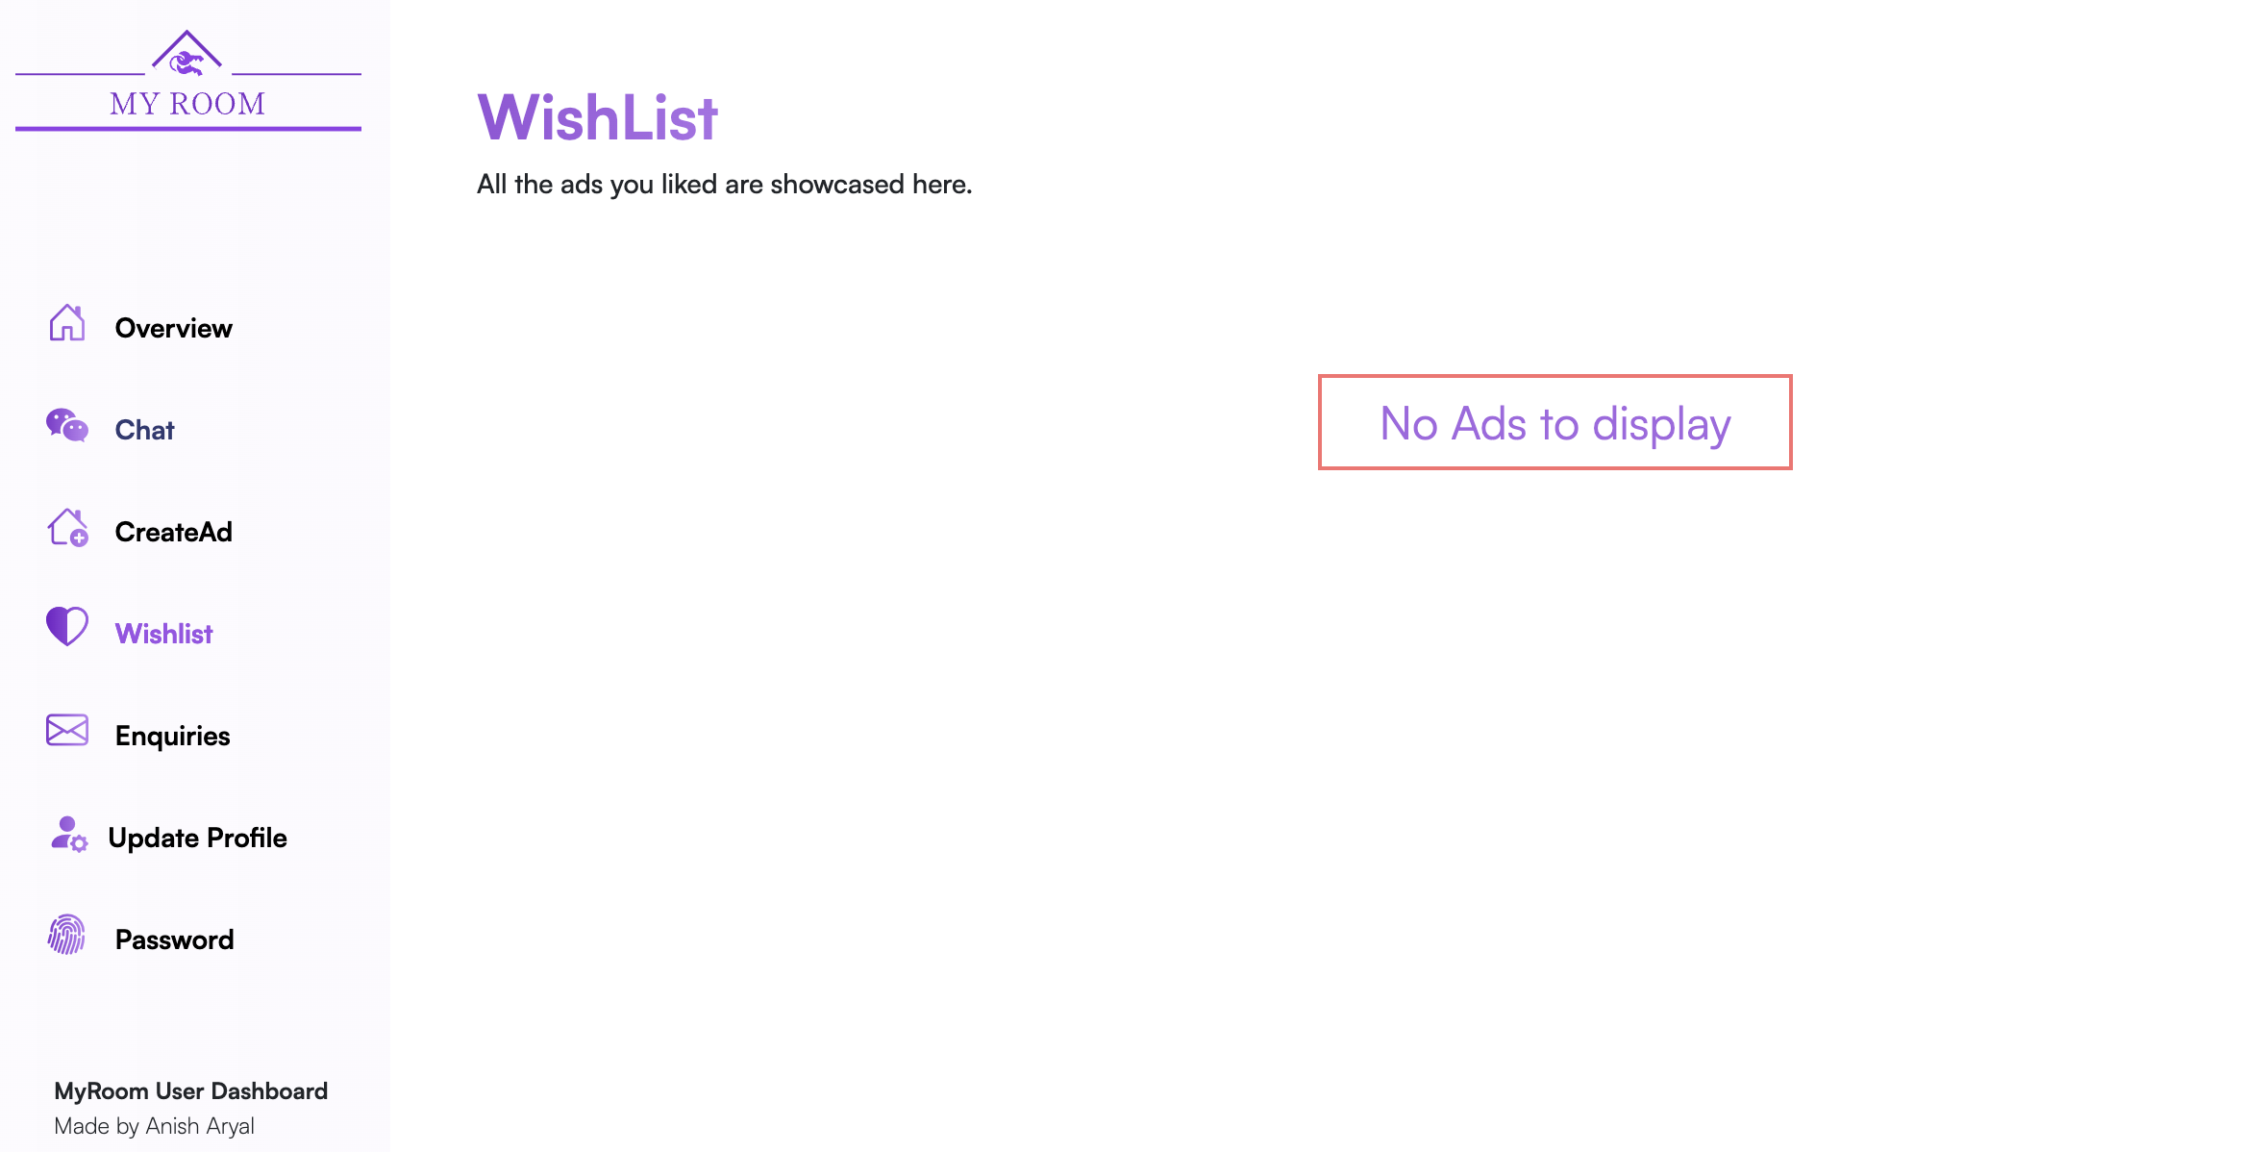

Figure 47: Add to Wishlist test Step 1

**Step 2:** Like an ad from the ad view page and check if success message pops up.

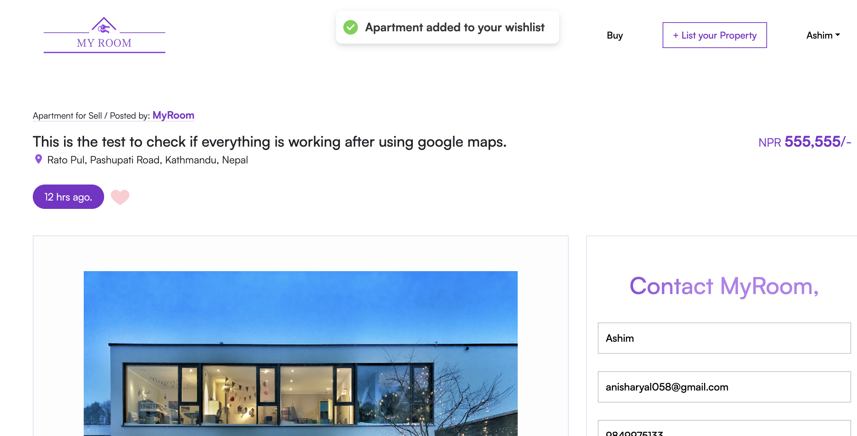

Figure 48: Add to Wishlist test Step 2

**Step 3:** Finding the issue in the code

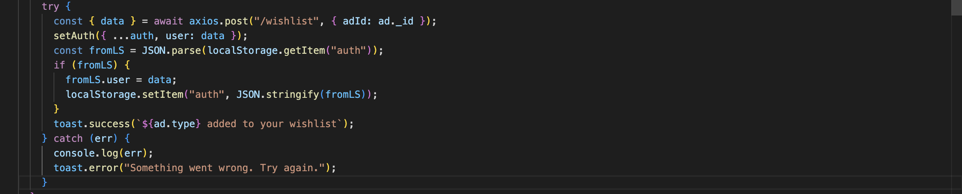

Figure 49: Add to Wishlist test Step 3

.

Successful request was made to endpoint the however nothing is seen in the user’s wishlist.



Figure 50: Add to Wishlist test Step 4

**Step 4**: Issue found and solving.

Everything looks fine in the frontend and Like button is making request to the ‘/wishlist’ end point in the backend so checking the controllers code connected to that end point.

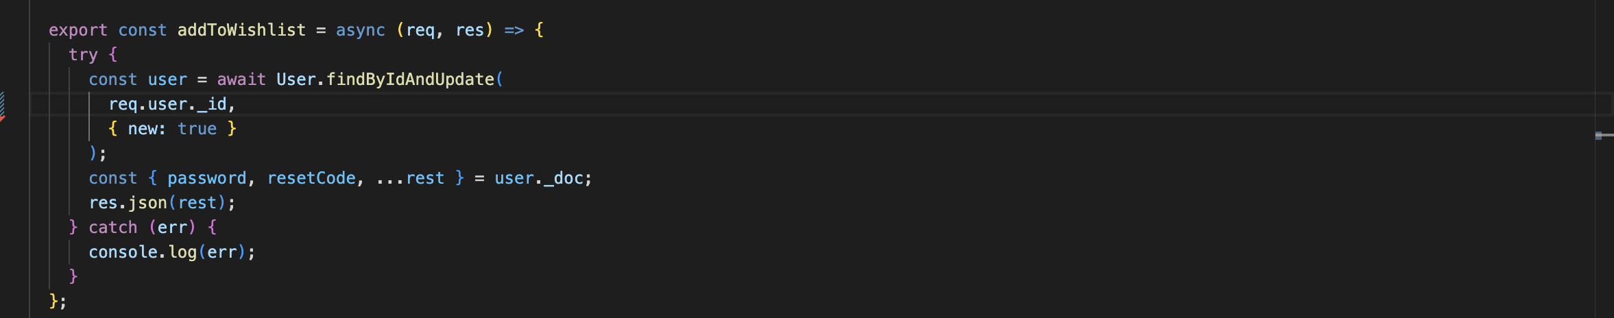

Figure 51: Add to Wishlist test Step 4 (fig 1)

In this controller function we can see that we have only search for the user’s id and not actually passed anything to the user model so fixing the issue by adding the liked ad ID to the user’s wish list.

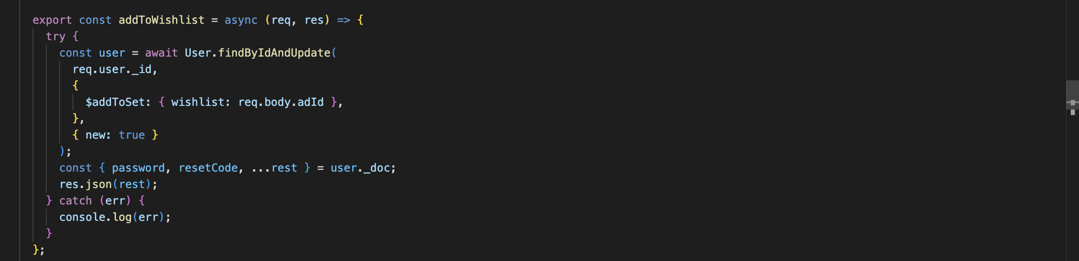

Figure 52: Add to Wishlist test Step 4 (fig 2)

**Step 5**: Testing if the error is fixed

|  |  |
| --- | --- |
| **Objective** | **Test if Wishlist is working properly** |
| **Action** | Click the heart icon on the ad view page to add the item to the wish list |
| **Expected Result** | Liked ad should be added to users Wishlist |
| **Actual Result** | Liked ad added to users Wishlist |
| **Conclusion** | Test successful. |

Table 22: Add to Wishlist test after fixing error (step 5)

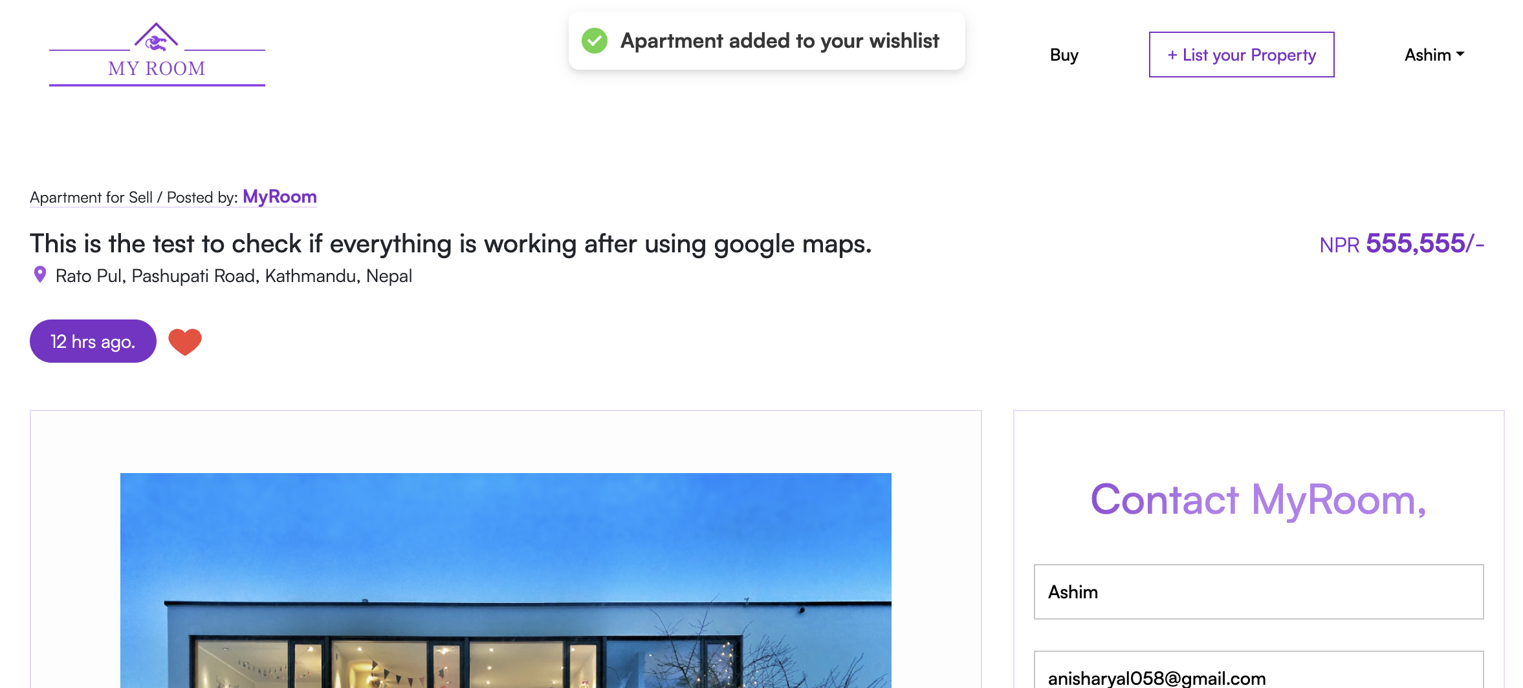

Figure 53: Add to Wishlist test Step 5

Liking the ad in the ad view page

**Step 6**: Test Successful since the ad is added to the users Wishlist.

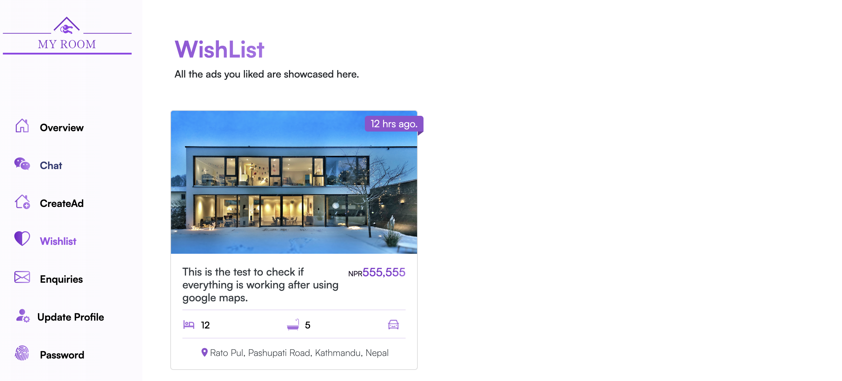

Figure 54: Add to Wishlist test Step 6

### Test-7: Test to Display all the ads posted by user.

|  |  |
| --- | --- |
| **Objective** | **Test if logging functionality is working properly** |
| **Action** | Click the “Dashboard” option present in the navbar under user’s name |
| **Expected Result** | User should be redirected to the Overview page and all the ads posted by the user should be displayed in the overview section |
| **Actual Result** | User is successfully redirected to the Overview page and all the ads posted by the user is seen in the overview section |
| **Conclusion** | Test Successful. |

Table 23: Test to Display all the ads posted by the user

**Step 1:** Click the dashboard option present in the navbar under user’s name.

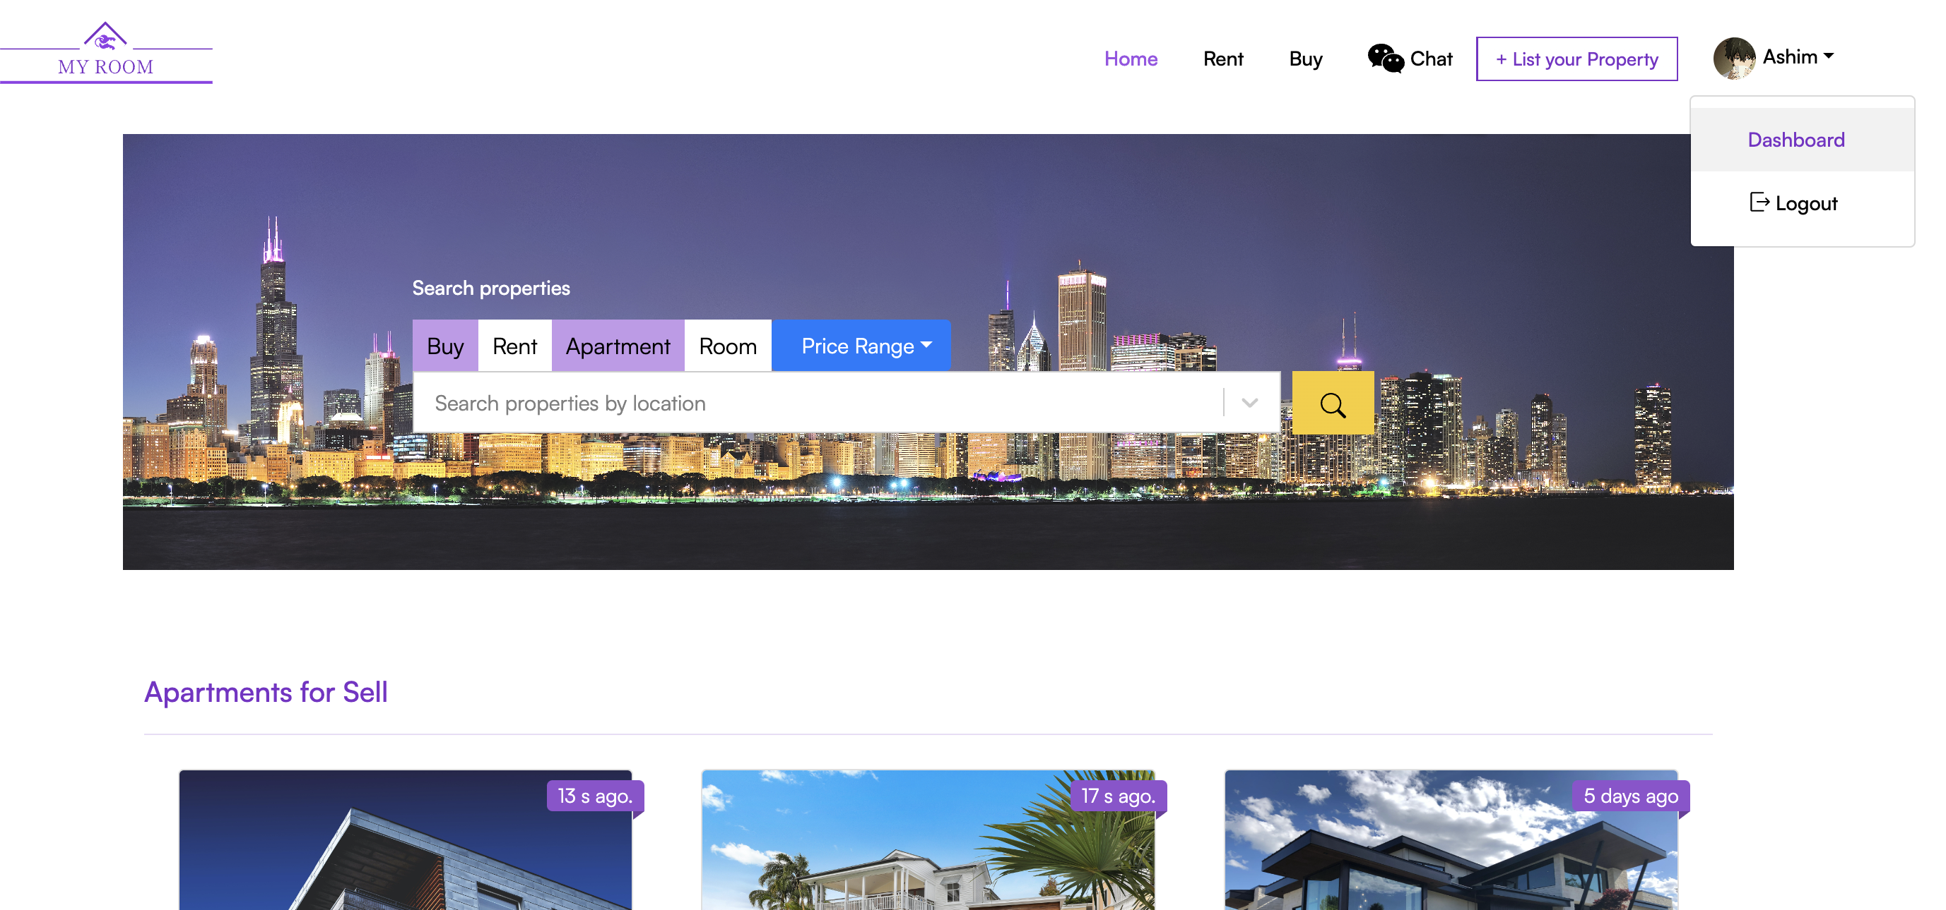

Figure 55: Step 1 of Test to see all the ads posted by the user

**Step 2:** User is redirected to Overview Page

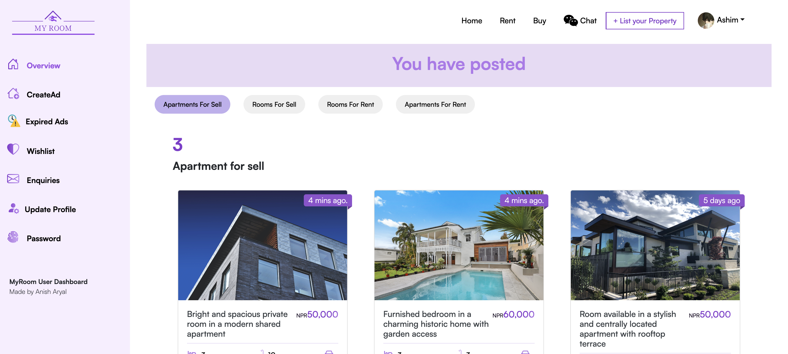

Figure 56: Step 2 of Test to see all the ads posted by the user

**Step 3:** All the ads posted by the user is seen.

1. **All the posted Apartments for sell**



Figure 57: Step 3 of Test to see all the ads posted by the user (Apartments for sell)

1. **All the posted Rooms for sell**

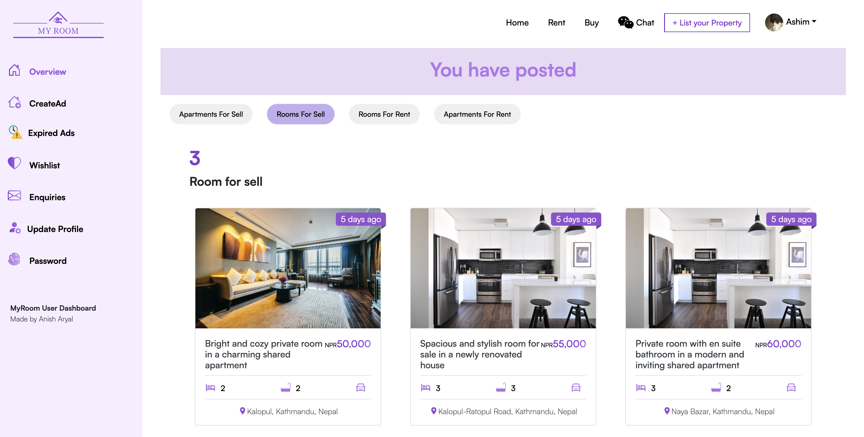

Figure 58: Step 3 of Test to see all the ads posted by the user (Rooms for Sell)

1. **All the posted Rooms for Rent**

User have not posted any rooms for rent so “0 Rooms” for rent is seen in the Rooms for rent section.

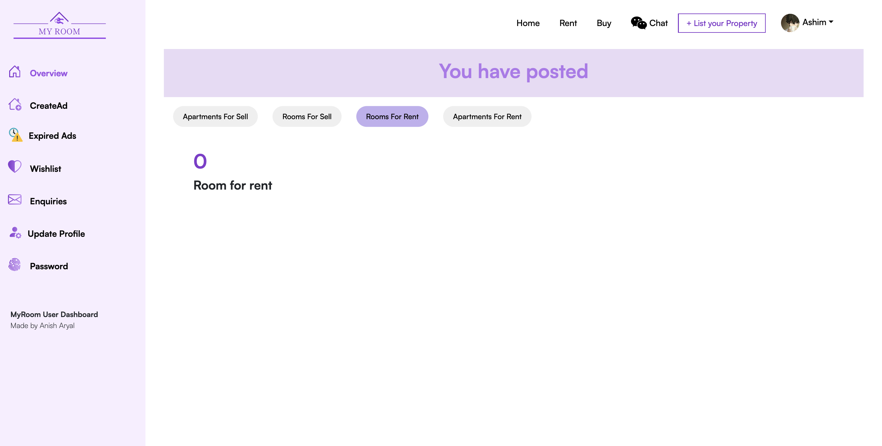

Figure 59: Step 3 of Test to see all the ads posted by the user (Rooms for Rent)

1. **All the posted Apartments for Rent**

User have not posted any rooms for rent so “0 Rooms” for rent is seen in the Apartments for rent section.

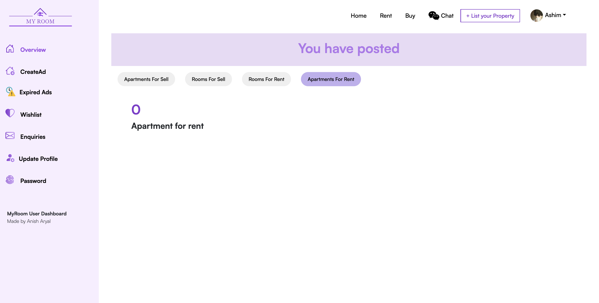

Figure 60: Step 3 of Test to see all the ads posted by the user (Apartments for Rent)

### Test 8: Test for Update Profile Functionality.

|  |  |
| --- | --- |
| **Objective** | **Test for Update Profile Functionality** |
| **Action** | Click the on the Update profile page from the sidebar present in the dashboard and form should be displayed with previous information.   1. Update the Profile as you like. 2. Click on the Update Profile Button |
| **Expected Result** | 1. User’s profile with previously saved information should be displayed along with the form to change the information. 2. Updated information should be displayed after the user clicks on the update profile button |
| **Actual Result** | Form with previously saved information is displayed and after making changes and clicking on the update profile button profile of user can be seen with new changes. |
| **Conclusion** | Test Successful. |

Table 24: Test for Update Profile Functionality

**Step 1:** Click on theupdate profile button from the sidebar.

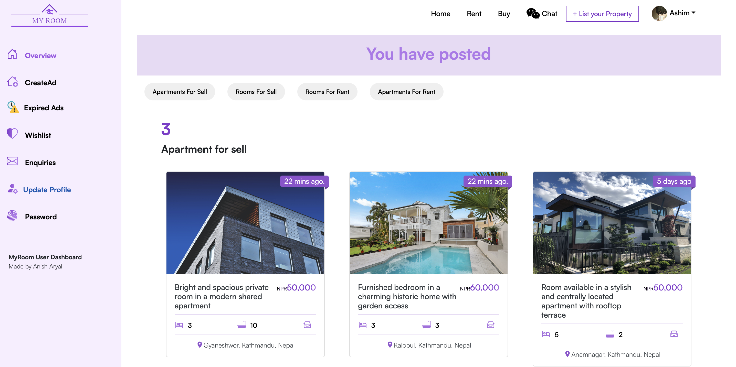

Figure 61: Step 1 of Test for Update Profile functionality.

**Step 2:** Form with the previously saved user’s information is displayed. As we can see the user previous information on the label of the input field.

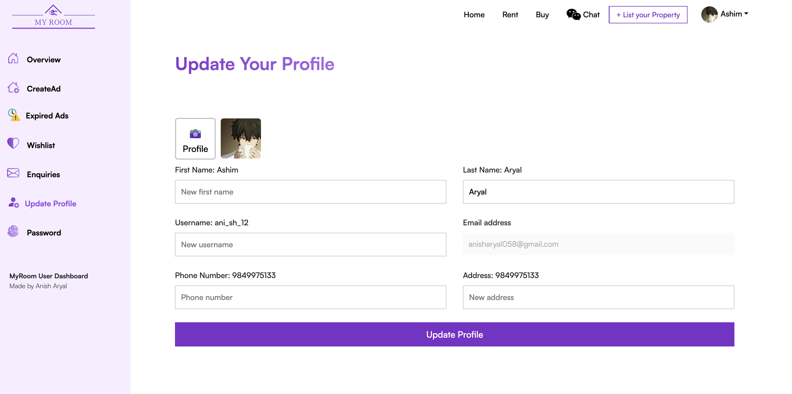

Figure 62: Step 2 of Test for Update Profile functionality.

**Step 3:** Changing some information in the input field, filling it with new information and clicking the “Update Profile” Button.

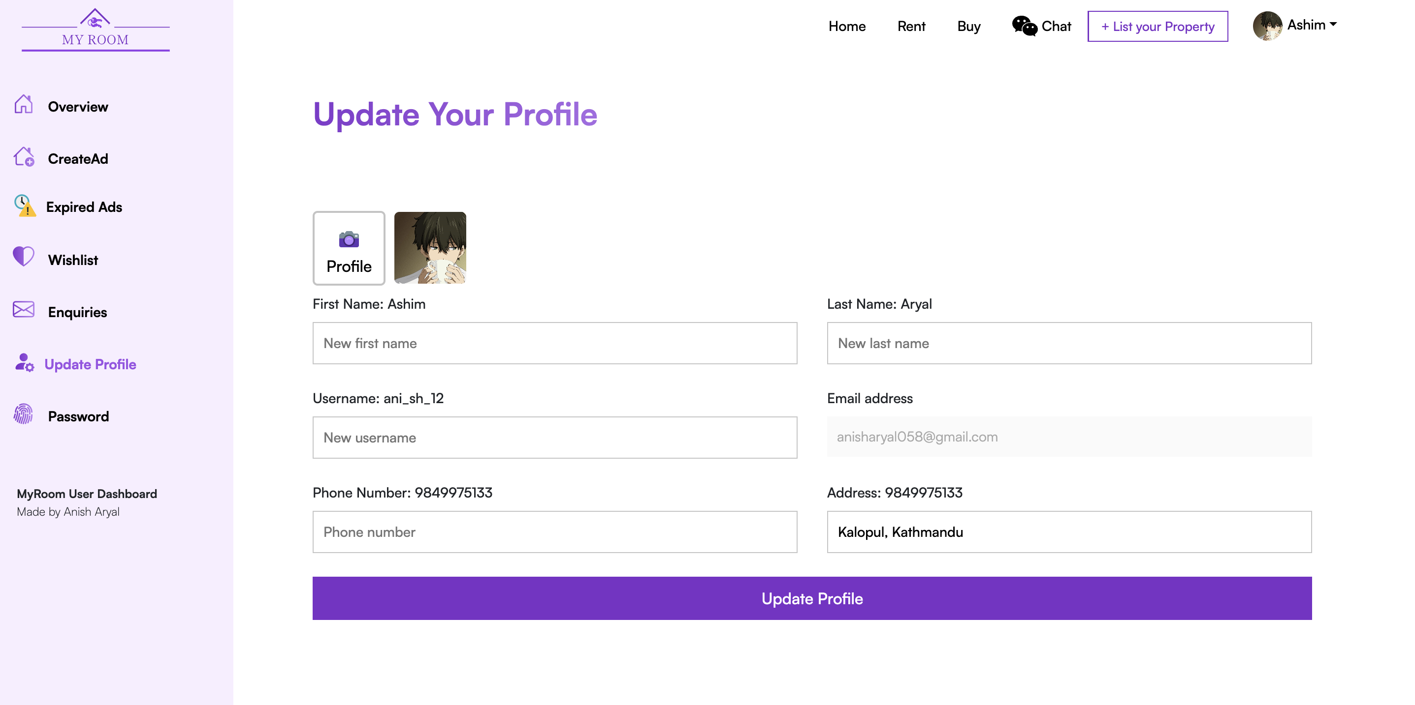

Figure 63: Step 3 of Test for Update Profile functionality.

**Step 4:**  We can see the Updated information on the label above the input field as Address was changed to new address.

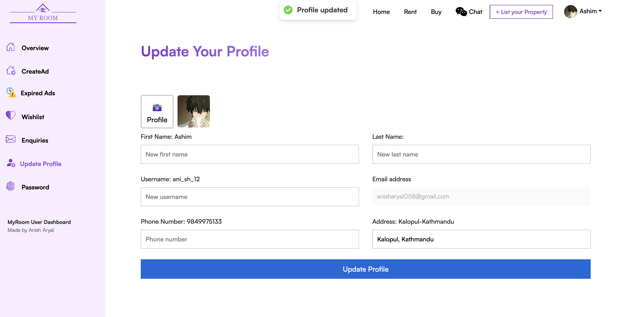

Figure 64: Step 4 of Test for Update Profile functionality.

### Test 9: Test for Message Seller Functionality.

|  |  |
| --- | --- |
| **Objective** | **Test for Message Seller Functionality.** |
| **Action** | Click on the “Have a Chat” button present on each property details page. |
| **Expected Result** | User should be redirected to the chat page and Seller should receive a new message from the buyer which says ‘Hi’ and seller should be added on the chat list of the user. |
| **Actual Result** | User is redirected to the chat page and Seller is added to the user’s chat list and seller received a new message from the buyer that says “hi”. |
| **Conclusion** | Test Successful. |

Table 25: Test for Message Seller Functionality.

**Step 1:**  Getting Started.

1. Buyer’s Chat list before clicking on the have a chat button on Property details page.

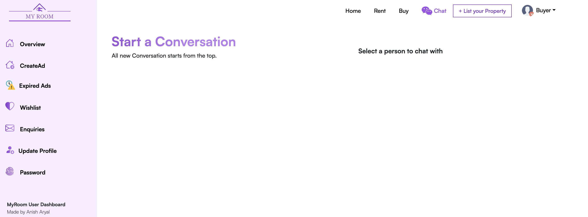

Figure 65: Step 1, Buyer's Chat list before performing the test.

1. Seller’s Chat List before clicking on have a chat button.

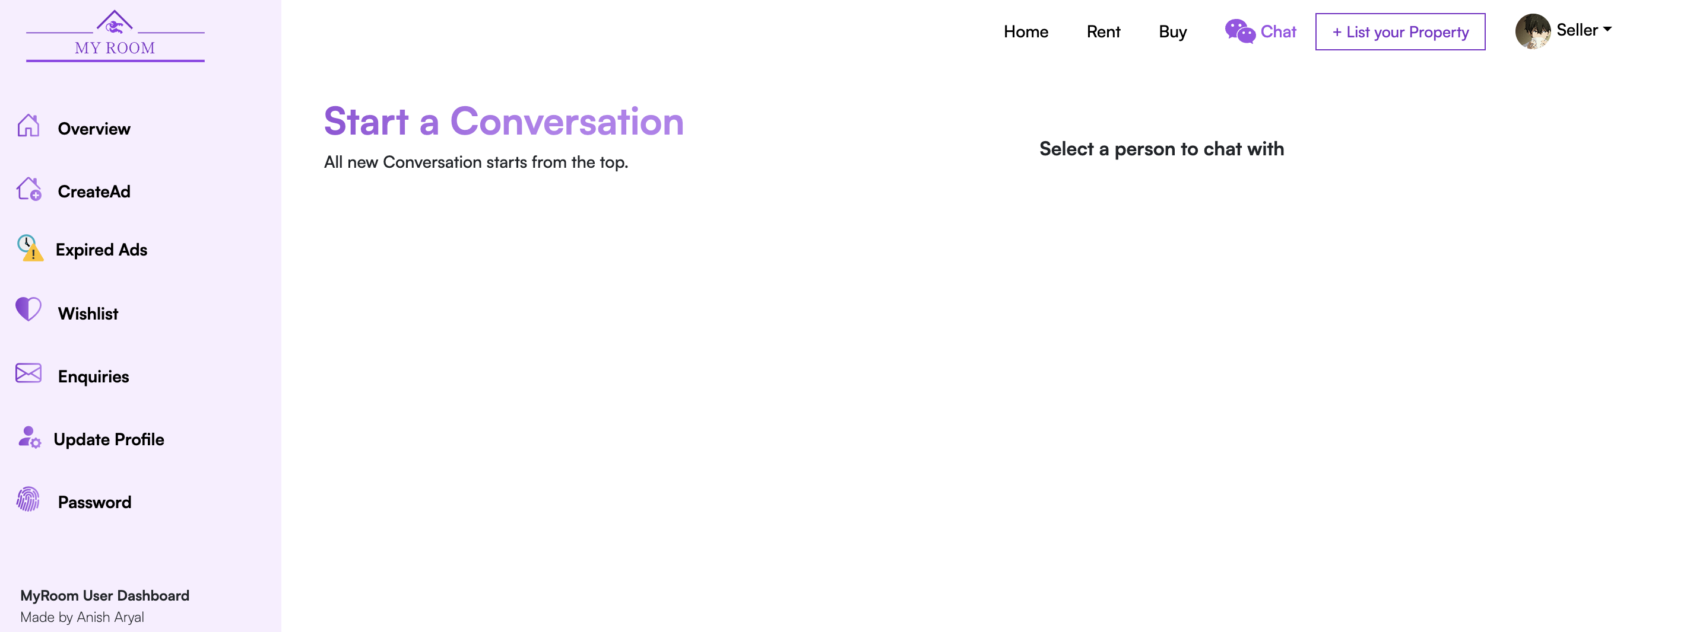

Figure 66: Step 2, Seller's Chat list before performing the test.

**Step 2:** Clicking on the “Have a chat” button present in the property details page from Buyer’s Account.

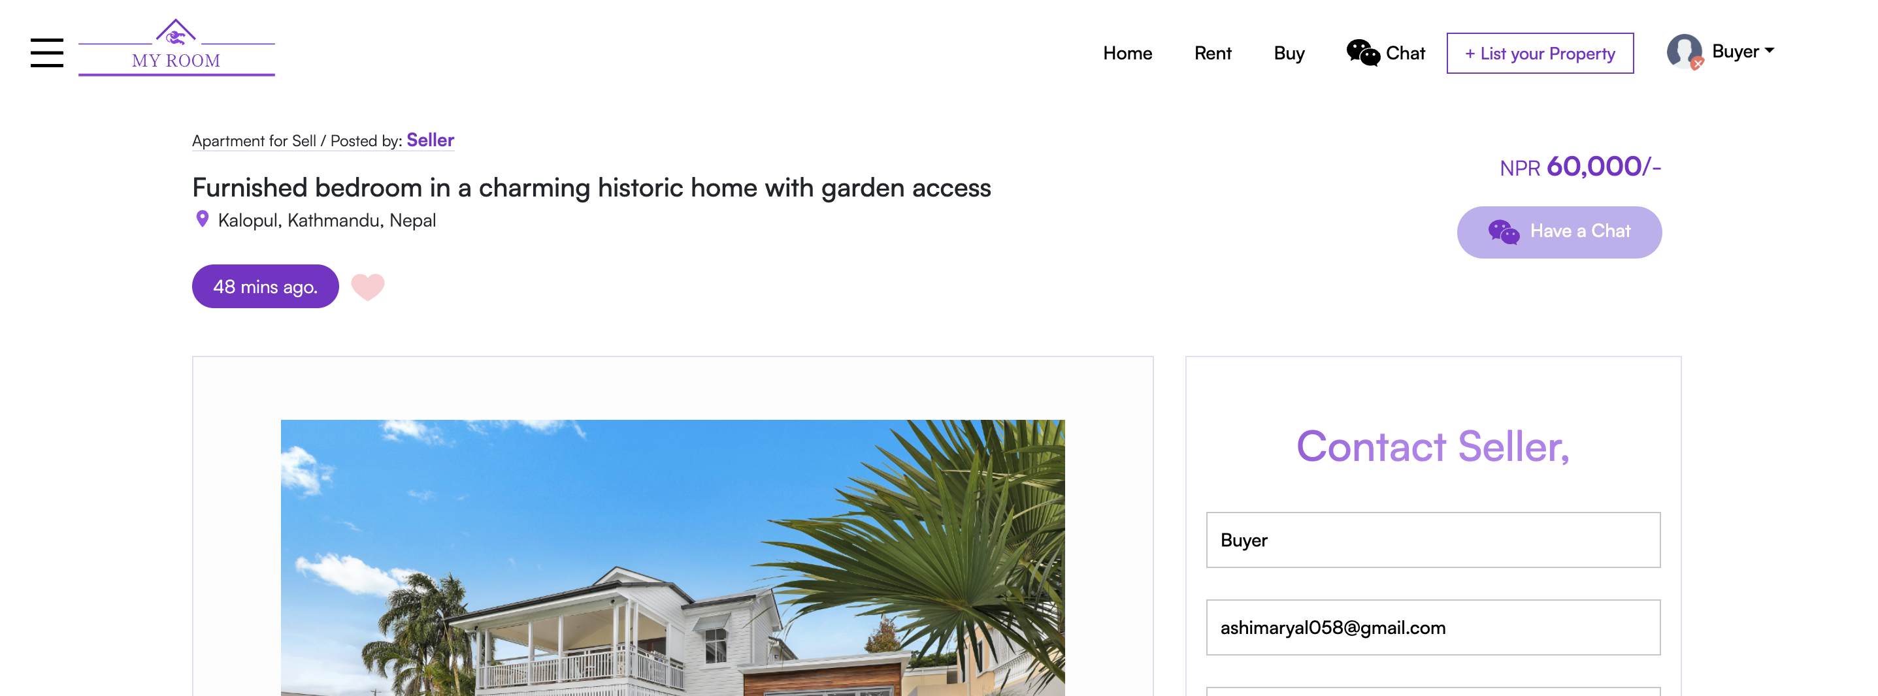

Figure 67: Step 2 of test for message seller functionality.

**Step 3:**  Seller is added to the buyer’s Chat list.

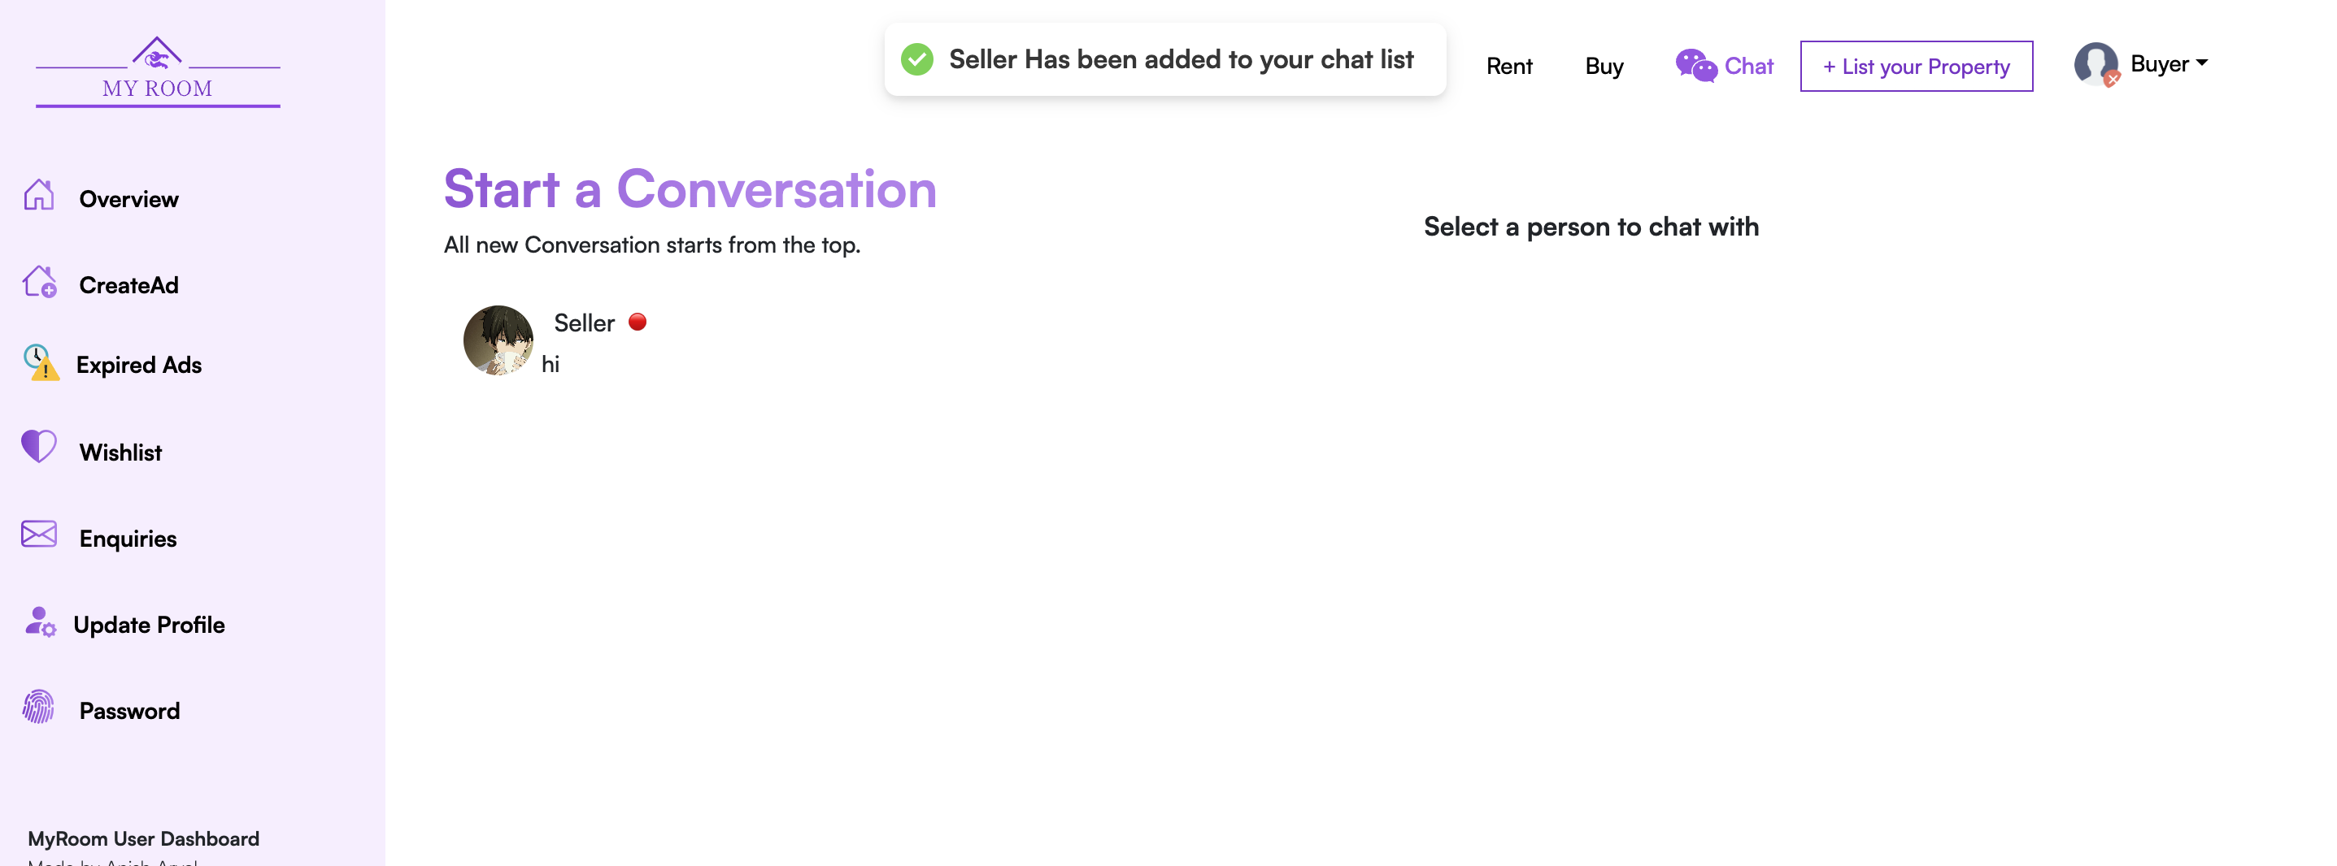

Figure 68: Step 3 of test for message seller functionality.

**Step 4:**  Checking if the seller received the message from the buyer.

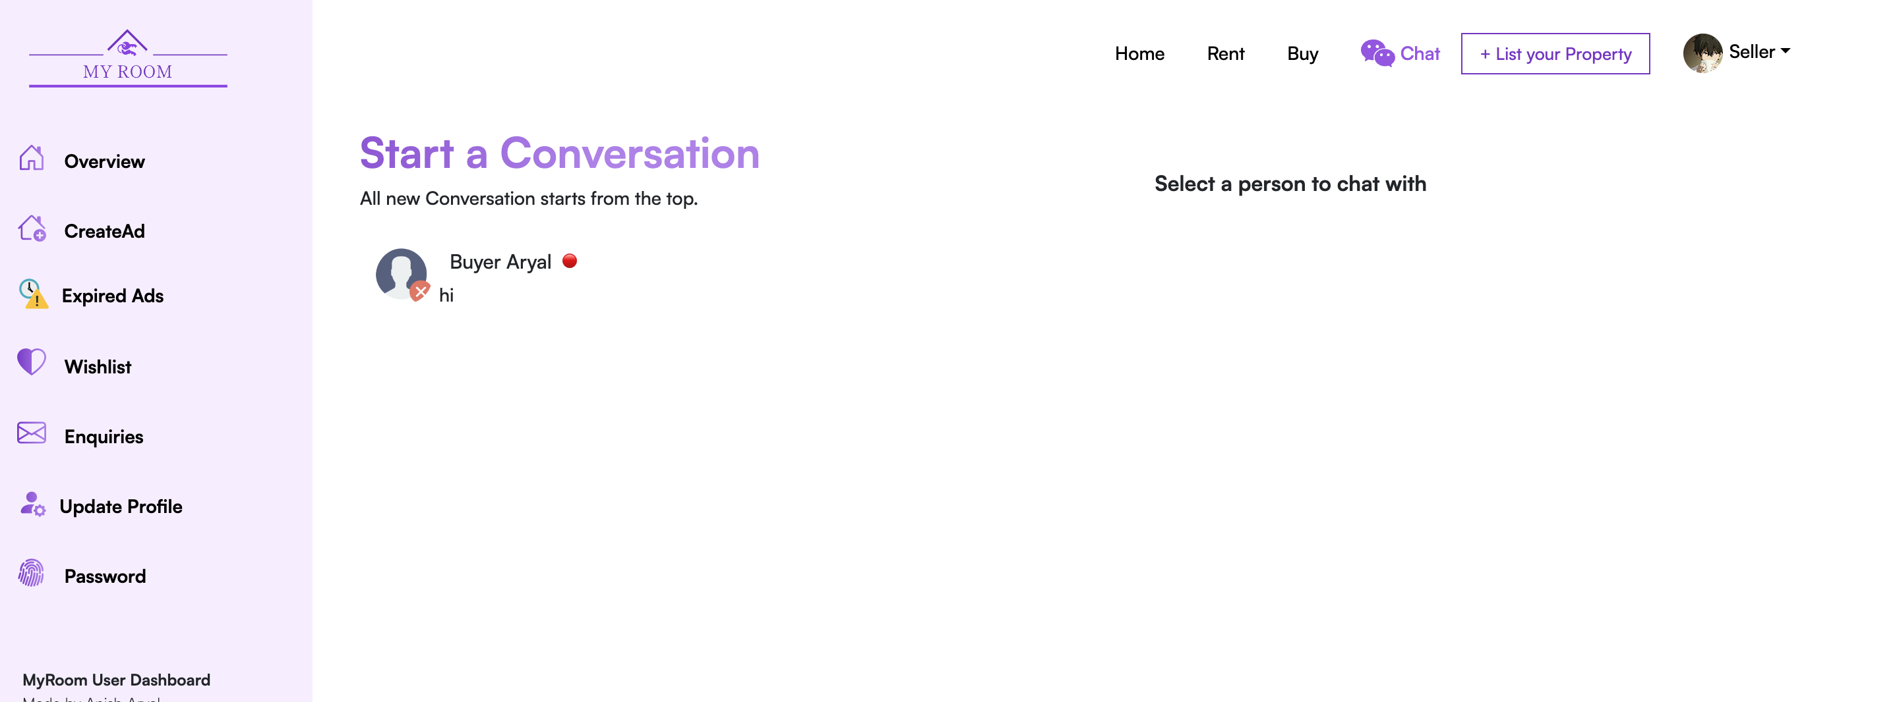

Figure 69: Step 4 of test for message seller functionality.

**Step 5:** Opening the Message that seller received from the buyer, We can see that it has been 2 minutes from the time user received the message.

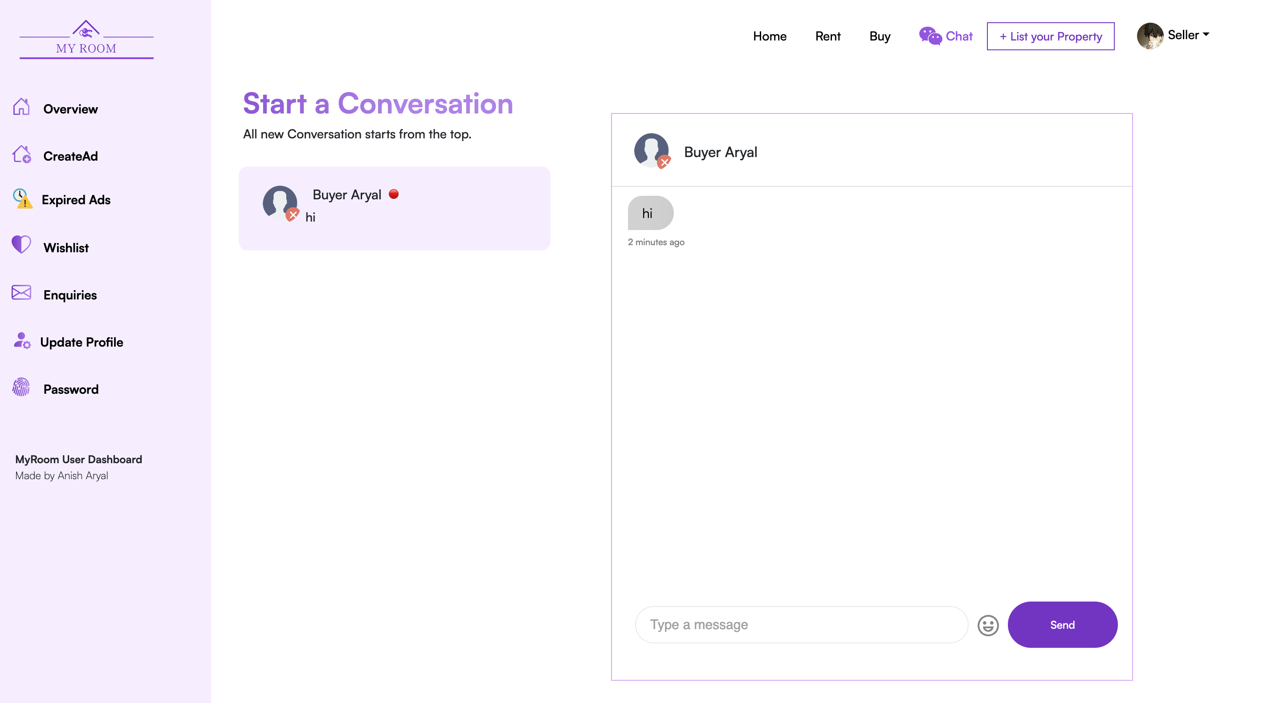

Figure 70: Step 5 of test for message seller functionality.

### Test 10: Test for Chat Functionality.

|  |  |
| --- | --- |
| **Objective** | **Test for chat Functionality.** |
| **Action** | Open the chat page and select the person to chat with then chat box opens write a new message and click send. |
| **Expected Result** | User should be redirected to chat page and chat list should be seen after clicking on the chat option in the navbar. After selecting the person to chat with and typing a new message other person should receive the message after clicking on the send button |
| **Actual Result** | User is redirected to chat page and chat list is seen after clicking on the chat option in the navbar. After selecting the person to chat with and typing a new message other person received the message after clicking on the send button |
| **Conclusion** | Test Successful. |

Table 26: Test for Chat Functionality

**Step 1:** Open the chat page clicking the chat option from the navbar.

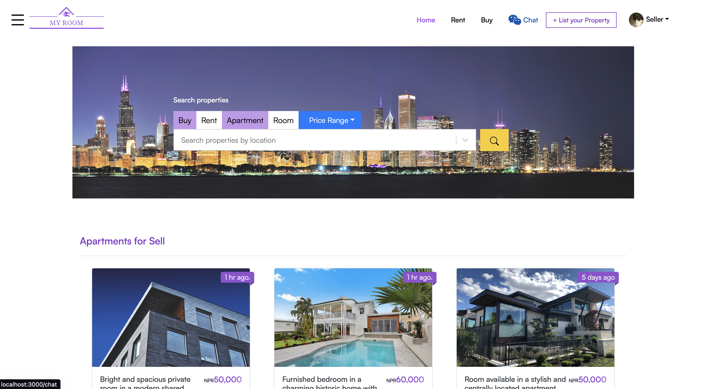

Figure 71: Step 1 of Test for chat functionality.

**Step 2:** Select the Person to chat with from the chat list.



Figure 72: Step 2 of Test for chat functionality.

**Step 3:** Write a new message and click on the send button.

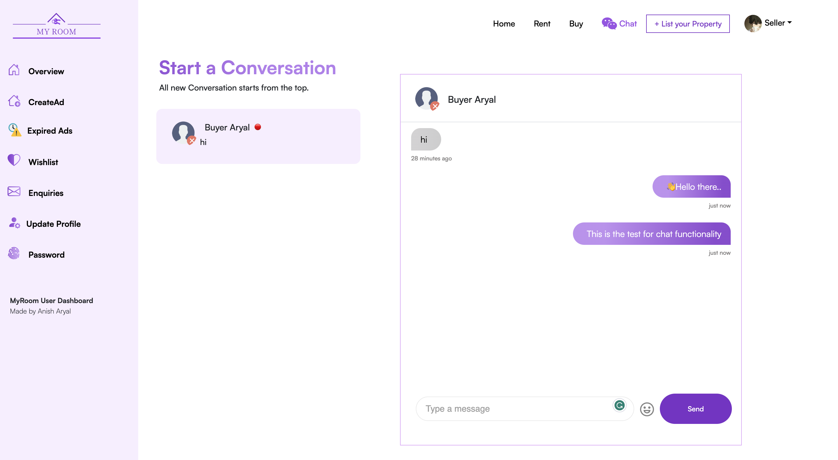

Figure 73: Step 3 of Test for chat functionality.

**Step 4:**  Checking if the other person received the new text message.

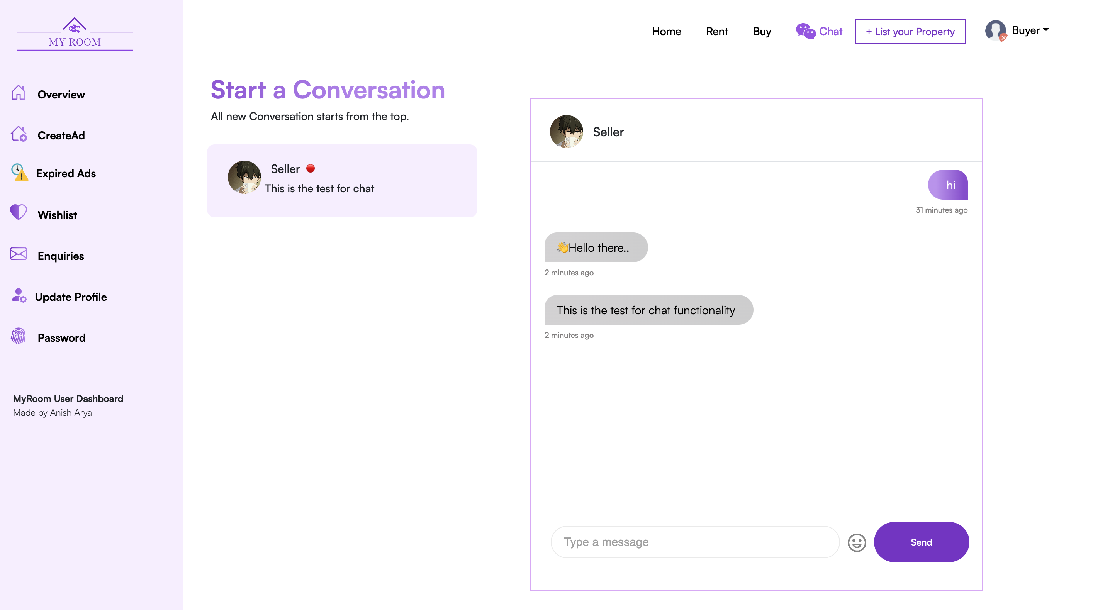

Figure 74: Step 4 of Test for chat Functionality.

### Test 10: Test for Update Password Functionality.

|  |  |
| --- | --- |
| **Objective** | **Test for chat Functionality.** |
| **Action** | Open the chat page and select the person to chat with then chat box opens write a new message and click send. |
| **Expected Result** | User should be redirected to chat page and chat list should be seen after clicking on the chat option in the navbar. After selecting the person to chat with and typing a new message other person should receive the message after clicking on the send button |
| **Actual Result** | User is redirected to chat page and chat list is seen after clicking on the chat option in the navbar. After selecting the person to chat with and typing a new message other person received the message after clicking on the send button |
| **Conclusion** | Test Successful. |

Table 26: Test for Chat Functionality

## White Box Testing

### Test 1: User Registration

|  |  |
| --- | --- |
| **Objective** | **Test if log out button work properly** |
| **Action** | Fill the register form on the registration page and click the register button. |
| **Expected Result** | * Proper validation should be carried out and suitable message should be dispayed. * If the email already exist in the MyRoom database user shouldn’t be able to registered and be notified * Check if the phone number given is unique to the system. * Check if any fields are empty. * After all the validation done and no error is found user should receive an email from Myroom with activation link and user should be redirected to home page * After user clicks on the activation link from the mail user should be logged in into the system |
| **Actual Result** | User is successfully registered to the system. |
| **Conclusion** | Test successful. |

Table : User Registration test

**Step 1:** Open the register page.

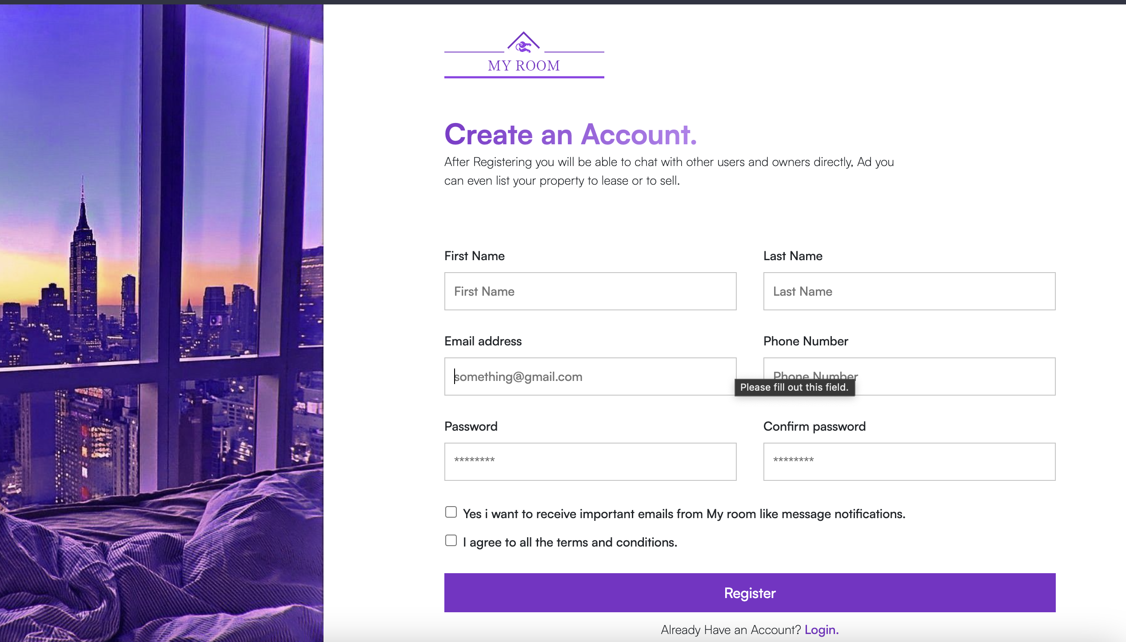

Figure : User Registration Step 1

**Step 2:** Filling the form and clicking the register button.

Trying to register with **duplicate email.**

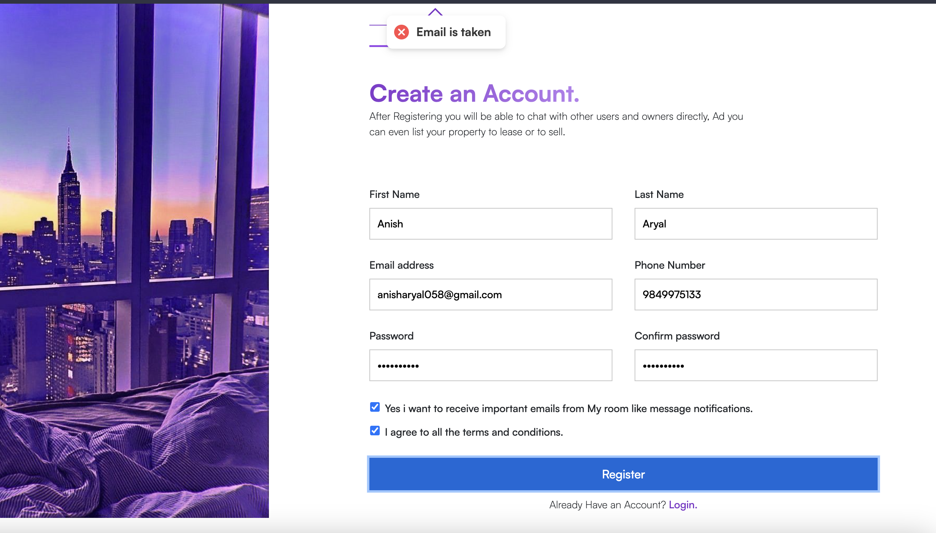

Figure : User Registration Step 2(figure 1)

Email is taken is error message displayed since the user with same email already exist.

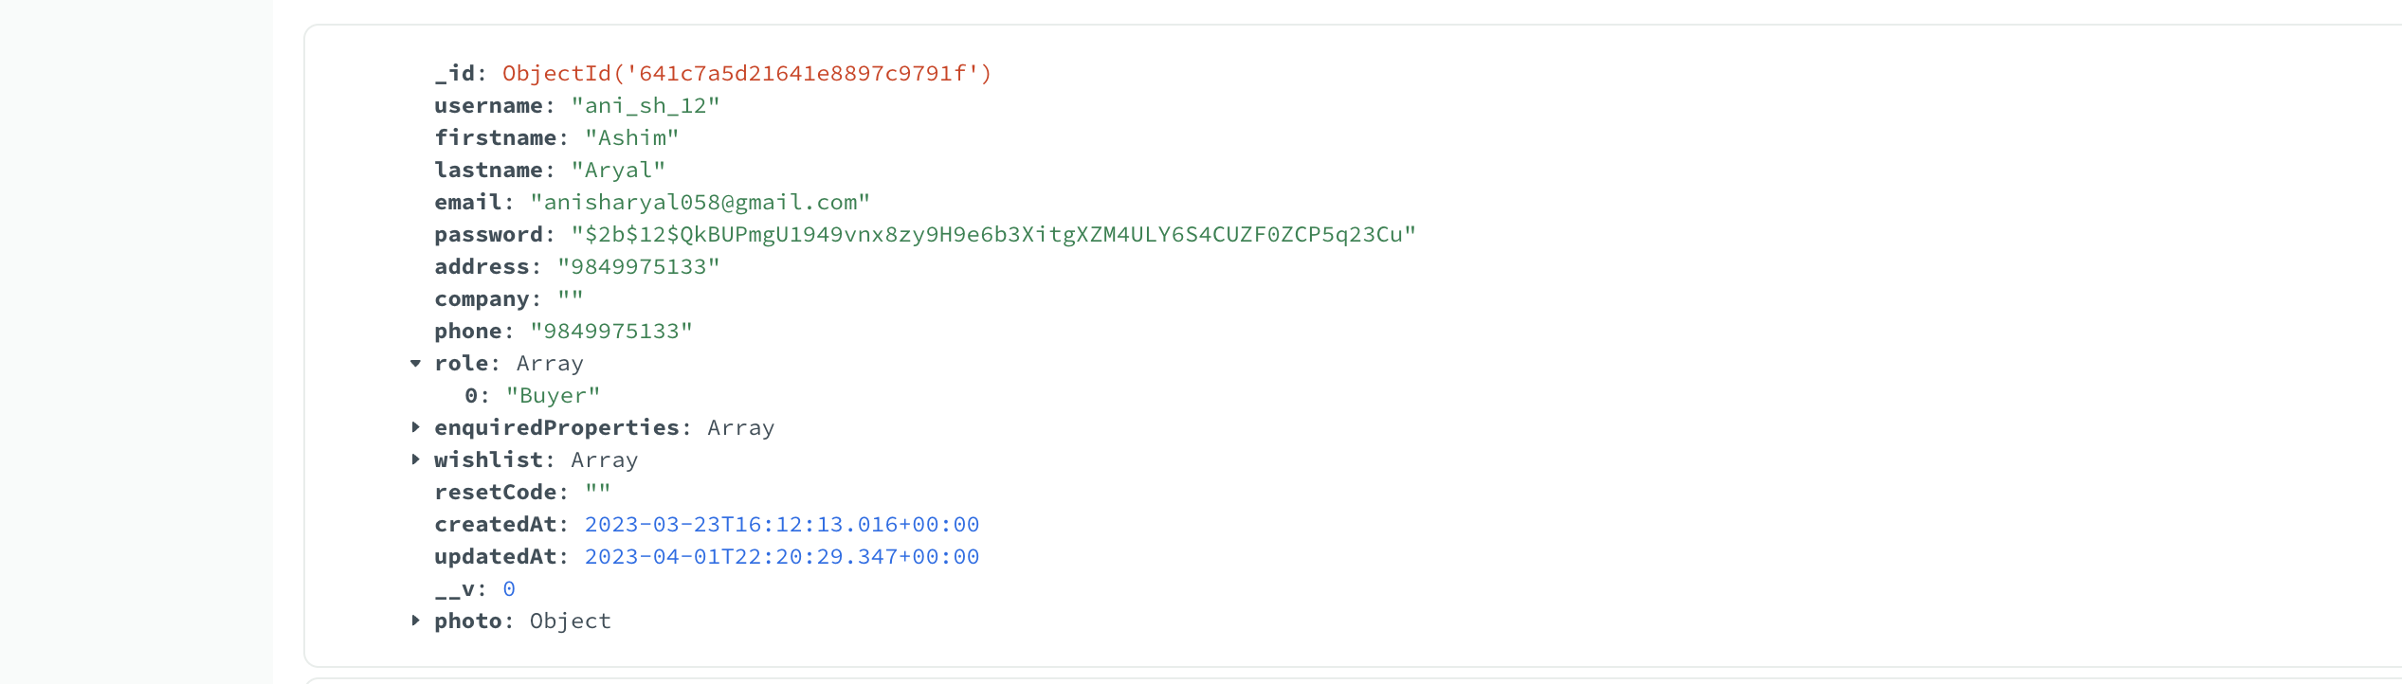

Figure : User Registration step 2 (figure 2)

Trying with **duplicate phone number.**

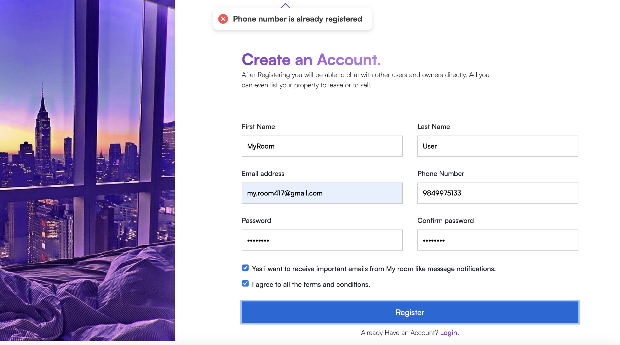

Figure : : User Registration step 2 (figure 3)

Filling the form correctly.

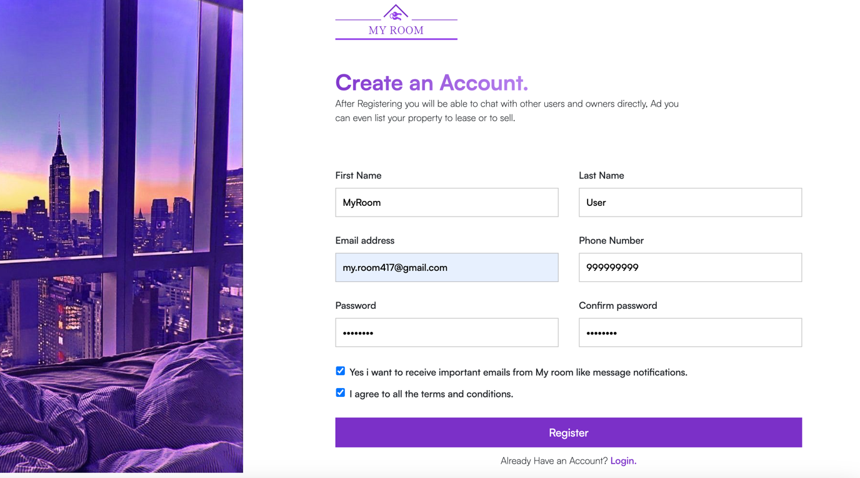

Figure : : User Registration step 2 (figure 3)

**Step 3:** Afterclicking the register button user is redirected to home page with, please check your email message dialog.

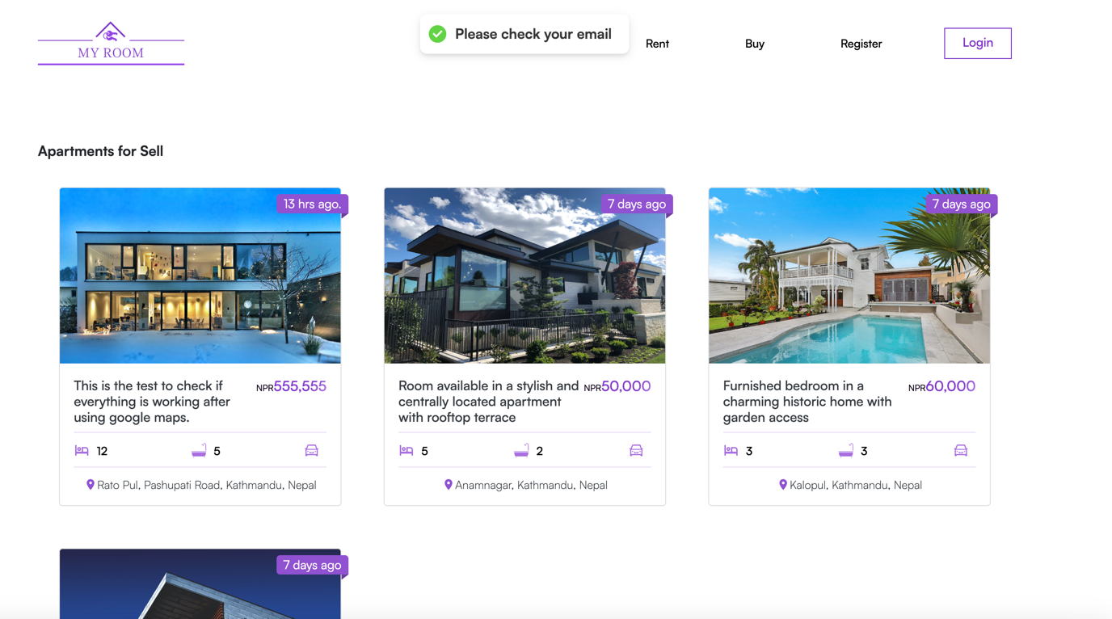

Figure : : User Registration step 3

.

**Step 4**: checking the email and clicking on activation link

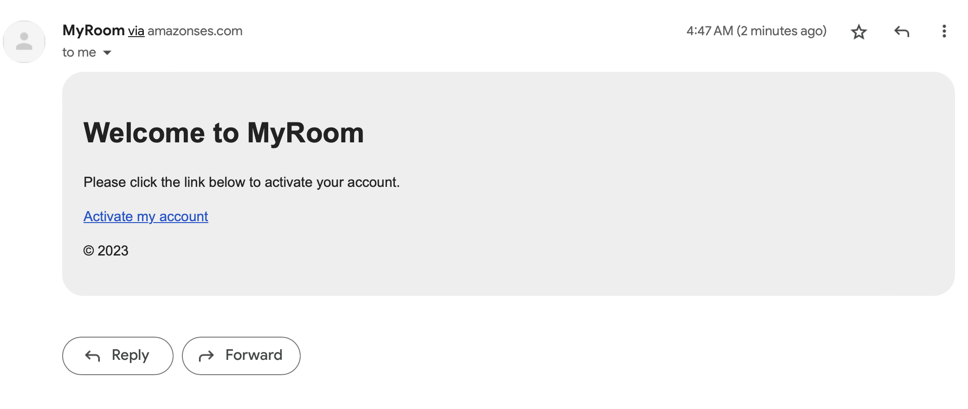

Figure : User Registration step 4 ( fig-1)

After clicking on the activation link user is logged in to the webapp and redirected to the home page.

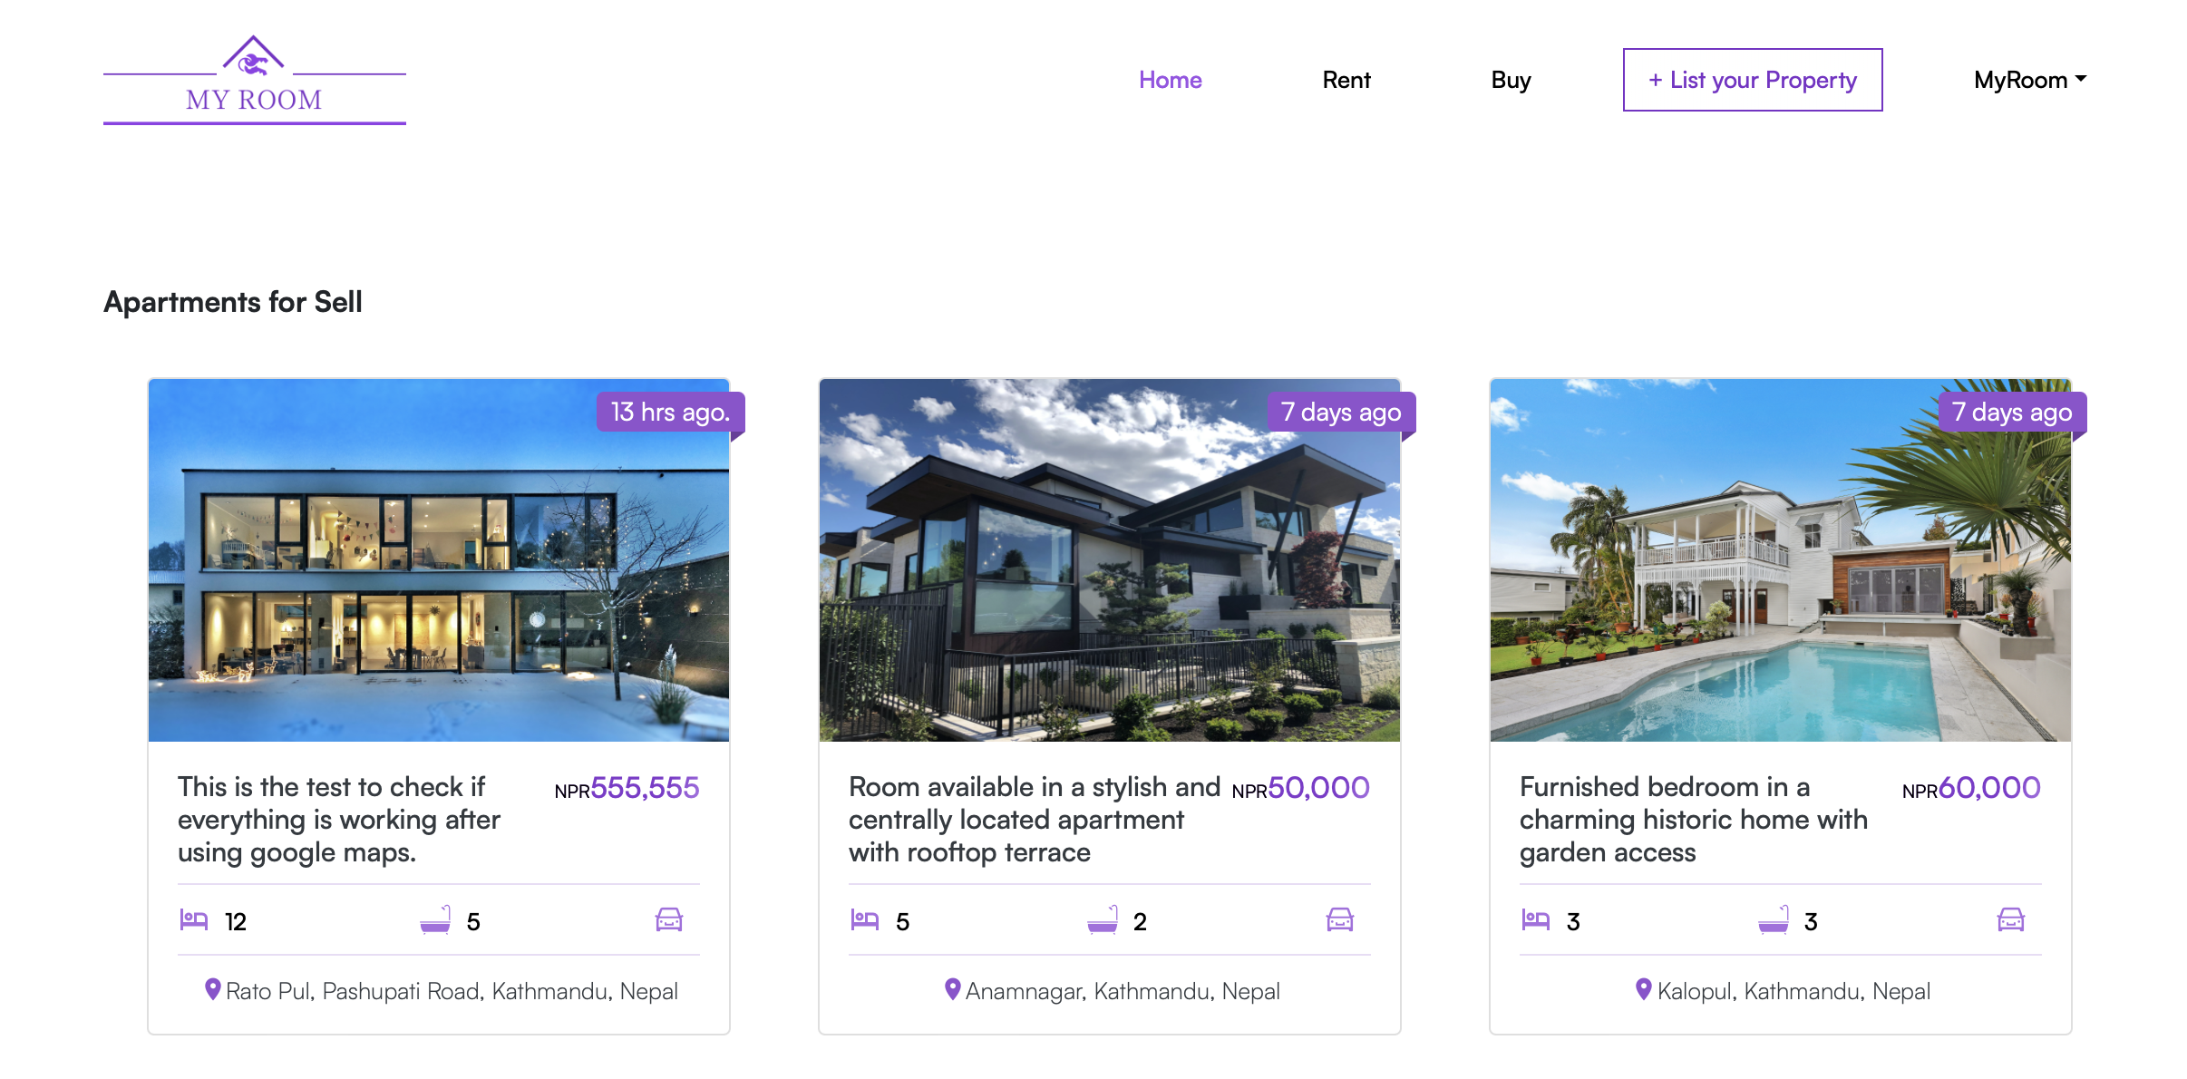

Figure : : User Registration test step 4 (fig- 2)

**Step 5**: Test Successful since the new user with information in previously filled is created in the database.

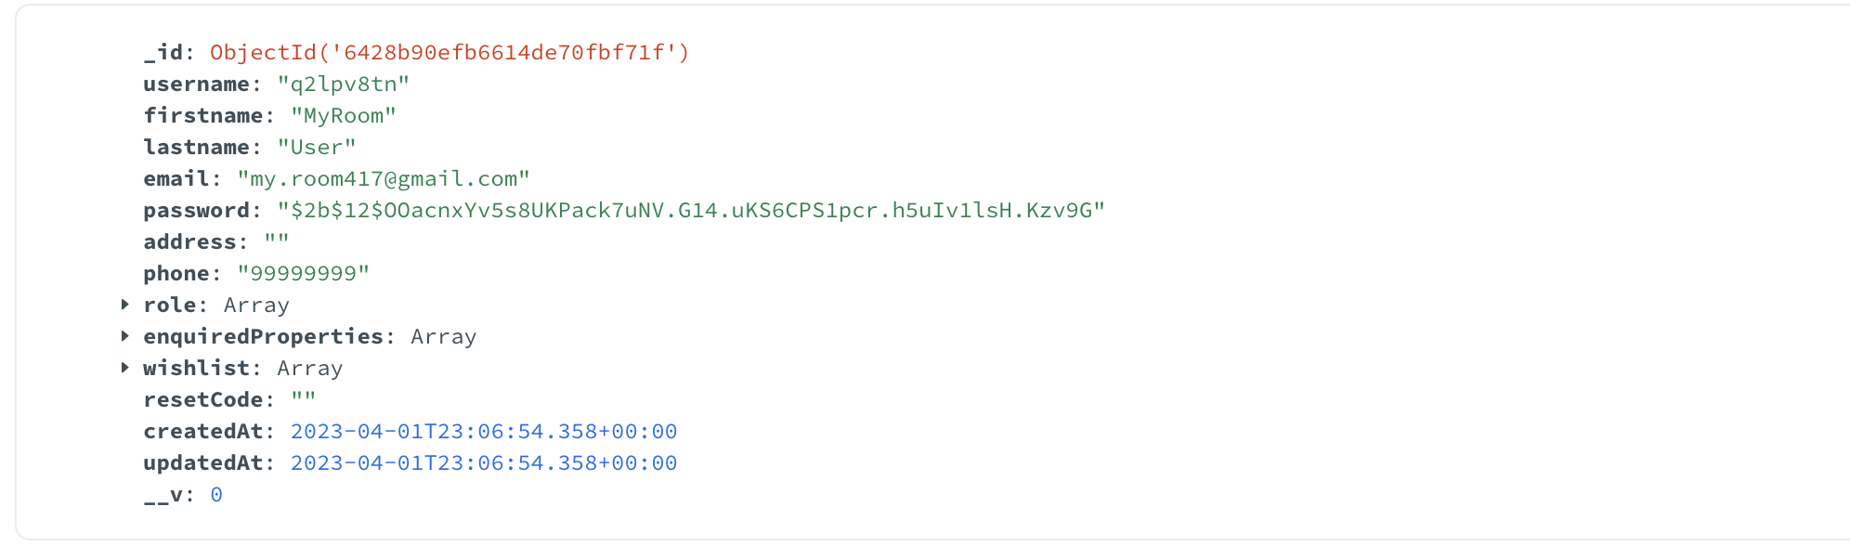

Figure : User Registration test step 6

### Test 2: Admin Login

|  |  |
| --- | --- |
| **Objective** | **Test if Admin login is properly** |
| **Action** | Click the “login” button after filling the information correctly |
| **Expected Result** | Admin should be logged in to the application and redirected to Dashboard with one additional sidebar item My Room Users. |
| **Actual Result** | Admin is redirected to dashboard |
| **Conclusion** | Test successful. |

Table : Admin Login test

**Step 1:** Below shown user have the role of Admin and is trying to register to the system.

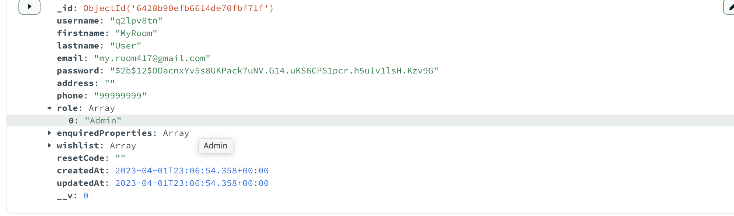

Figure : Admin Login Step 1 (fig-1)

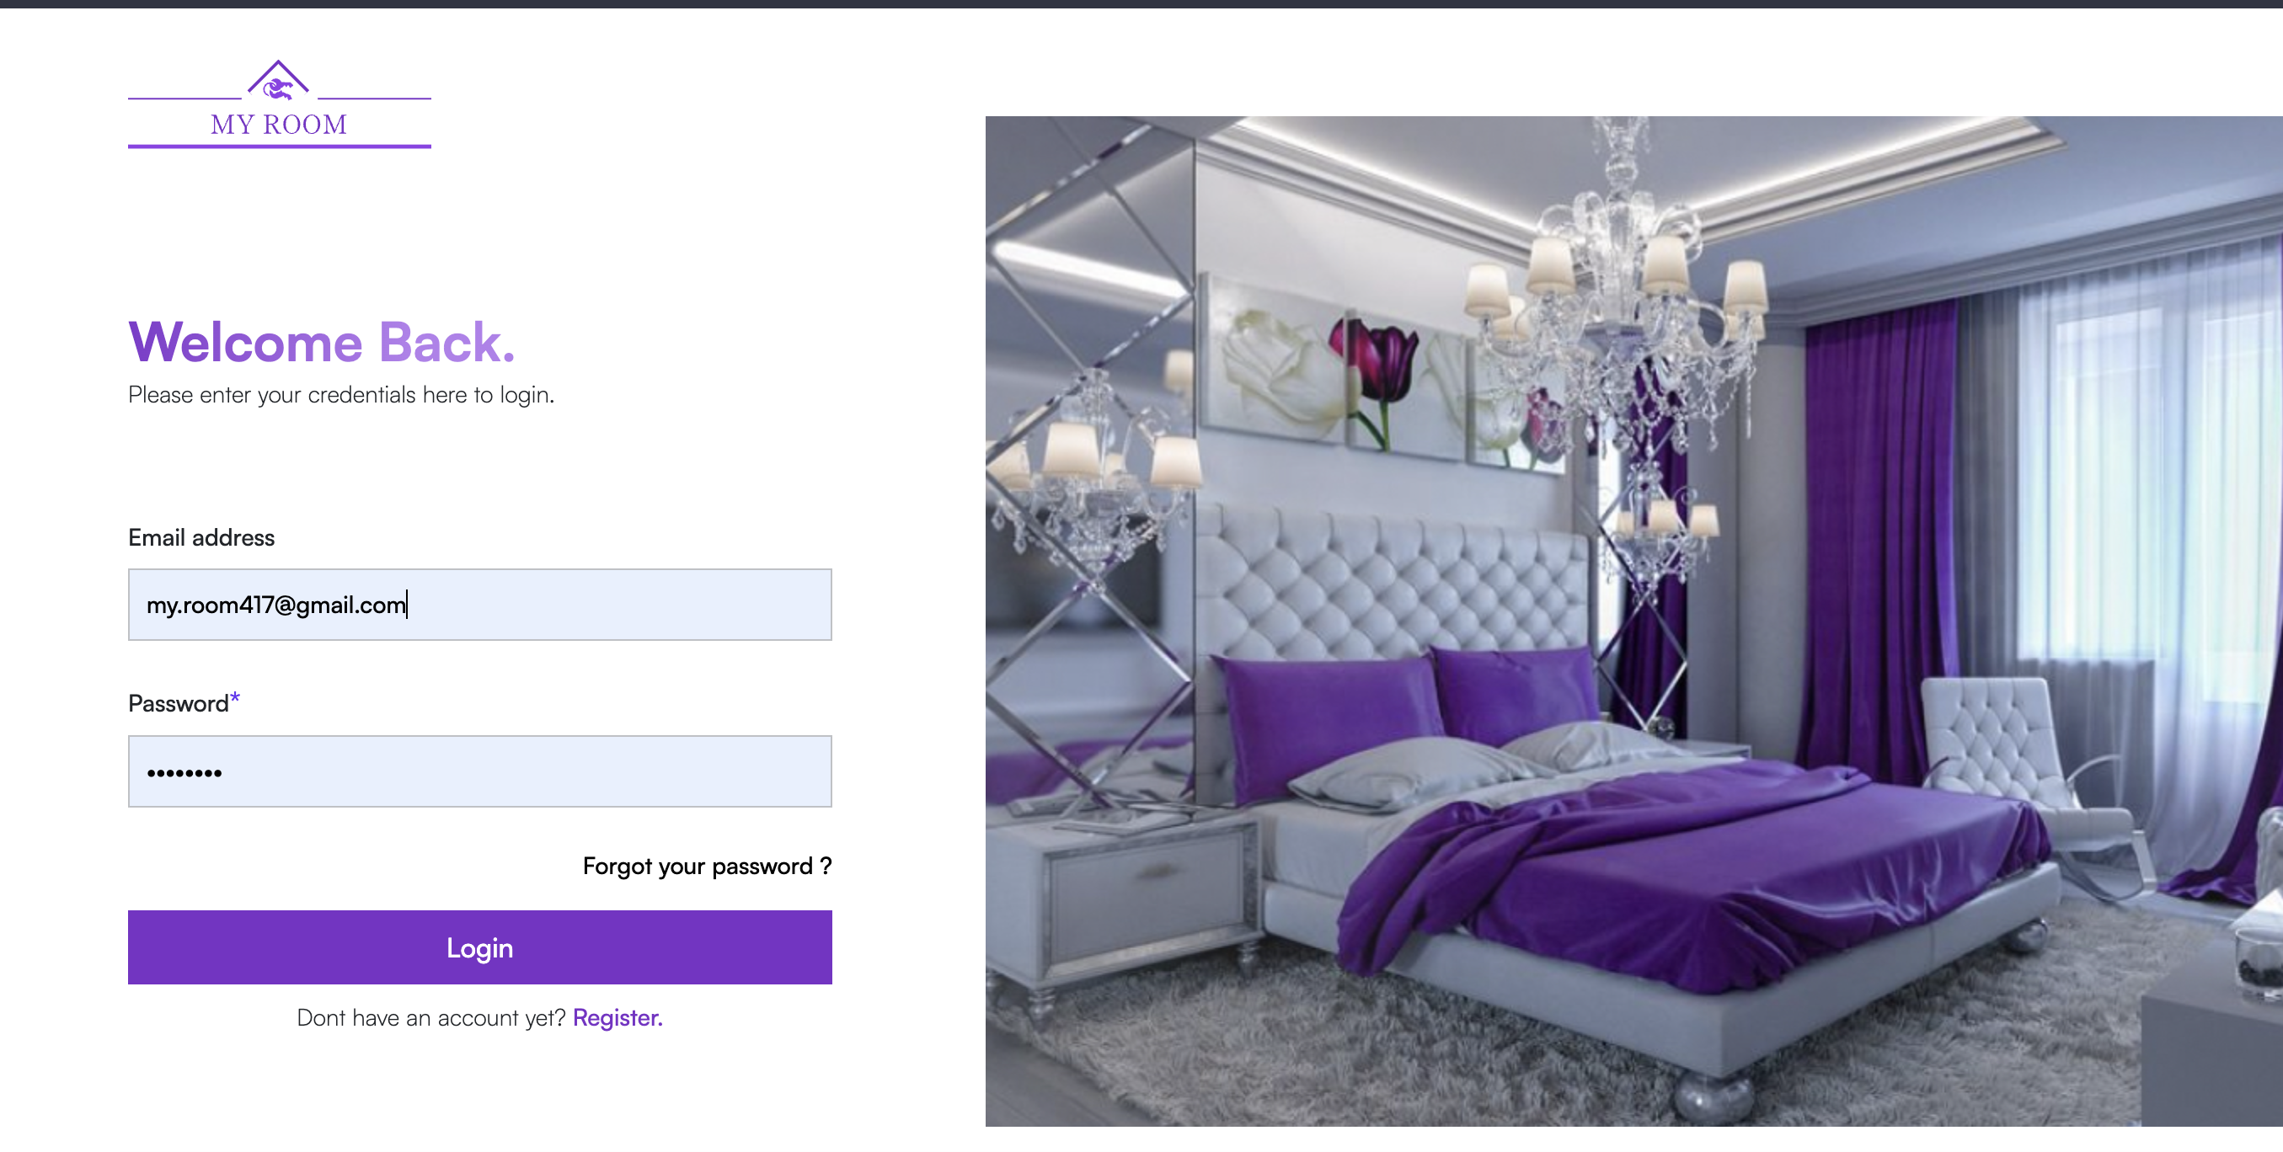

Figure : Admin login step 1 (fig-2)

**Step 2:** Test successful as admin is logged in and redirected to dashboard.

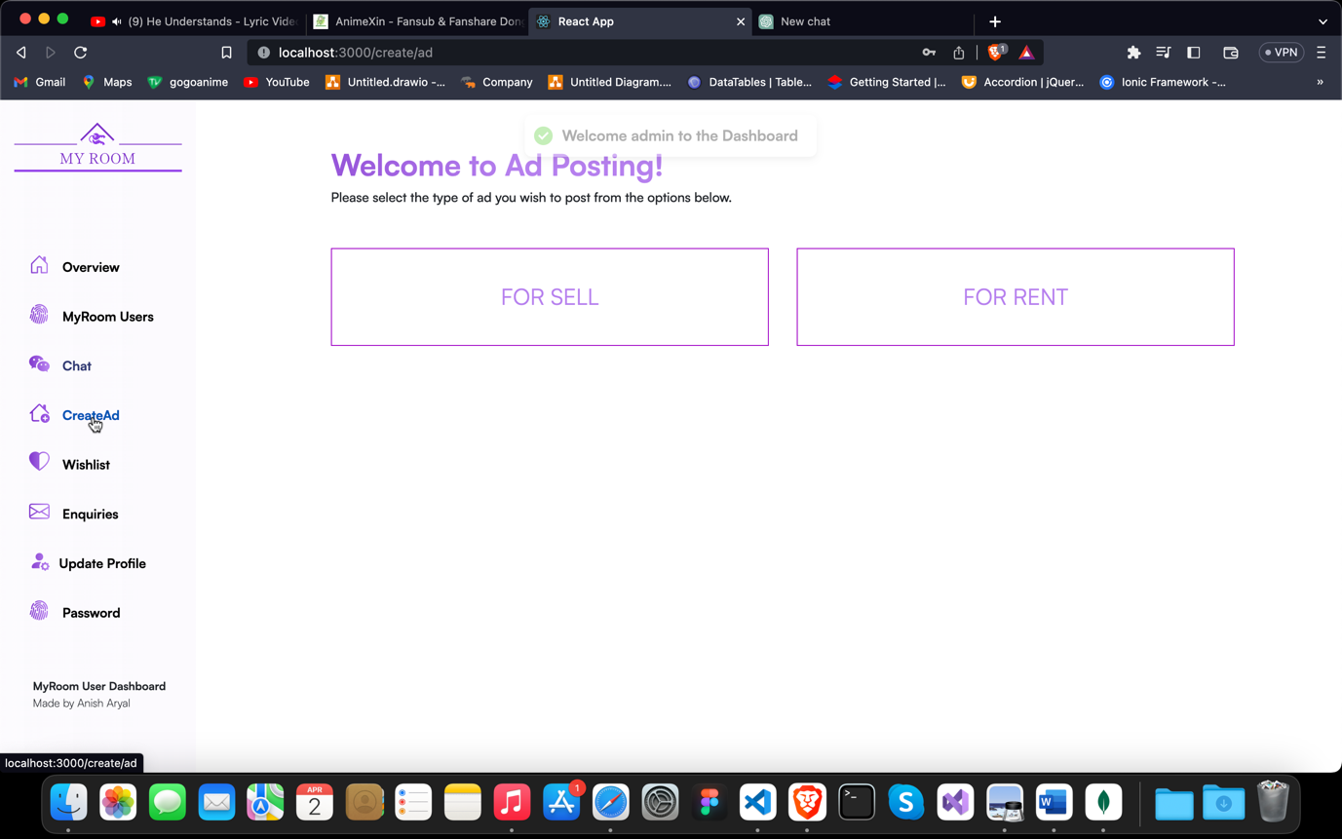

Figure : Admin login step 2

### Test 3: Create a new Ad

|  |  |
| --- | --- |
| **Objective** | **Create a new ad for listing property.** |
| **Action** | Click the “List your property” button on the navbar after logging in. Choose the type of ad you wish to post first choose either to rent or to sell then fill the form properly. |
| **Expected Result** | * If there are any validation errors those errors should be notified to the user with suitable message. * If user doesn’t upload the photo, they should be notified to upload at least one. * New ad should be created in the database after successful validation and user clicking on the post ad button |
| **Actual Result** | Admin is redirected to dashboard |
| **Conclusion** | Test successful. |

Table : Creating a new ad test

**Step 1:** Checking the number of ads in the database.

There are only 10 ads at-the-moment in the database.

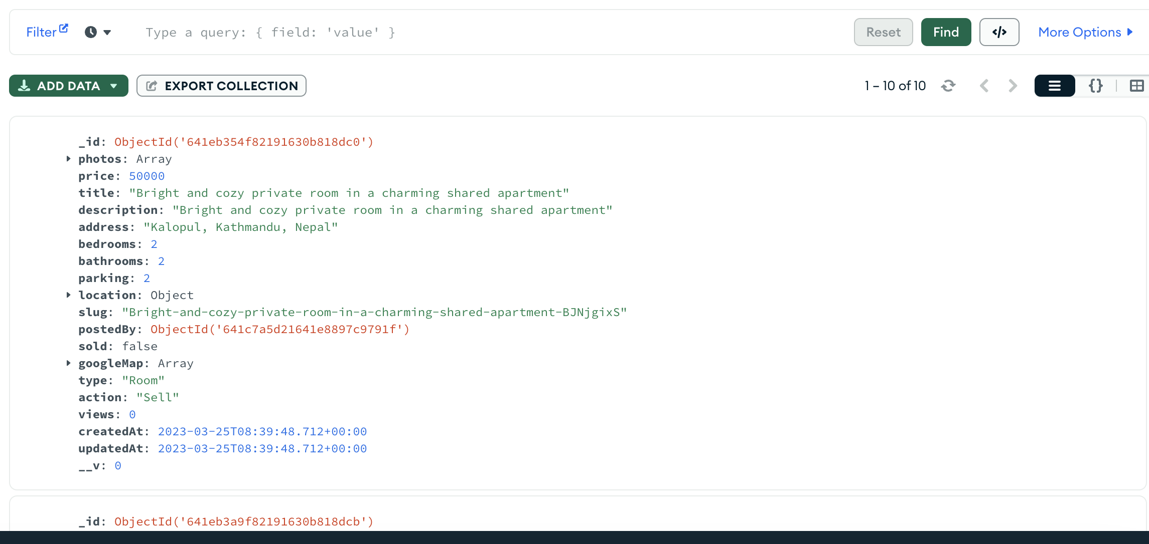

Figure : Creating new ad step 1

**Step 2:** Fill the form, this step shows all the validations.

* + 1. **No Image Uploaded**

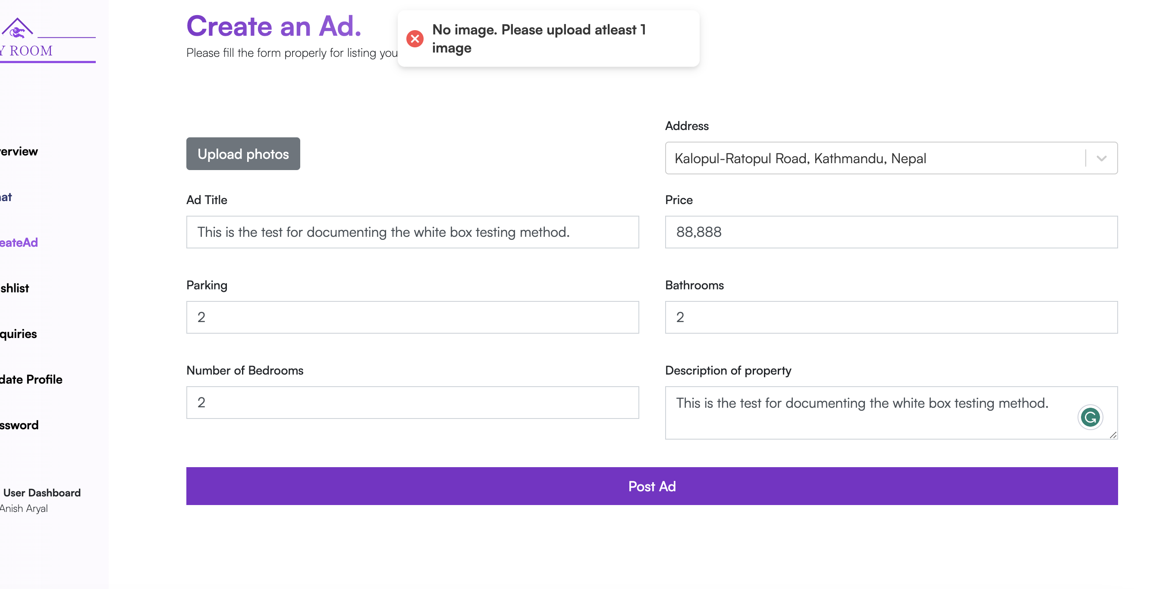

Figure : Creating new ad step 2 (No Image Uploaded)

* + 1. **No Title Provided**

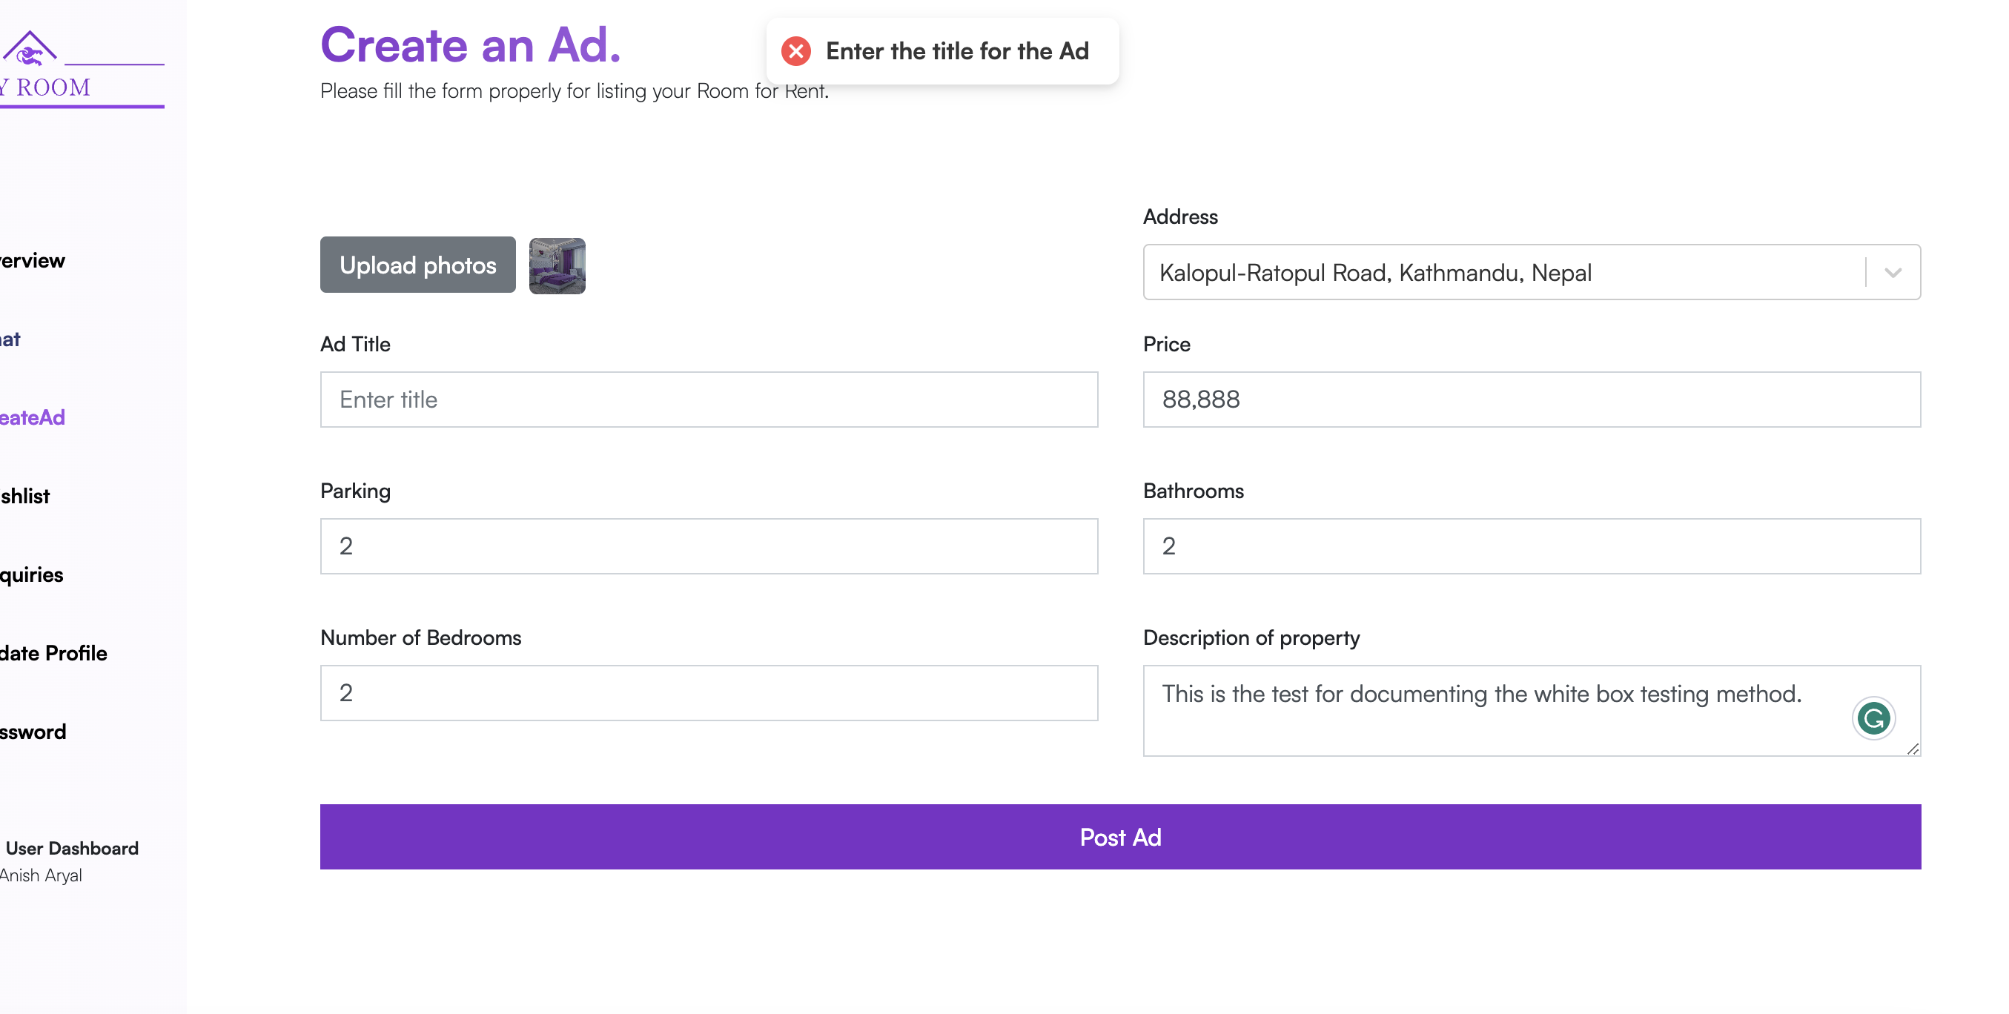

Figure : Creating new ad step 2 (No Title Provided)

* + 1. **No Price Provided**

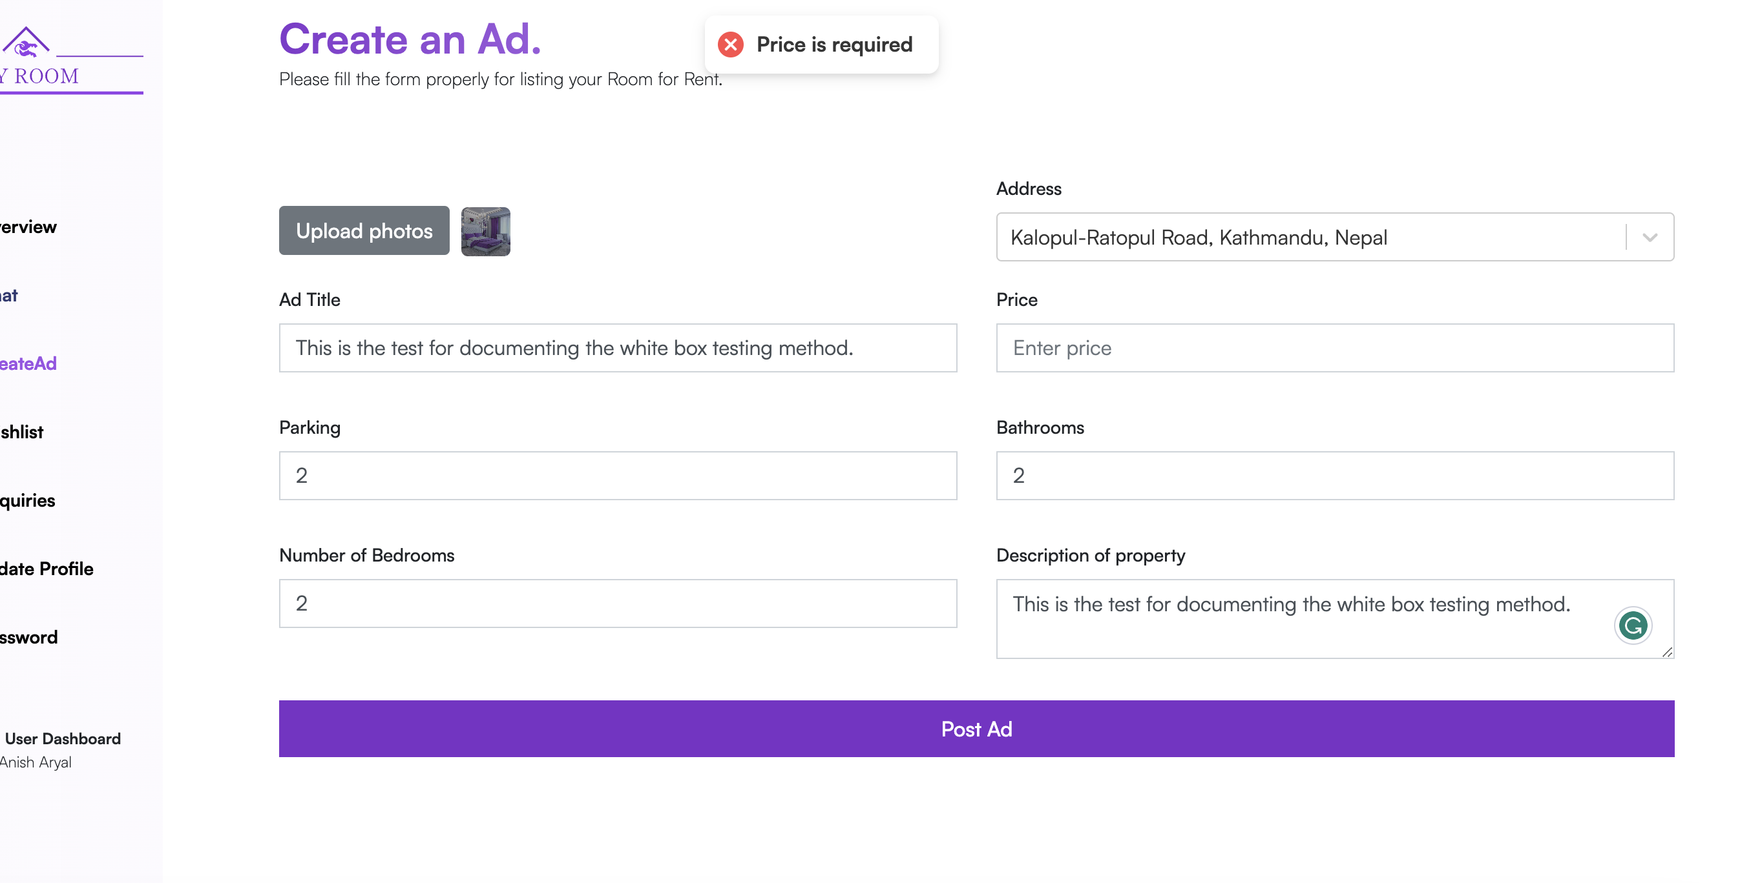

Figure Creating new ad step 2 (No Price provided)

* + 1. **No Description of the property given**

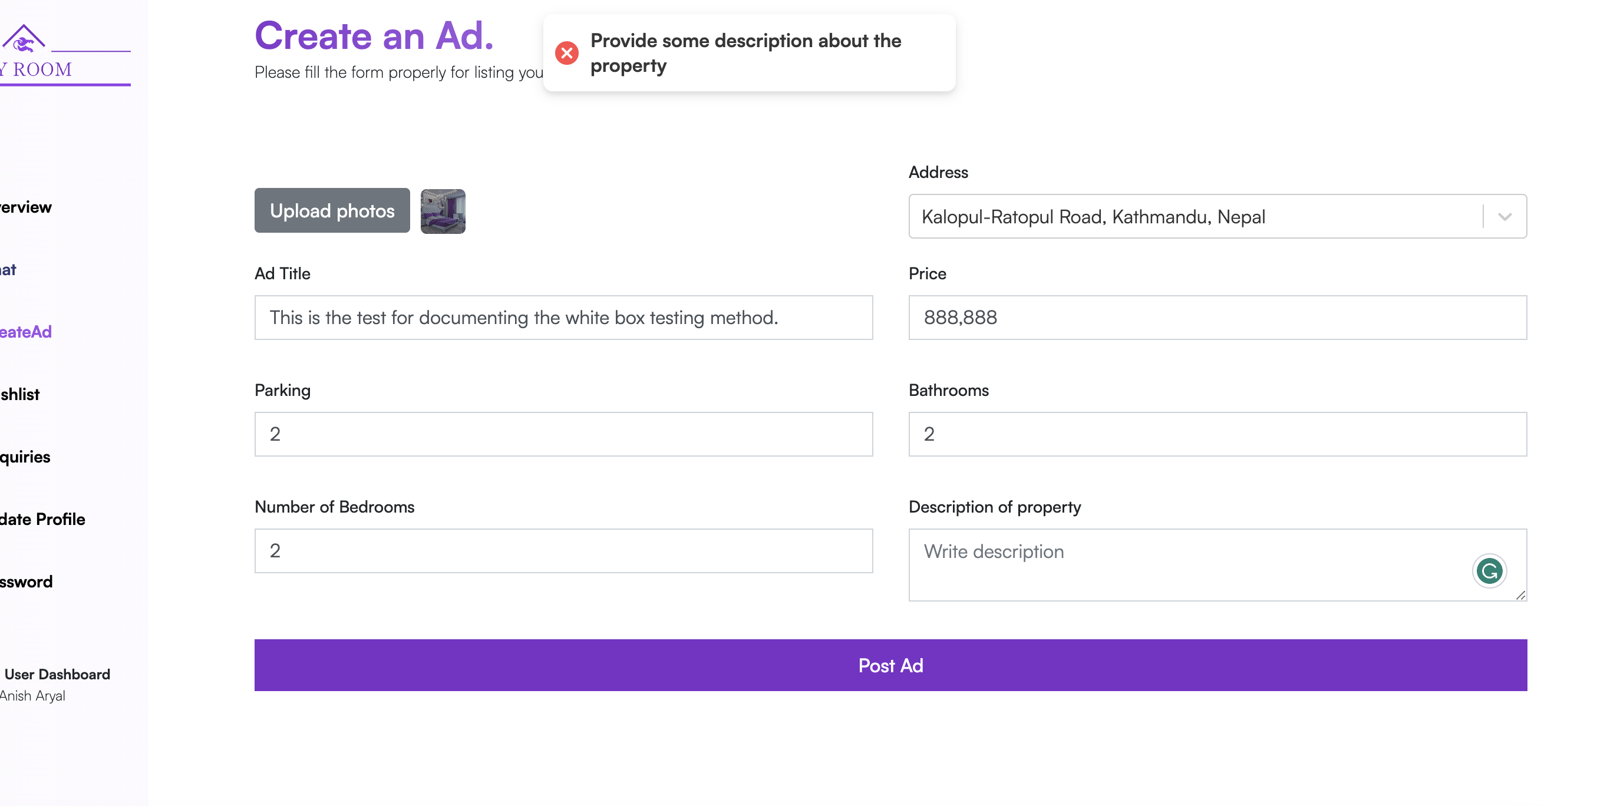

Figure : Creating new ad step 2 (No Description)

**Step 3:** Filling the form with complete information and clicking on the Post Ad Button

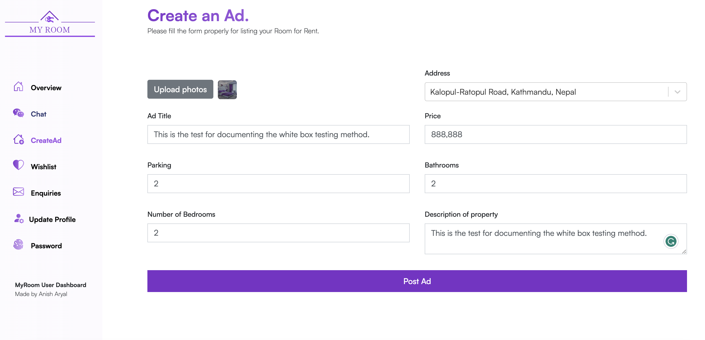

Figure : Creating new ad step 3

**Step 4:** Clicking on the post ad button.

After clicking on the post ad button user is then redirected to home page.

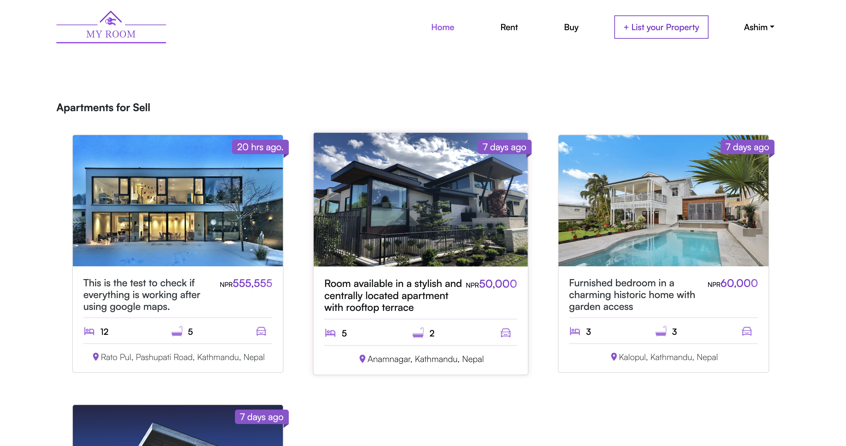

Figure : Creating new ad step 4

**Step 5:** Test successful as we can see the ad with above filled information is added to the database. We can also see that the number of ads changed from 10 to 11 after adding the ad.

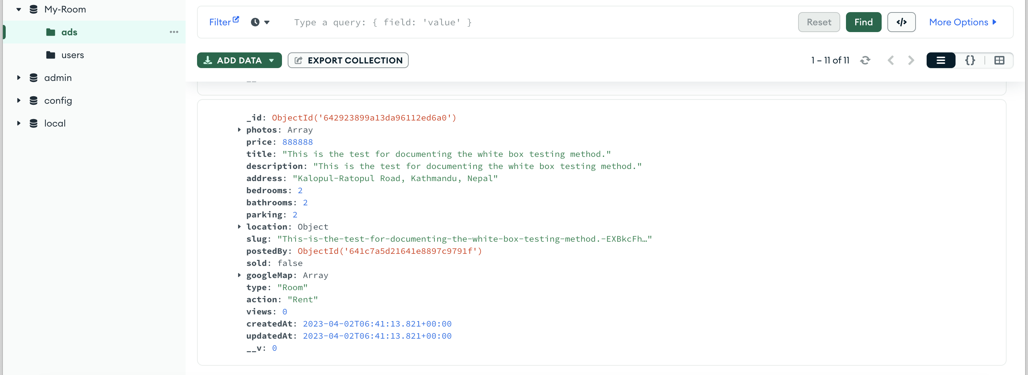

Figure : Creating new ad step 5

# Appendix

## 

## SRS Document

### Project Title: My Room

### Category: Web Application

### Introduction

#### Purpose

When developing software, the requirements stage involves the creation of Software Requirements Specifications (SRS) (also called a requirements document). This report is created after all requirements have been collected, assessed, and laid out, serving as a foundation for software engineering initiatives. In order to help clients, determine whether the report (SRS) meets their needs, it is a formal report that also acts as a software representation. The prerequisites for both users and the system are carefully described as well.

The purpose of this SRS is to specify the requirements for the room/apartment finder web application, which will allow users to search for and list properties for lease or sale and make the process of finding rooms/apartments seamless.

#### Project Scope

The proposed room/apartment finder web application is a platform that allows users to search for and find rooms or apartments to rent or buy. The room/apartment finder web application will include a login and registration system, a chat feature, a comment feature, a property listing feature, a map showing the location of properties, a search and filtering function, a feature for reporting inappropriate listings, etc. The application will also allow users to upload images of their properties. The application will be developed making it proper responsive and optimized for the use in the desktop websites and for mobile devices as well. It allows users to list their own properties for rent or sale, and to interact with other users through a chat feature.

Some potential advantages of this system for people are:

* + 1. **Convenience**: The room/apartment finder web application provides a centralized platform for users to search for and find rooms or apartments, saving them the time and effort of searching through multiple sources.
    2. **Ease of use**: The application has a user-friendly interface and various features, such as an advanced search option and easy filtration options, to make it easy for users to find properties that meet their specific needs and preferences.
    3. **Increased visibility**: The application allows users to list their own properties, providing them with increased visibility and the opportunity to reach a wider audience of potential renters or buyers.
    4. **Communication**: The chat feature allows users to communicate with each other and ask questions about properties, facilitating the process of finding and securing a room or apartment.

### Overall Description

#### Product Description

The room/apartment finder web application will be developed as a web-based application that can be accessed from any device with a web browser. It will be developed using React for the frontend and Node.js for the backend and it will use a Mongo DB database to store user and property information.

#### User Characteristics

My Room web application will be developed as a web-based application that can be accessed from any device with a web browser. It will be developed using React for the frontend and Node.js for the backend and it will use a Mongo DB database to store user and property information.

#### Constraints

There may be constraints on the development of the room/apartment finder web application, such as budget constraints, time constraints, or technical constraints. Some of the constrains are listed below:

1. Product may not be completed on time as the project might take longer than expected.
2. There could be the problem with budget as some APIs may not be free and should be purchased.
3. Some frameworks, API, technology may not work on the device that the project is being built on.
4. There might occur some technical difficulty like some software, frameworks not working properly on the device this project is being developed.

### System Perspective

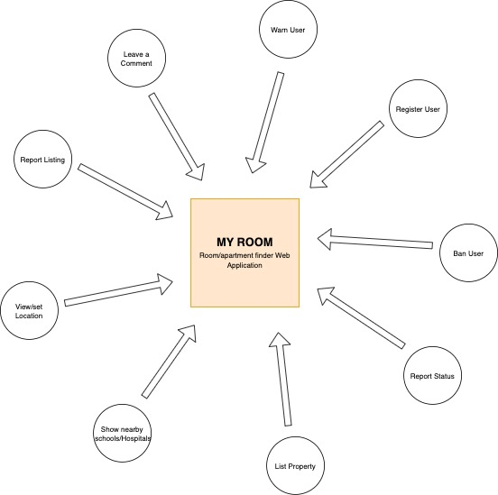

Figure : System Perspective

### System Features